Running Refresh Dynamic Group Process – The QRG is great!

Note: This process runs nightly for all the dynamic groups. When a time reporter is newly enrolled and the timesheet is to be filled soon after on the same day, this process can be run ad-hoc by the college time and labor admins.

Nav>Set Up HCM>Security>Time and Labor Security>Refresh Dynamic Group

If this is the first time running this process, select Add a New Value and create a Run Control ID, otherwise, select Find an Existing Value and select Search.

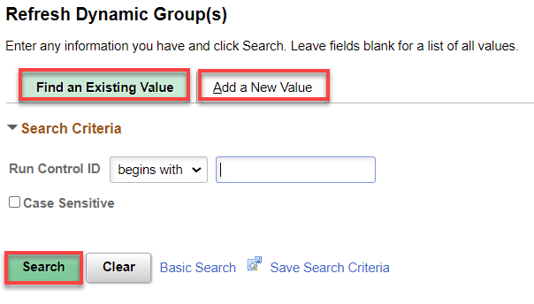
The Refresh Dynamic Group page displays. Use Current Date, unselect Refresh All Dynamic Groups, if checked, Add Group ID (typically College Number ALL), click Run.

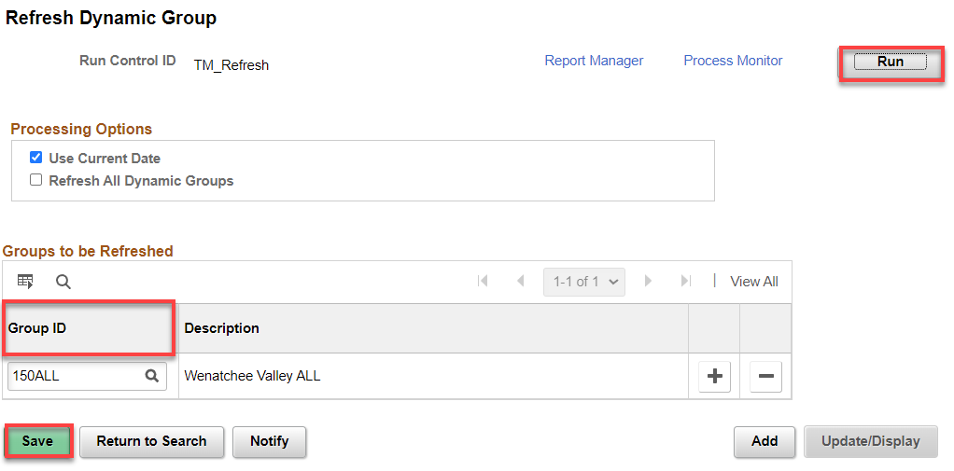

The Process Scheduler Request page displays. Select the OK button.
The Refresh Dynamic Group button displays.

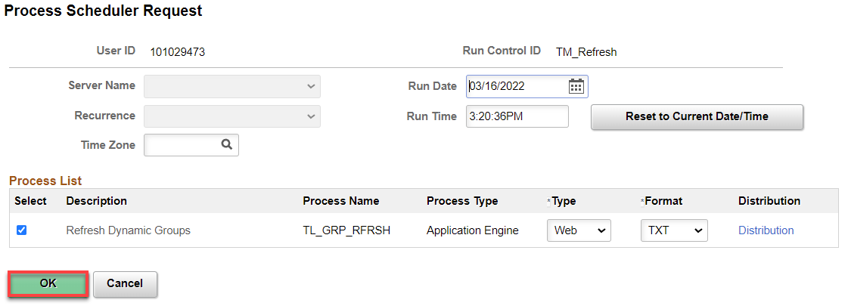

Select the Process Monitor link at the top of the page.

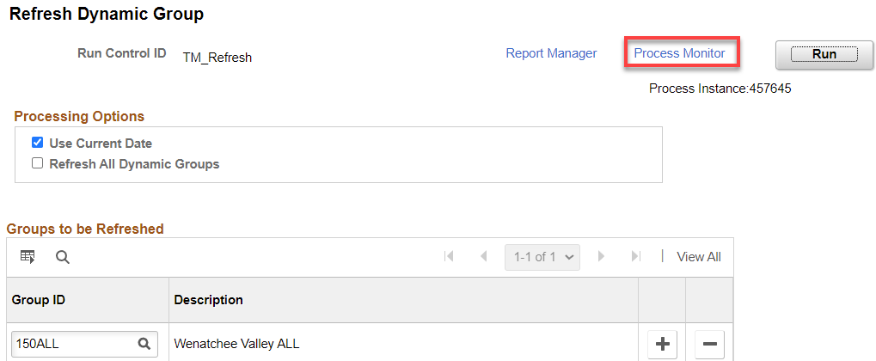

Select the refresh button until the Process TL_GRP_RFRSH has a Run Status of Success and a Distribution Status of Posted. Select the Details link.

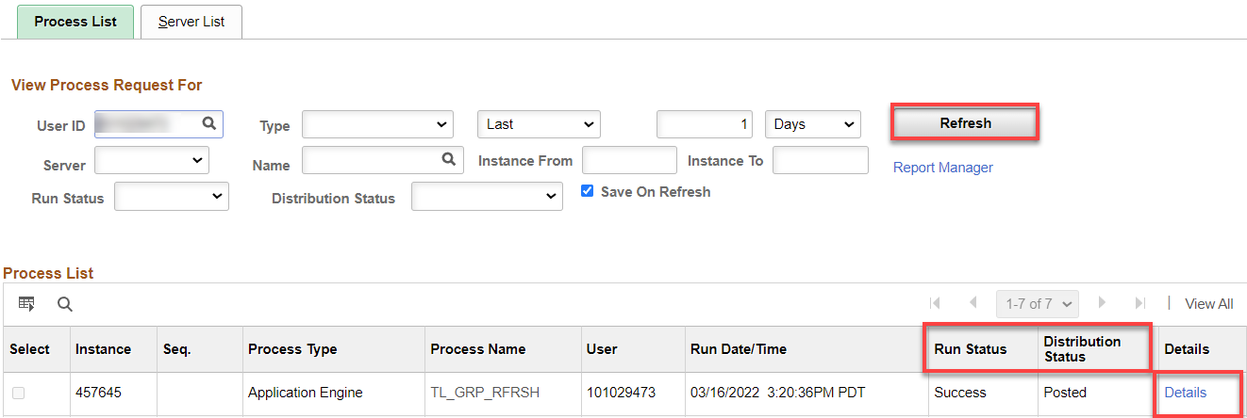

Select the View Log/Trace link.

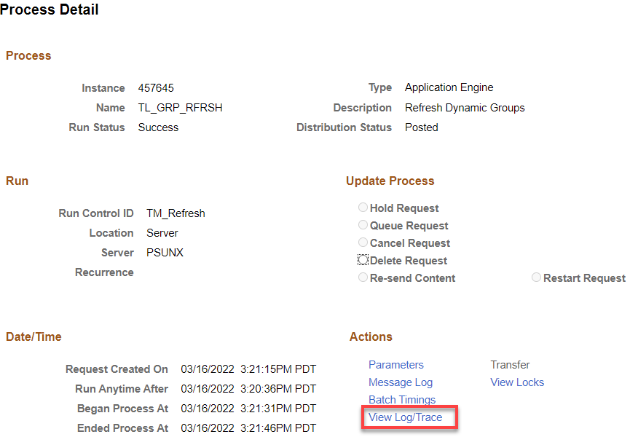

Select the .log file to make sure the process ended normally.

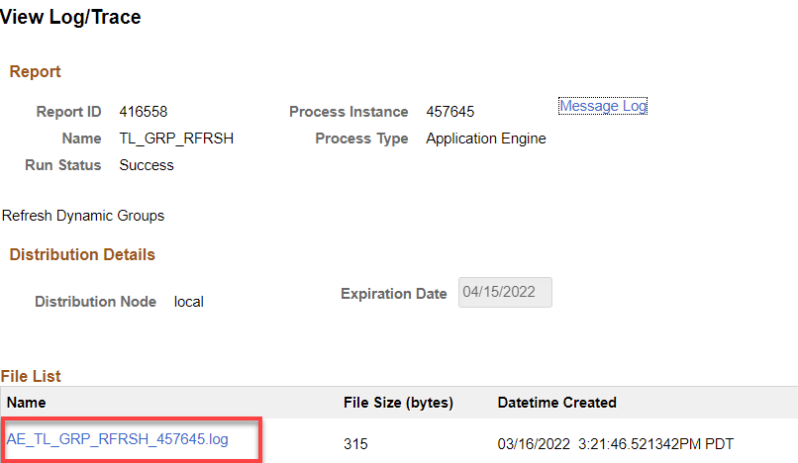

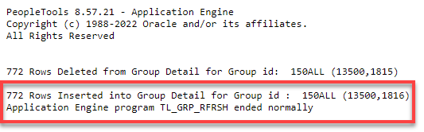

Click Return, OK and Save.

The process to refresh dynamic group(s) is now complete.

That’s it!

