Reporting Time (punch time) - Timesheet

Reporting the number of hours you worked is done in CTC>HCM>Employee Self Service>Time tile.

Navigation: Employee Self Service (homepage) > Time (tile/homepage) > Enter Time (tile)
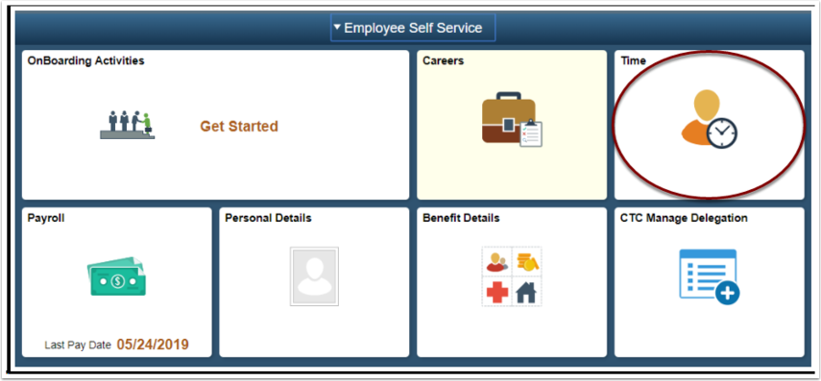
- The Time homepage displays.
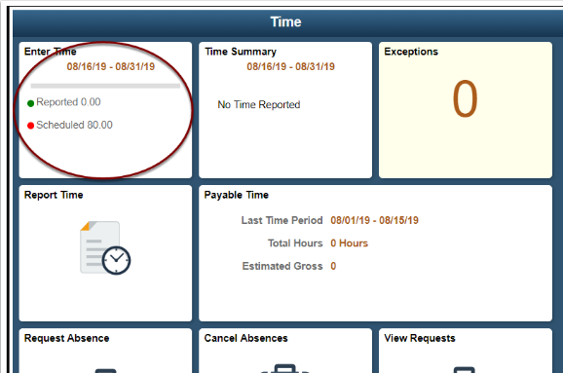
- Select the Enter Time tile.
- There is a View Legend link at the top of the page that gives additional details about information that can be seen on the screen.
- Select a Time Reporting Code (TRC) from the drop-down on the right.
- Enter the following:
    - In: time that the employee started work for the day.
    - Lunch: time that the employee left for their meal.
    - In (from Lunch): time that the employee returned to work.
    - Out: time that the employee finished work for the day.
- If no meal is taken enter the following:
    - In: time the employee started work for the day.
    - Out: time the employee finished work for the day.
- Time is assumed to be 24 time if no AM or PM entry is indicated.
    - For example, 8:00 AM can be entered as either 8 or 8AM in the timesheet.
    - For example, 2:00 PM can be entered as either 14 or 2PM in the timesheet (i.e. if 2 is entered without the PM then the system will assume that means 2AM).
- Select Submit.
- Select OK to acknowledge the affirmation statement.
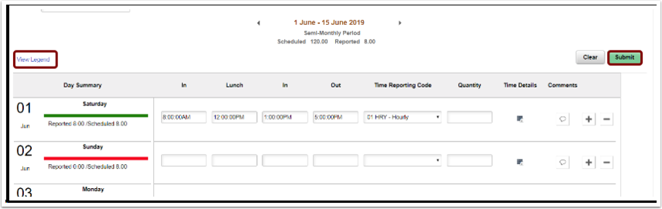
- The Enter time page displays.
- Time will be processed periodically and sent to the employee’s manager for approval.
- NOTE: Time is processed periodically, but at minimum overnight. Time entered may not be visible to the employee or manager in other screens until the overnight processing has occurred.

Important Things to Note
Timesheets are due by 10 a.m. the day after the 15th and the day after the last day of the month.
Pay days are normally on the 10th and the 25th

That’s it!

