Update Federal Tax Data QRG is great but we have not updated federal tax data for anyone since they can do it in Employee Self Service. With that said, we can update it.

I created this document mainly because we can check what someone has put in (single, married, additional tax, etc.) because they ask. WE CAN MAKE CHANGES BY ADDING A ROW – BUT we prefer employees do it in Employee Self Service.

Nav>Payroll for North America>Employee Pay Data USA>Tax Information>Update Employee Tax Data

Federal Tax Data tab: Add + a row, add Effective date and any changes, save.

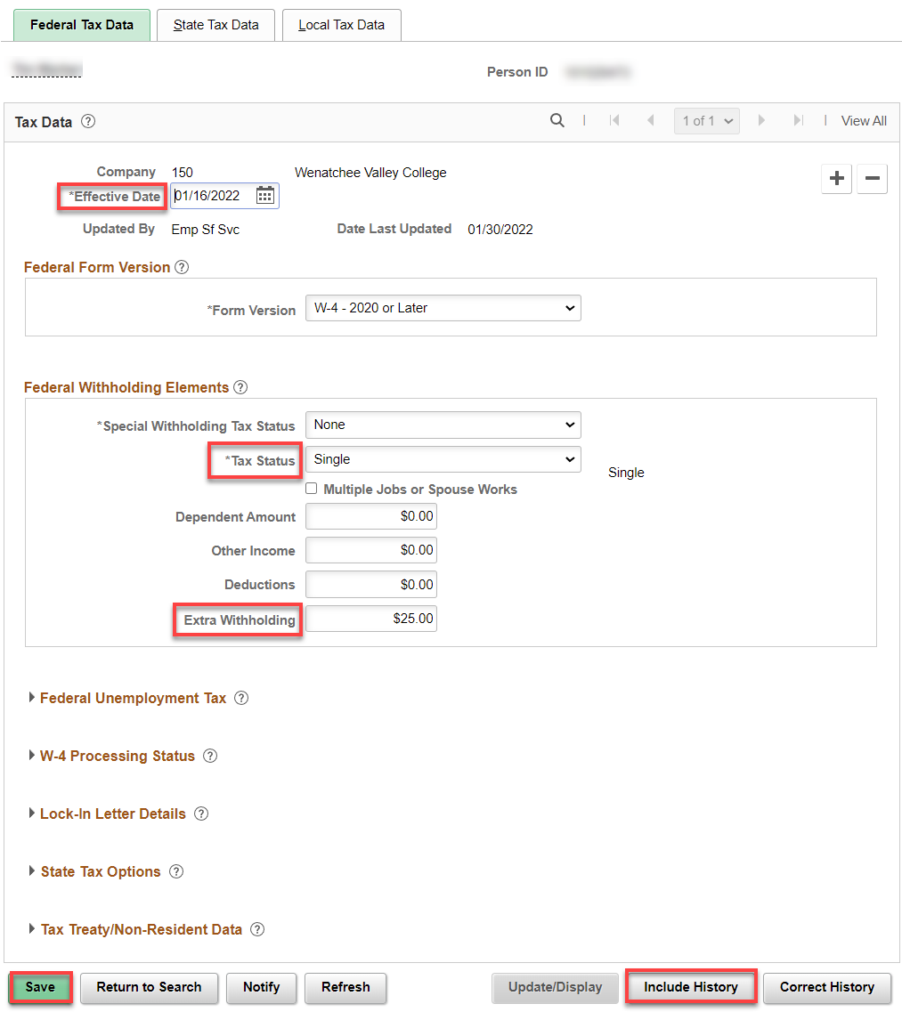

To check history, just click Include History and look at the other pages. Cheers!

