Prepay Deduction Setup, Calendars and Pay Cycles The QRG is GREAT!

Nav>Set up HCM>CTC Custom>Prepay Deduction Mapping
Nav>Set up HCM>CTC Custom>Prepay Calendars
Nav>Set up HCM>Payroll for North America>CTC Custom>Employee PrePay

QHC_PY_PREPAY_CAL_CYCLE_SCH - Prepay Calendar, cycle, schedule. This query shows the college’s PrePay Calendar number(s), Pay Cycles, Pay Cycle Description, Schedule (Pay Period start), and PrePay Factor (number of deduction periods).
WVC’s is as follows:
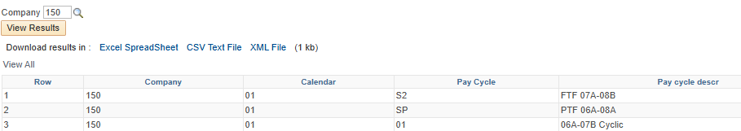
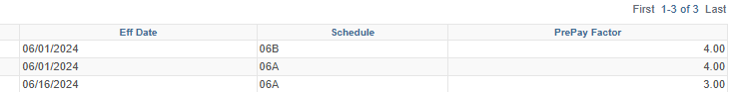

PrePay Deduction Setup – See QRG

Creating PrePay Calendars

For WVC, we had a lot of calendars come over from Legacy, however, we only use Calendar 01. Select 01.

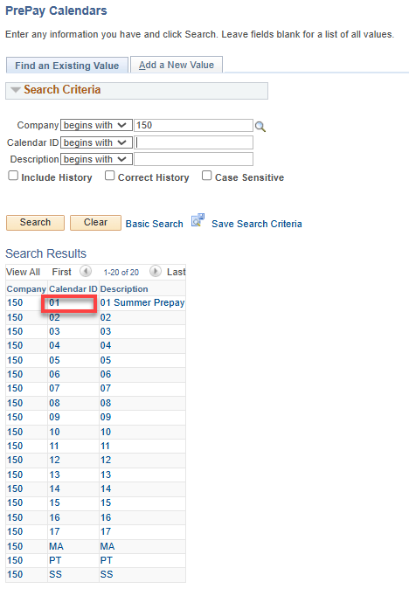
The PrePay Calendar shows out current PrePay Deductions as follows:
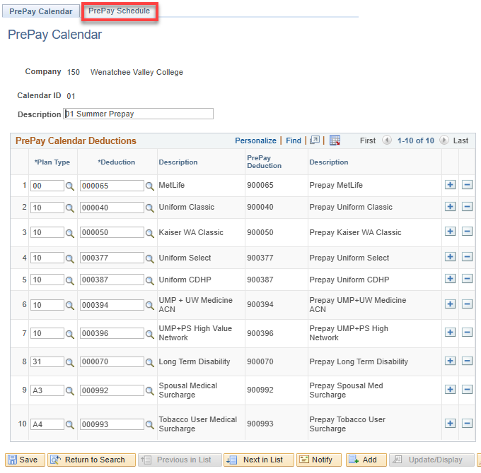

Click on PrePay Schedule to see PrePay Schedules. Select Next in List or View All.

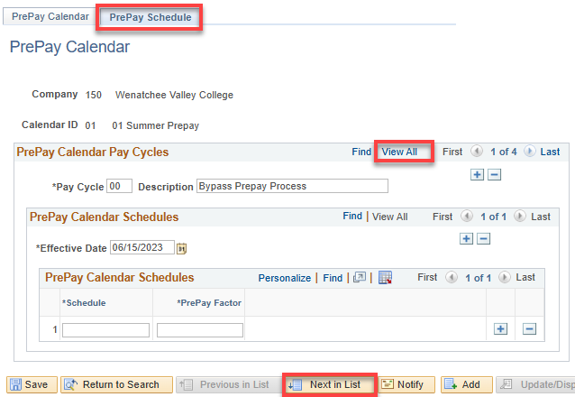
Select View All shows all of our PrePay Schedules. They can be edited by Adding a Row.
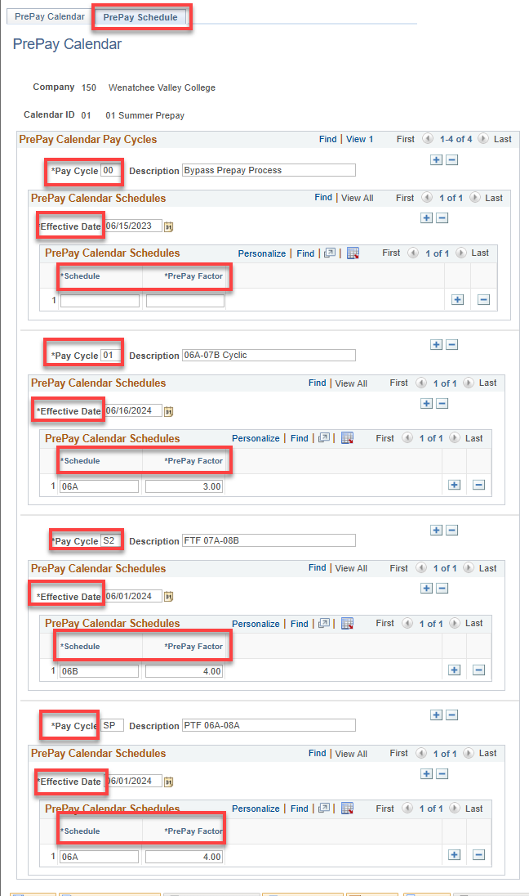

Assign a PrePay Pay Cycle to an Employee

Nav>Set up HCM>Payroll for North America>CTC Custom>Employee PrePay

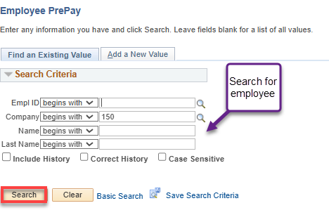
Add Pay Cycle that is correct for the employee type. Save.

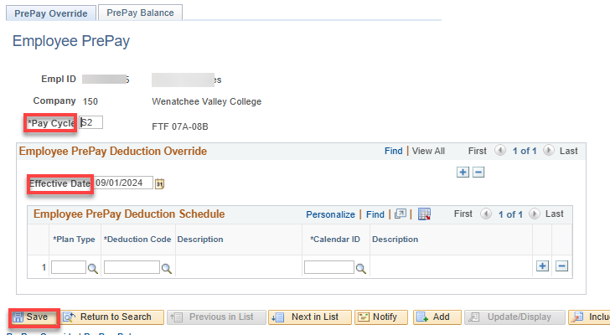

To check who is missing or needs their Pay Cycle changed, run QHC_HR_CTC_JOB_DATA - Empl Job and CTC Job Data and sort by Pay Group.

That’s it!

