Addresses – Which is used for what? And changing where checks are mailed.

All employees must have a home address. Employees that are paid for travel must have the correct address in Home. In addition, a payroll error warning will be created without a home address.

Mailing Address is used for W2s and is first in the hierarchy.

If there is no mailing address, the system will pull the home address.

There’s a lot of information in the QRGs but nothing states the hierarchy so I put in a ticket and the above is all I learned. Plus, I had Webex meetings.

To change checks going from Home to Mailing or back

Go to Workforce Administrator, Maintain EE Pay Data.

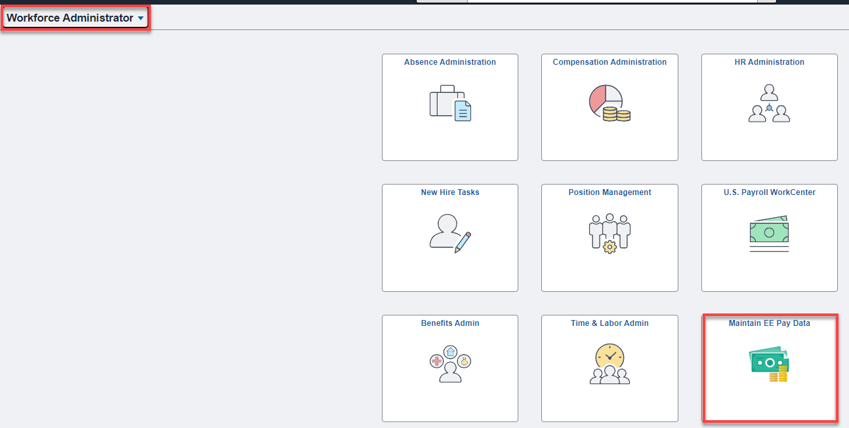

Seach for the employee.

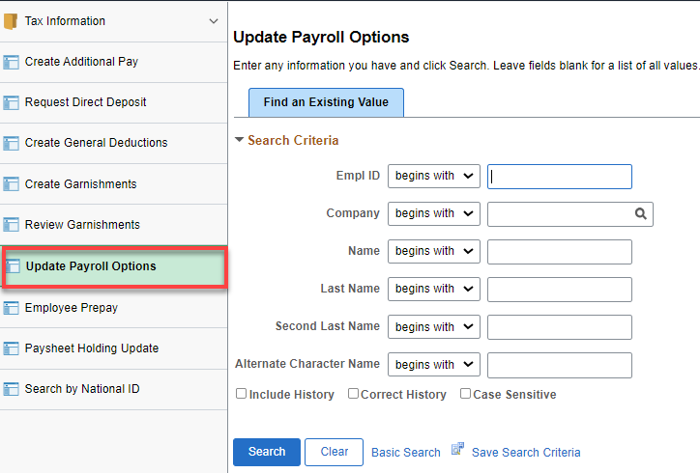
Select the preferred address for mailing checks (W2’s use Mailing Address unless there is not a Mailing Address, then it uses Home Address). Save.

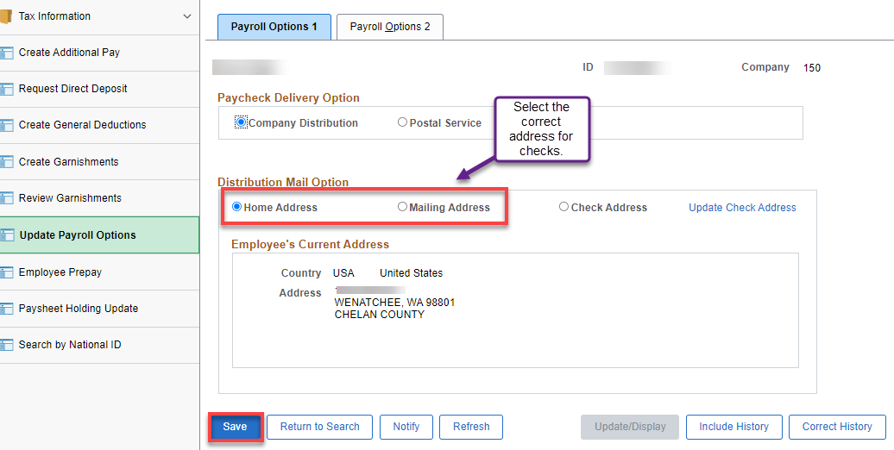

You can run query ERE_PERSDATA_ADDRESS_W_CO to see who is missing a home address, and who is either missing address line 1, or has an apartment number listed there. OR you can look at the HR Validation report that comes from OFM and look for any Residence Address warnings.

That’s it!

