Terminating an Employee – FT Faculty

http://ctclinkreferencecenter.ctclink.us/m/79718/l/1011431-9-2-termination-offboarding-checklist-details

Go to Job Data for the correct Empl Record

IF THE EE IS NOT WORKING THE FULL PAY PERIOD, FIRST ADD A ROW WITH AN EFFECTIVE DATE DURING THE LAST PAY PERIOD AND PUT THE FINAL COMPENSATION (see compensation below).

Work Location tab: Add a row (+), change the effective date (PUT THE DAY AFTER THE LAST PAY PERIOD (e.g., 1/1 for last day of 12/17), add an Action, Reason, change job indicator if needed.
Put in Last Day Worked and check the Override Last Day Worked box (if different).
Save.

For Retirement
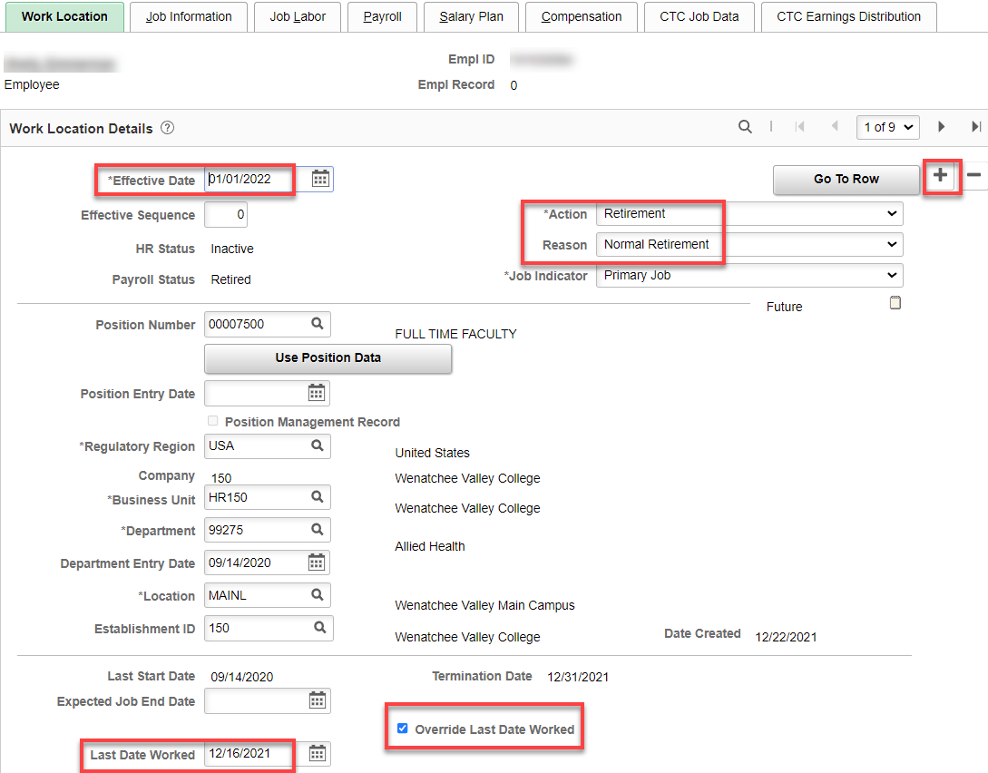

For Resignation
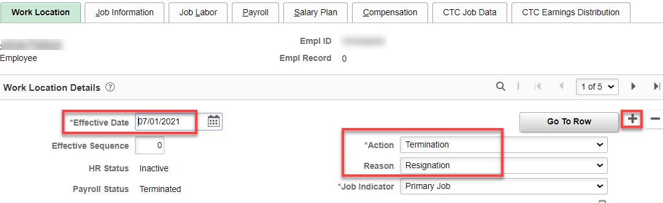

Nothing for Job Information or Job Labor tabs.

Payroll Tab: change Absence System to Other.

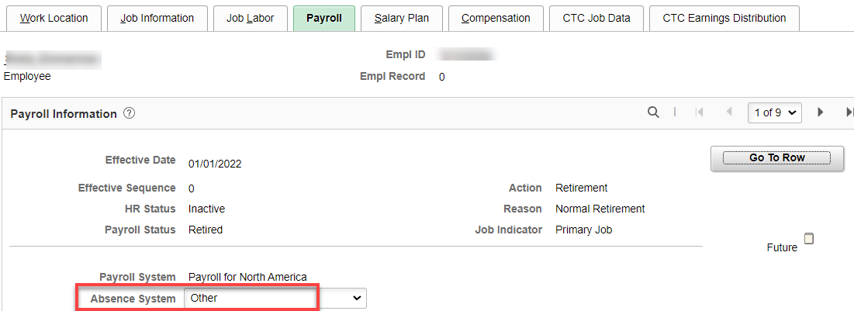

Salary Plan tab: nothing to do.

Compensation tab: ctcLink is SUPPOSED to be able to calculate the correct salary. I suggest calculating the correct rate of pay and having payroll correct the payline if needed.

If less than a full pay period: ctcLink should calculate the daily rate correctly, however, it is a good idea to calculate the daily rate x the number of days in the last pay period and let payroll know so they can correct the Payline if there is a difference. Calculation is: Annual salary/175 x # of days worked in pay period.

In addition, because FT faculty have equal pay periods but a varying number of work days per pay period, the difference paid and the amount owed must be calculated.

Compensation tab example : for faculty, which are paid on a daily rate, and the termination date is less than the full contract year, the salary must be calculated by daily rate. Calculate salary for the days worked until the end of the last full pay period, then check salary already paid. If there is a difference, it must be added or subtracted as a PSHUP file.

Example: full time salary of full-time salary of $92,278/175 = $527.30 x 61.33 days = 32,339.31 (amount earned) minus $26,914.44 ($3844.92 x 7 amount paid) = $5424.89 difference to be paid through PSHUP file.

BE SURE TO ADD A ROW BEFORE TERMINATION TO PUT THE LAST SALARY IN OR IT WILL NOT PUSH THROUGH TO THE PAYSHEET (because the termination date is in the next pay period).

CTC Job Data tab: I’m not sure it matters but I change Job Term, Contract Units and Contract End Date. Clear Balloon Payment ID, if applicable.

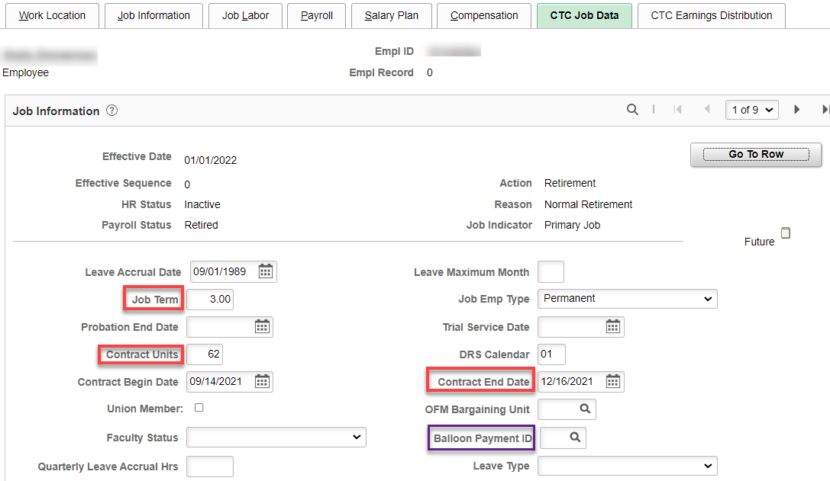

No Other Tabs Need Changed/Updated

Select Employment Data hyperlink – QRG Maintaining Time Reporter Data
Select Time Reporter Data hyperlink
Add a row (+)
Add effective date (first of next month- otherwise an absence request, if not processed, will not process) and change status from Active to Inactive
Select Ok

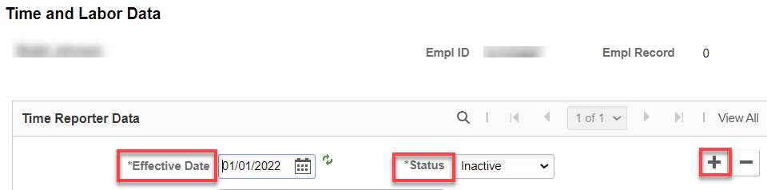

Select Benefits Program Participation hyperlink
Add a row (+) to Benefit Program Participation Details
Put the effective date (1st of the next month). Change Benefit Program to SB0
Save

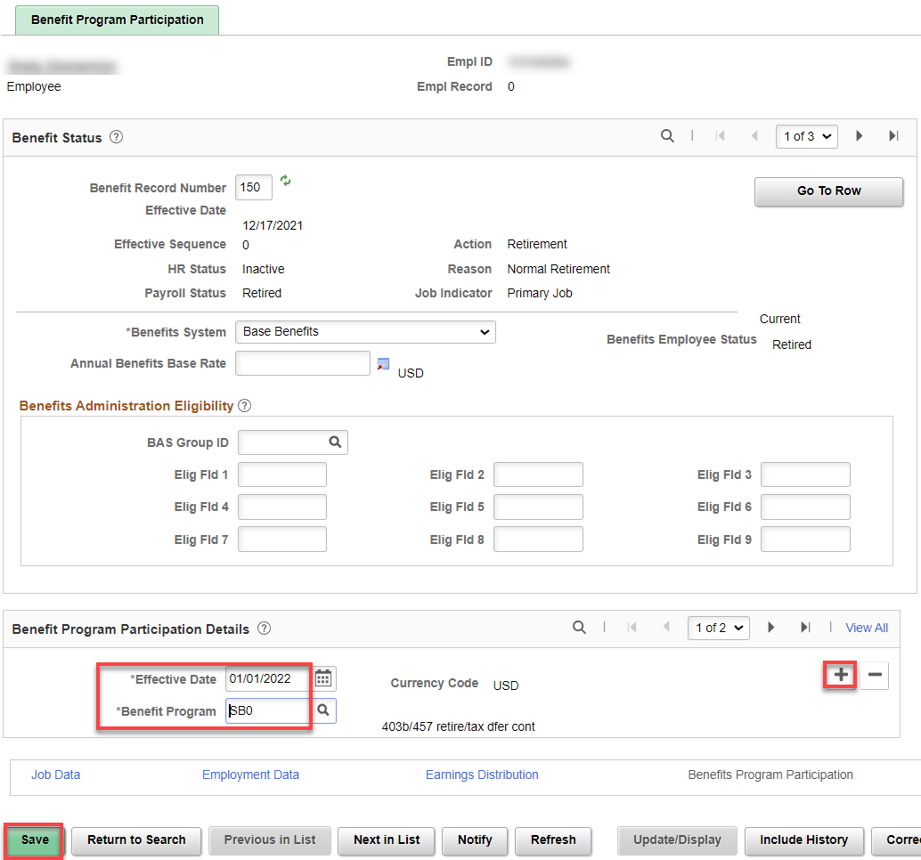

Terminating Benefits
Use the 1st of the following month for the effective date for all benefits (except Health & Simple Benefits and Spending Accounts).
Update PAY1: this will populate screens for medical, dental and simple benefits (spousal and/or tobacco surcharges).

Nav/Workforce Administrator>Benefits Admin tile (start at the top and work down)

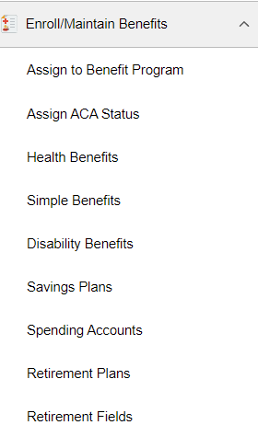

Assign to a Benefit Program (should be already filled out if changed in Job Data (above)

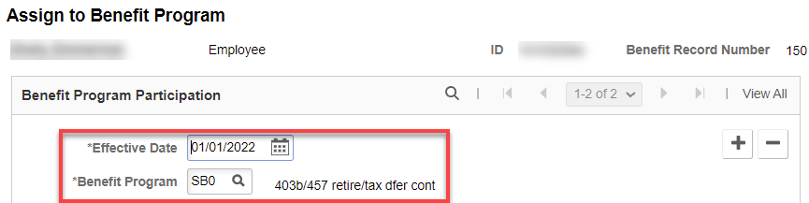

1. The following screens will be updated by PAY1 (overnight process):
- Simple Benefits (surcharges)
- Health Benefits

Pay1 is the system of record for Health and Tobacco & Spousal Surcharge, at which time it becomes a Payroll deduction), so for those benefits termination should be entered in Pay1 so the overnight change file can insert a record in PeopleSoft.
Insertion can be done in ctcLink immediately if there are time sensitive deduction issues, but any entry done in Pay1 will overwrite the ctcLink entry (should they be different, if they are the same then nothing will change in ctcLink).

2. Once Pay1 has been finished, and the overnight process has been run, enter the name or Empl ID of the employee being terminated.
3. Select the Search button.
4. Confirm the employee's benefits termination date. If the employee was not originally enrolled in a specific plan, no data will show and as a result, no termination date needs to be entered.

Update ACA Status
Nav/Benefits/CTC Custom/Assign ACA Status OR Workforce Administration>Benefits Admin tile
This value can be corrected, added or changed via + row

If less than 130 hours have been worked, use any date after last day worked, save.

If more than 130 hours worked in the month, use the 1st of the next month as the Effective Date, save.

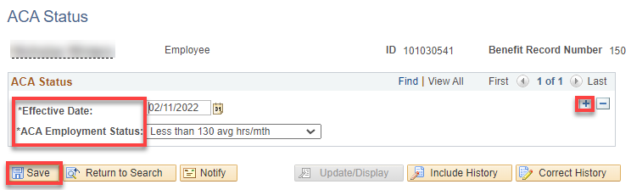

IF YOU NEED TO TERMINATE HEALTH & DENTAL BEFORE PAY1
Add + a row for Medical and terminate…Add + a row for dental USE THE END OF THE MONTH NOT the next day after like the rest of ctcLink. DO THE SAME FOR SIMPLE BENEFITS (surcharges)

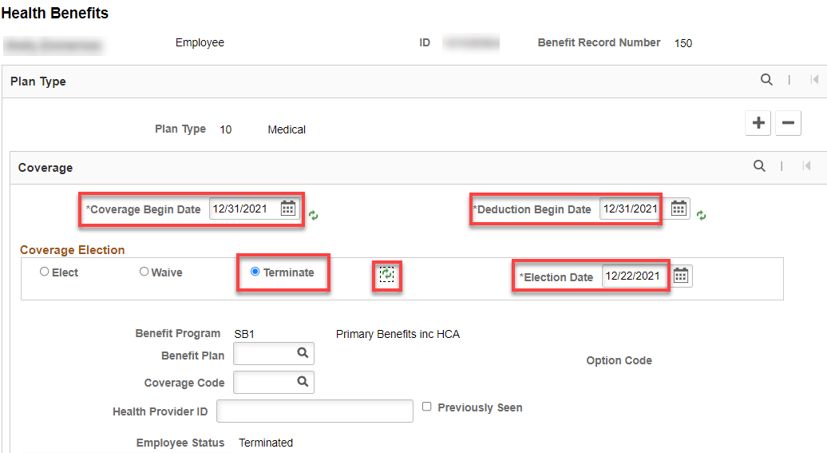

Terminate ctcLink Owned Data
Nav/Workforce Administrator>Benefits Admin tile OR Nav>Benefits>enroll in Benefits
1. Select the applicable benefit type from the navigation menu:
- Disability Benefits (add a + row under Coverage)
- Savings Plans
- Spending Accounts
- Retirement Plans
- Retirement Fields

2. Enter the name or Empl ID of the employee being terminated.
3. Select the Search button.
4. Enter the employee's benefits termination date where ctcLink is the system of record (Savings, Spending [HSA, DCA, FSA], Retirement and Disability). If the employee was not enrolled, there is no need to enter termination information.
5. If the termination date is 1st-15th Or in “A” Payroll:
- Health premiums and surcharges should be taken as normal.
- Take the full monthly premium for optional long-term disability.
- Optional LTD premiums are lagged, meaning they are paid on the 25th of current and 10th of the following month. Example: September optional LTD premiums are paid with deductions taken on the 9/25 and 10/10 paychecks.
- If the termination date is 16th - end of month.
- Do not take health premiums or surcharges on final check unless in arrears.
- Optional long-term disability premiums should be taken as normal (optional disability must be taken out by payroll – extra deduction)

Disability Benefits – TERMINATED BOTH BASIC AND OPTIONAL
Add + a row to Coverage, put in the termination date (first of the following month), click Terminate and Refresh. The screen will update. Save.

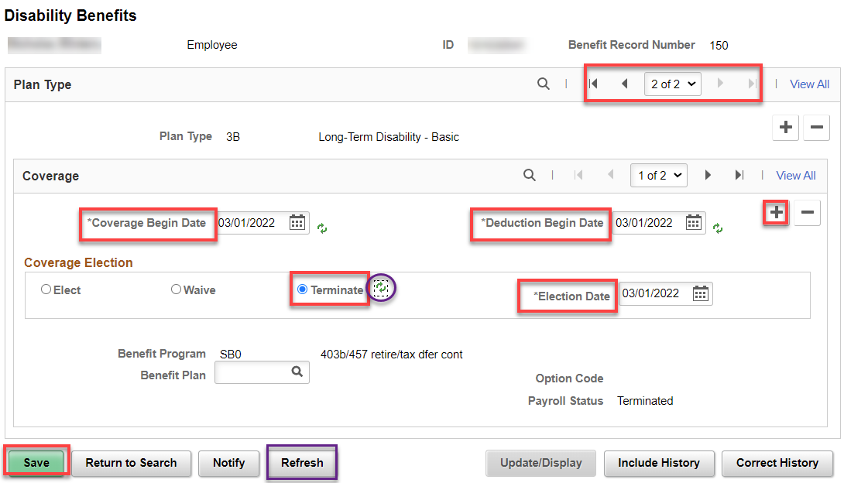

Savings Plans
Add + a row in Coverage, put in the termination date (first of the next month), click on Terminate and Refresh . The screen will update. Save.

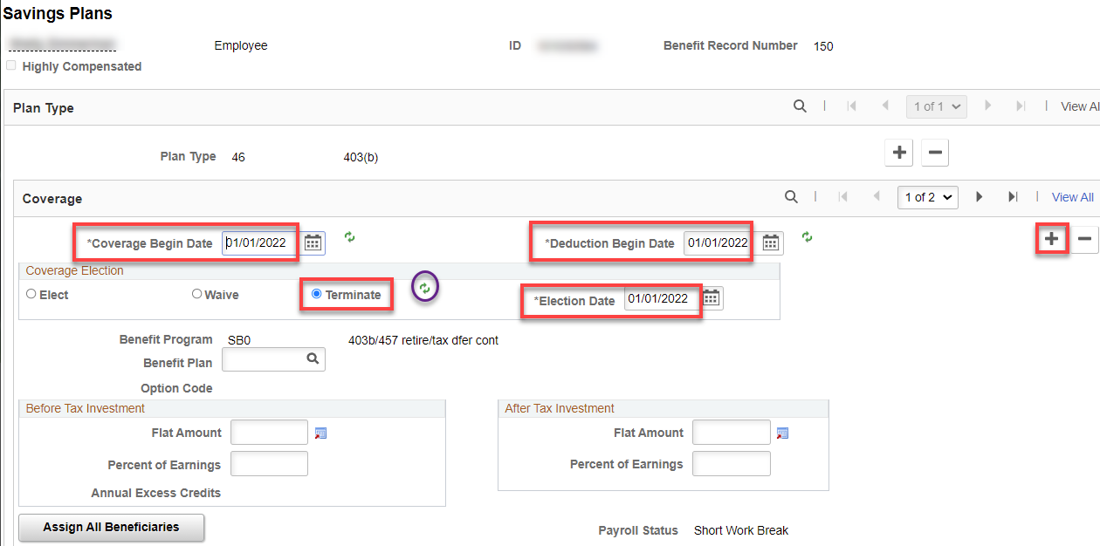

Savings Management (Nothing to do there as far as I know )

Spending Accounts (FSA, HSA)
Add + a row to Coverage, put in the termination date (You can’t put the 1st of the next month because the benefit plan is SBO) and Refresh. The screen will update. Save. IF NO PLAN IS SELECTED, NO NEED TO DO ANYTHING.

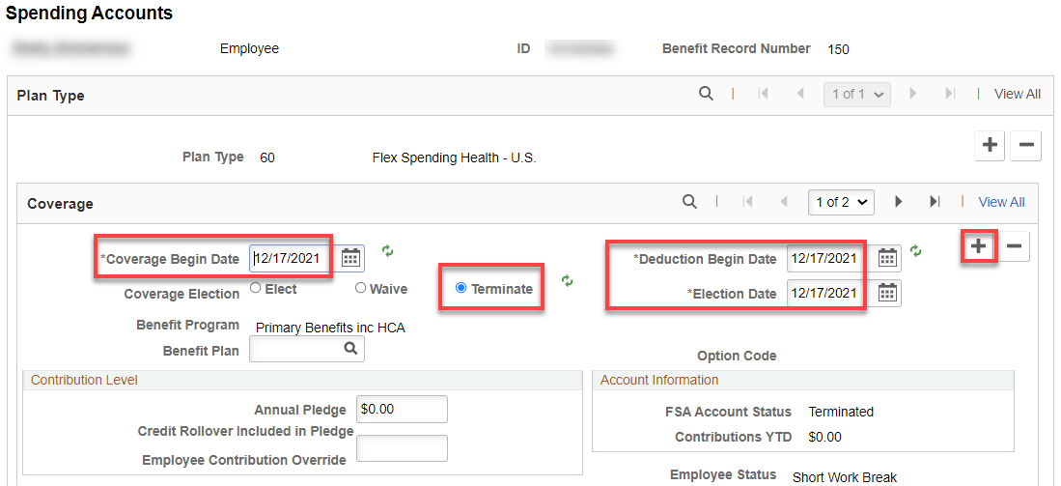

Retirement (read below first)

TIAA: If already SBO, add + a row, put in date after pay period (6/1 for a 5/31 last day) for all three dates, click Terminate, Refresh. The screen will update. Save. If SB1, add + a row, put in Deduction Begin Date and Election Date the 1st of the next month (match the end date of medical benefits), click Terminate, Refresh, Save. OR WAIT until after the last payroll runs.

DRS: If already SBO, add + a row, put in date after pay period (6/1 for a 5/31 last day) for both dates, click Terminate, Refresh, Save. OR WAIT until after the last payroll runs*.

*Enter the Termination Deduction Begin Date after the payroll confirms and before the DRS Data Load from Payroll is run.

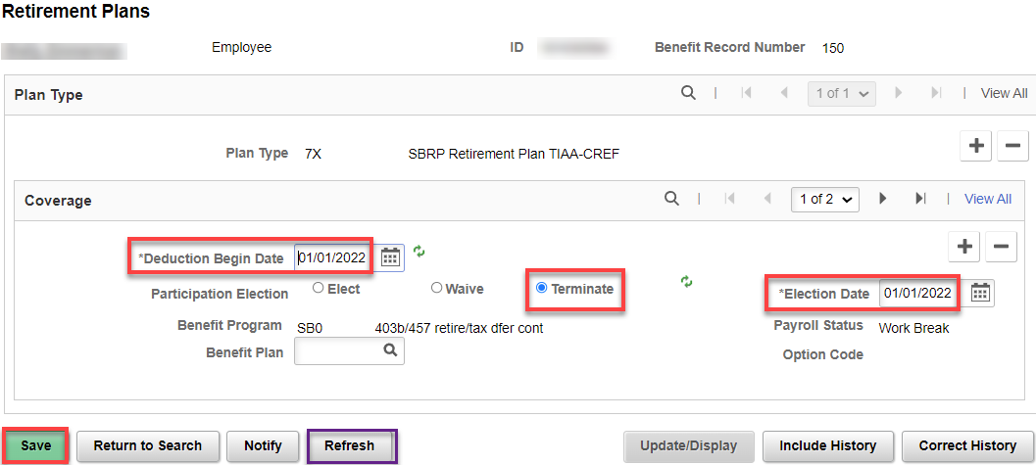

Nav/Workforce Administrator>Benefits Admin tile OR Nav>Benefits>CTC Custom>Retirement Fields

Nothing to do with Retirement Fields. As you can see, once the retirement plan is terminated, this screens Current Retirement Plan is blank. IT WILL CHANGE AFTER THE EFFECTIVE DATE.

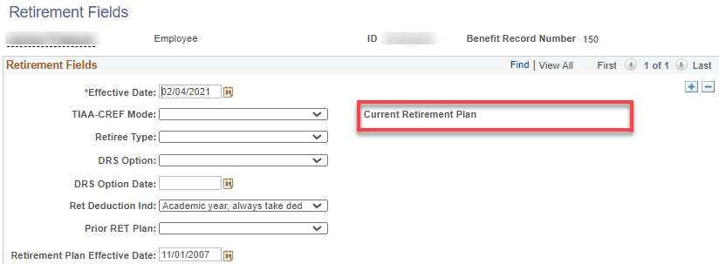

DRS Transaction
Nav>Benefits>CTC Custom>DRS Transaction

Payroll takes care of this page…thank goodness.

How do the retirement plans get updated for the different ages? It’s an automatic process, E-188, that is run by Central Payroll each pay cycle.

To check and adjust leave balances, see documentation Absence-Checking-Adjusting Leave Balances f Termed Employees.

That’s it!

