Terminating a Person BEFORE they Actually Started

This already happened to me and it will happen to you but terminating the person has to be done one way only or the system has issues and you cannot save the record.

Job Data

Work Location tab: add + a row, put the same day as the hire date as the termination date and change the Effective Sequence to 1, add Action (Termination) and Reason (if you want).

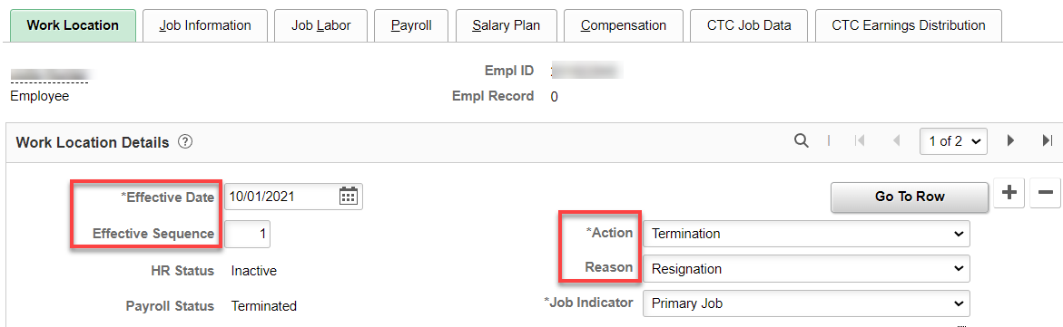

Nothing for Job Information and Job Labor tabs.

Payroll tab: put Absence Management to Other.

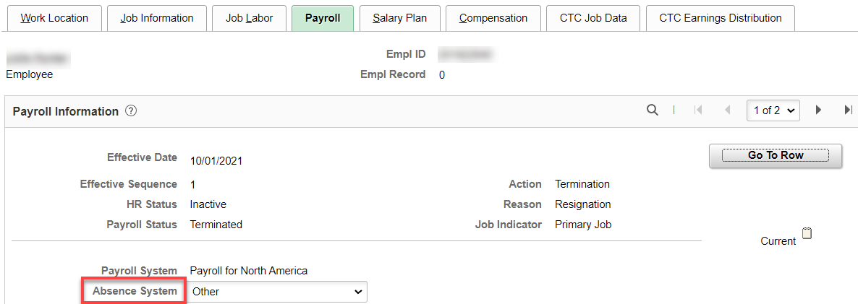

Nothing on any other tab.

Go to Employment Data hyperlink

DO NOT add a row. The Effective Date should still be the same as the hire date, change Status to Inactive, Save.

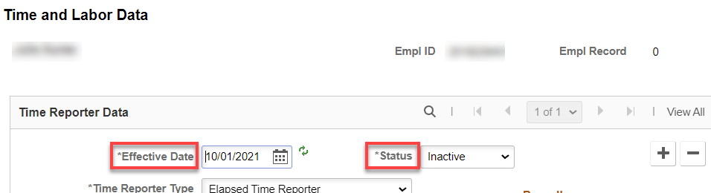

You will get the following warning but it is ok.

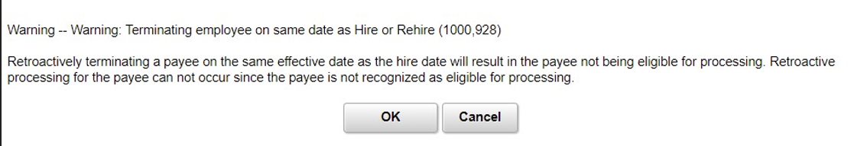

If you get the following message, you will not be able to save. You can delete the page and start over or put in a ticket.

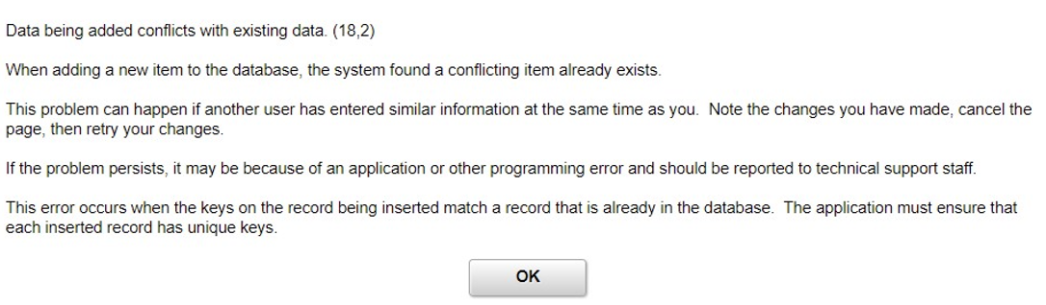

That’s it!

