Terminating Employee Due to Death

Enter Deaths QRG Also See Deceased Employee Payout for Payroll QRG for the section on FICA Status

Navigation: NavBar > Navigator > Workforce Administration > Job Information > Job Data

If employee has multiple Empl Records, select the applicable record from the Search Results.

Work Location Tab
Add + a new row
Enter Effective Date (one day after last paid day)
Enter Action (Termination) and Reason (Death)
Save.

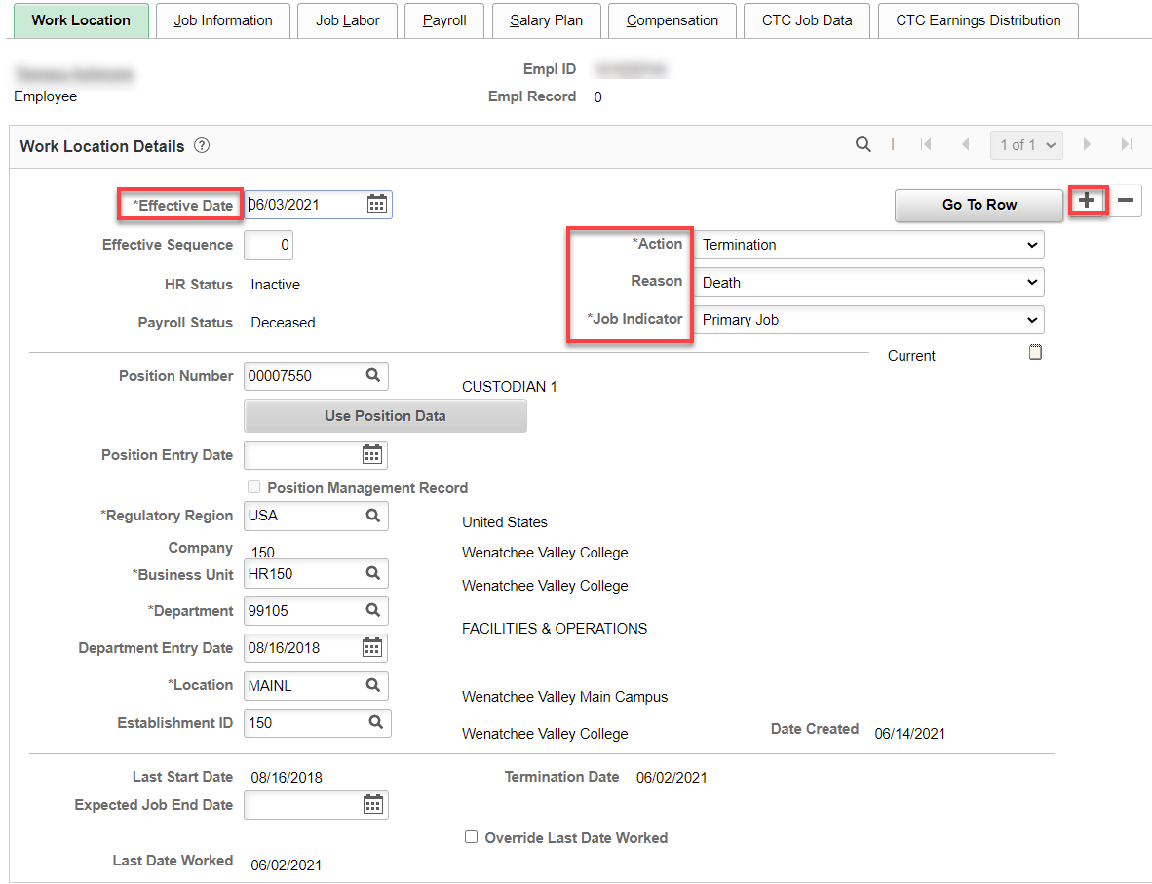

After selecting the Save button, you may receive a message like the one below. Carefully read the instructions and then select the OK button.

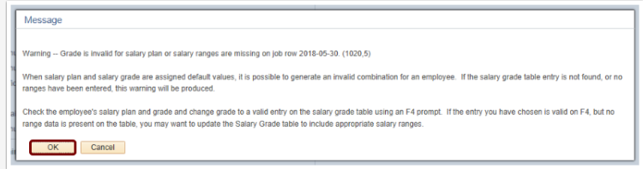
You may receive another warning message like the one below. Carefully read the instructions and then select the OK button.

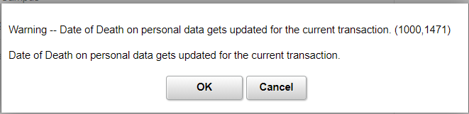

THEN, go through the rest of the terminating an employee procedure

Payroll Tab: Change Absence System to Other
Change Absence System to “Other” and FICA Status to “Exempt.”

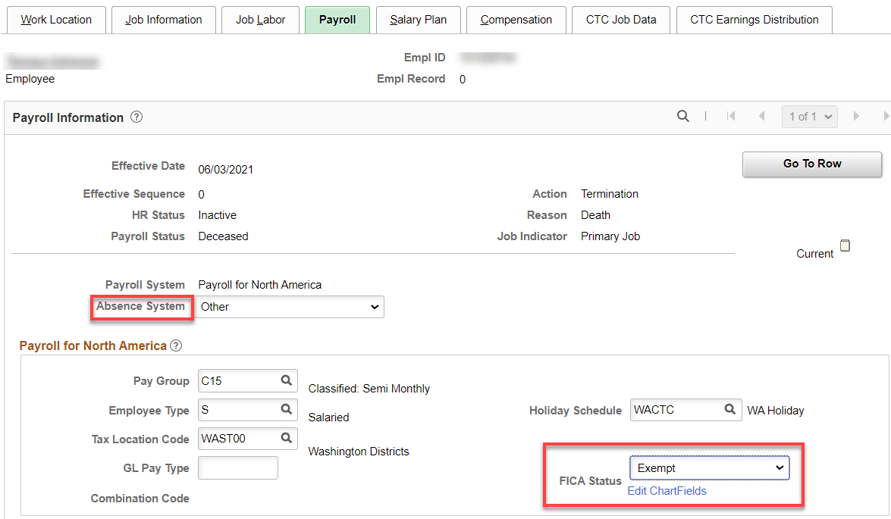

QRG says to go back after payroll to go back and change the status to “Subject.”

Compensation tab: Nothing for classified staff. For exempt and faculty, which are paid on a daily rate, the and the termination date is less than the full contract year, the salary must be calculated by daily rate. Calculate salary for the days worked until the change in salary, then check salary already paid. If there is a difference, it must be added or subtracted as a PSHUP file.

Example: full time salary of $60,009/261= $254.908045 x 44 days = $11,127.95376 (amount earned) minus $11,001.52 (amount paid) = $126.434 difference to be paid through PSHUP file.

No Other Tabs Need Changed/Updated

Select Employment Data hyperlink – QRG Maintaining Time Reporter Data
Select Time Reporter Data hyperlink
Add a row (+)
Add effective date and change status from Active to Inactive – put one day after the next pay period.
Select Ok

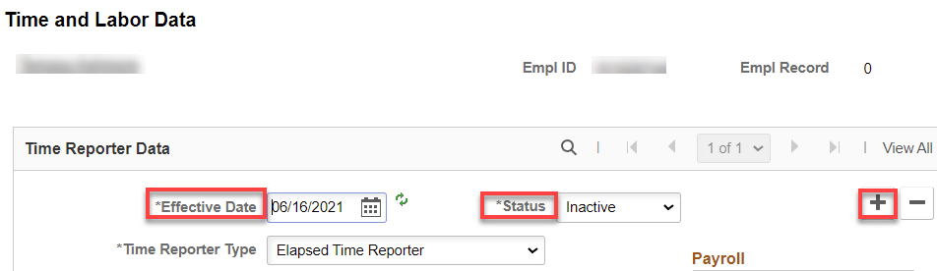

If the following warning comes up, change the effective date to one day after the pay period.
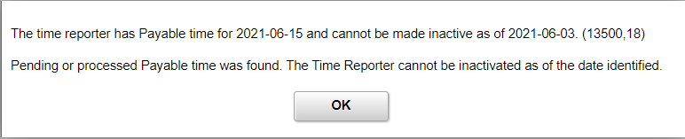

Select Benefits Program Participation hyperlink
Add a row (+) to Benefit Program Participation Details
Put the effective date (1st of the next month)
Change Benefit Program to SB0, Save.

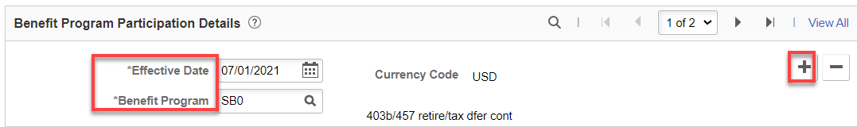

You may receive the following warning message. Read and choose OK.

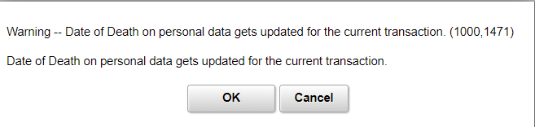

Update ACA Status
Nav/Benefits/CTC Custom/Assign ACA Status
This value can be corrected, added or changed via + row
Save

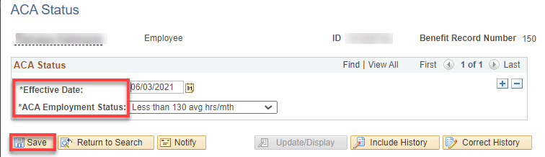

Terminating Benefits

See documentation on leave: LEAVE ADJUSTMENTS & PAYMENTS: MAKE SURE LEAVE INFO IS ON THE PAF SO PAYROLL CAN PAY OUT VACATION & SICK LEAVE. Payroll has its own procedures, including contacting family member and acquiring certificate of death.

You must now navigate to the Biographical Details page to record the actual date of death.

Biographical Details
Navigation: NavBar > Navigator > Workforce Administration > Personal Information > Modify a Person

Use the Date of Death field to record the date that the worker died. The system provided a default date as one day prior to the termination due to death date. You can override this value if needed.

Add + a row, put in the date of death, Save.

Biographical Details Tab

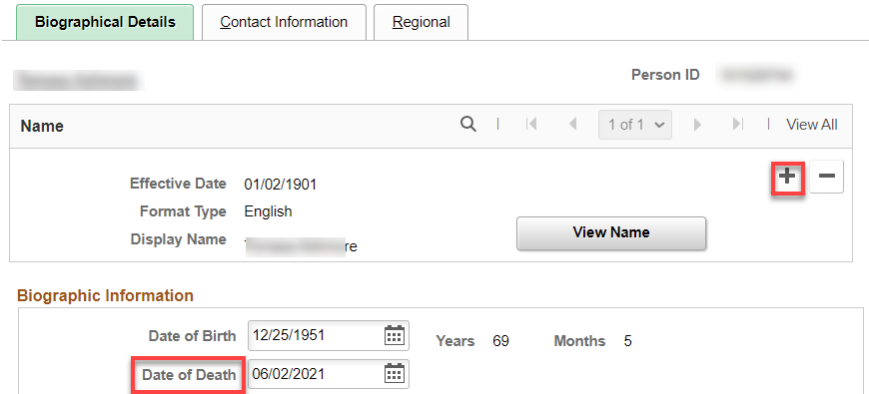

After selecting the Save button, you may receive a message like the one below.
Carefully read the instructions and then select the OK button.

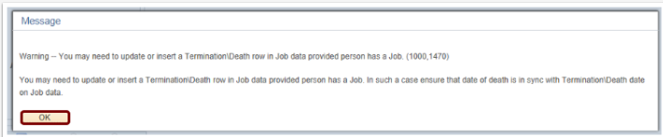

You can now navigate to the Person Organizational Summary page to review your changes.

Person Organizational Summary
Navigation: NavBar > Navigator > Workforce Administration > Personal Information > Person Organizational Summary

Use the Person Organizational Summary page to review a summary of a person's organizational relationships.

The system displays the termination effective date as the Termination Date, and the day before the termination date as the last date worked. The system uses these dates and the effective date in payroll processing and reporting. Review the summary.

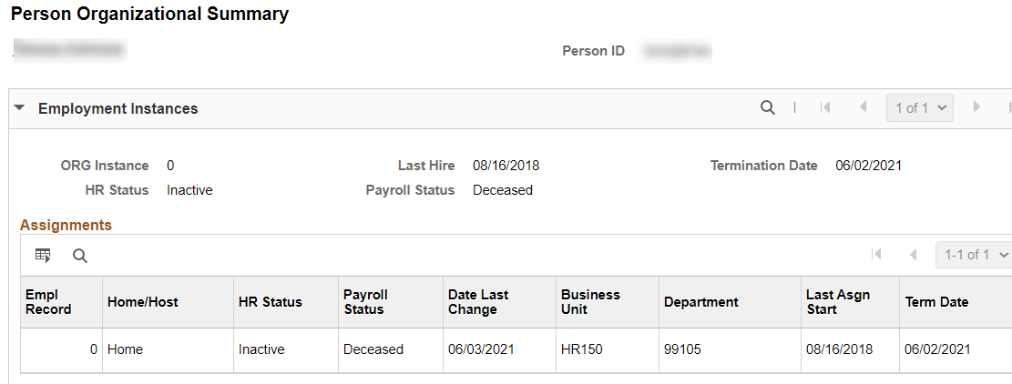

The process to review the person organizational summary is now complete.

That’s it!

Remember to work with payroll. They have their own processes. See Deceased Employee Payout Process for Payroll QRG.

Note: Before payroll can release the final check, they need to prepare some documents which need to be completed by the appropriate person. They also need a copy of the death certificate, and a copy of the will or estate documents and if you have a community property agreement. If there is no will or estate documents, a copy of the death certificate will suffice.

