**Updating FWL Assignment Type Rates**

1) Navigate to Assignment Type page and click on '+' to add a new row

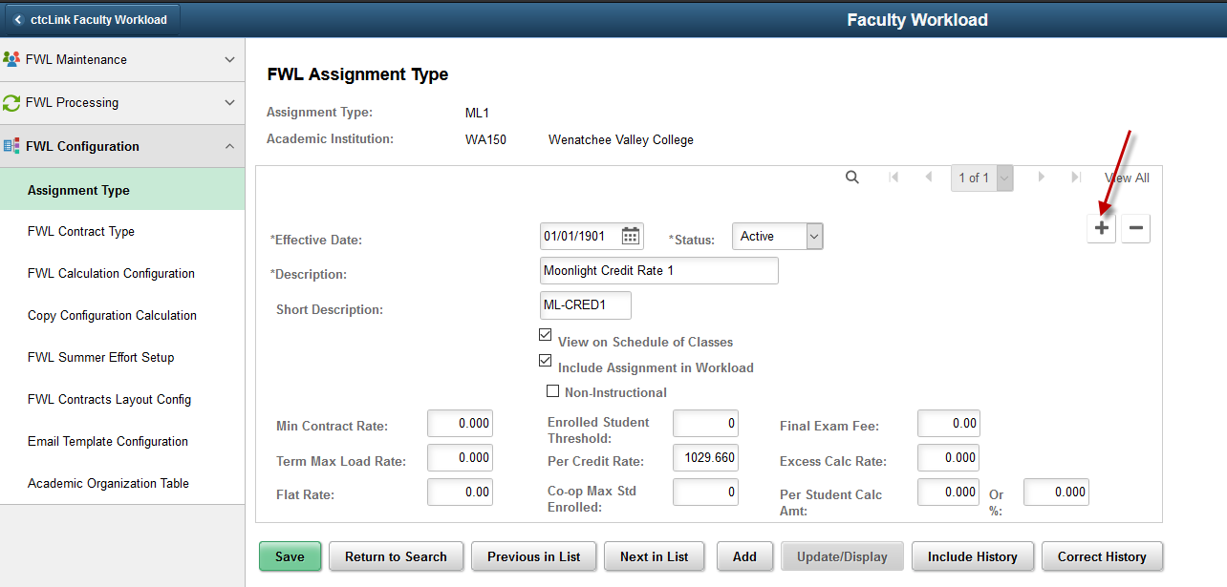

2) Effective Date: Enter new Effective Date

Update the rate in the desired pay rate field. e.g.- for ML-CRED1 enter new Per Credit Rate and click Save

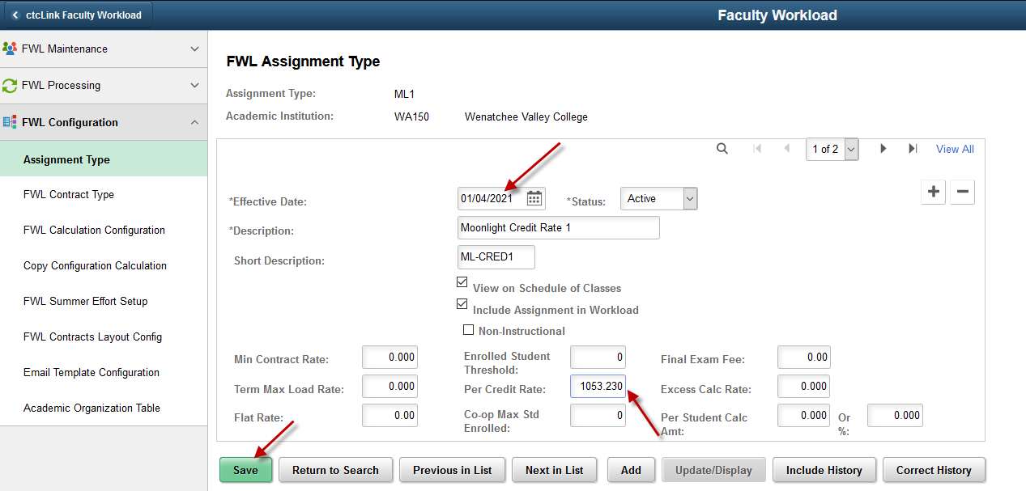

**Current Assignment Types**

|  |  |  |
| --- | --- | --- |
| **Assign Type** | **Descr** | **Short Desc** |
| DS1 | Directed Studies 1 | DIR-STUDY1 |
| IP1 | Independent Projects 1 | IND-PRO1 |
| RP2 | Release PT Overload | RP-OverPT |
| RT1 | Release FT Load 1 | RT-LOAD1 |
| SA1 | Special Assignment 1 | SA-1 |
| RT2 | Release FT Load 2 | RT-LOAD2 |
| SA2 | Special Assignment 2 | SA-2 |
| SA3 | Special Assignment 3 | SA-3 |
| SA4 | Special Assignment 4 | SA-4 |
| SA5 | Special Assignment 5 | SA-5 |
| RP1 | Release FT Overload | RP-OverFT |
| MU1 | Individual Music Instruction 1 | MUSIC-IND1 |
| PR1 | Prorated Class | PRORATED1 |
| ML1 | Moonlight Credit Rate 1 | ML-CRED1 |
| AD1 | Adjunct Credit Rate 1 | PTF-CRED1 |

I give the rates to Aimee Pope and she updates as well as does everything else in FWL 😊