To enter retirement only for an hourly employee

Job Data: Add benefit program (probably SB2) with the effective date (when they meet the DRS requirements), or when they become eligible, add + a row. Save.

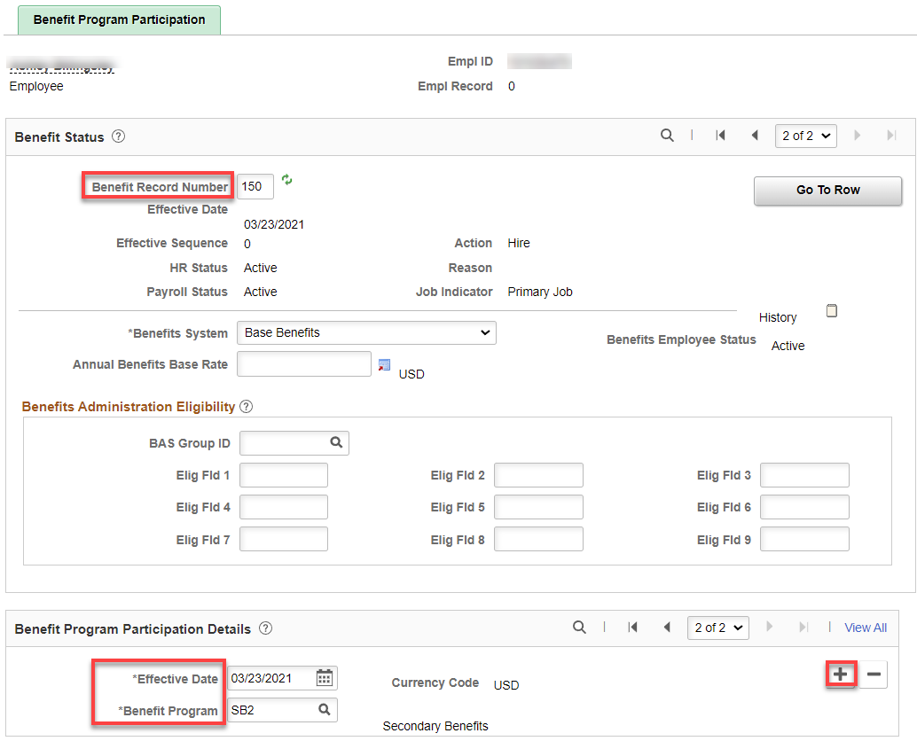

Retirement Plan
Nav>Benefits>Enroll in Benefits>Retirement Plans

Dates are very important and must be the same on both the Retirement Plan, Retirement Fields and DRS Transaction pages. See QRG Dates on Retirement Plan Pages.

Add Plan Type, Deduction Begin Date, Election Date (DATES MUST BE THE SAME-NEVER CHANGE THE ELECTION DATE IF THERE IS A PRIOR DATE…DRS wants only one Election Date) and Benefit Plan, Save.

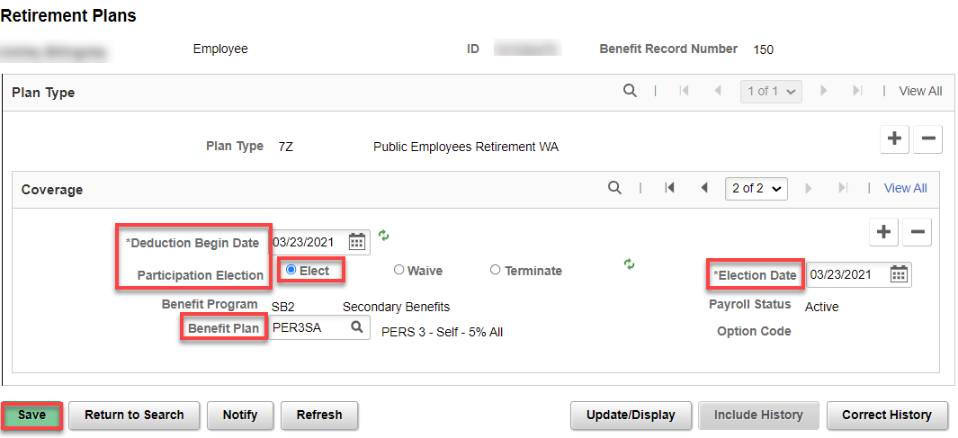

Enter Retirement (ONLY NEEDED FOR DRS PLANS)

Nav>Benefits/CTC Custom/Retirement Fields

Add the Effective Date, DRS Option, DRS Option Date, and Retirement Plan Effective Date, Save.
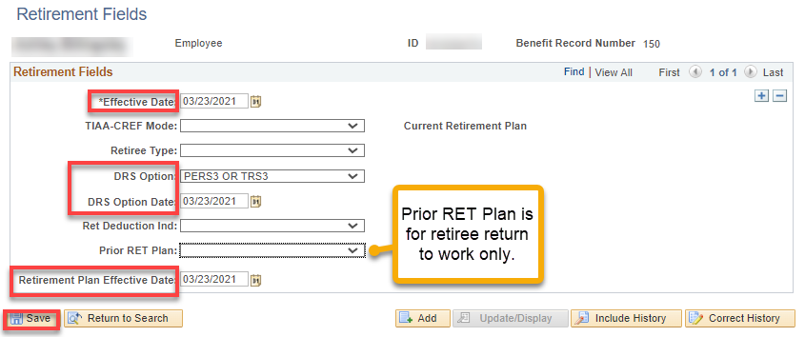

DRS Transaction
Nav>Benefits>CTC Custom>DRS Transaction

Payroll takes care of this page…thank goodness.

How do the retirement plans get updated for the different ages? It’s an automatic process, E-188, that is run by Central Payroll each pay cycle.

That’s it!

