Maintain Primary Flags – Note: The Primary Flags and Primary Job in Job Data have nothing to do with each other.

The process Primary Job Flag Update (M-044) is run by Payroll administrators as part of the payroll process twice a month. It sets the Benefits Primary Flag to the job (Empl Record) being paid so Benefit deductions are taken on the correct payroll cycle.

NOTE: While the process will move the flag indicator so that benefits will be deducted from the correct job, this flag will only be moved if the employee holds multiple jobs within the same Pay Group. If the employee needs their Primary Job Flag moved to an EMPL Record that is associated with a different Pay Group than benefits were deducted from previously, it must be done manually through the Maintain Flags page.

Benefits>Maintain Primary Jobs>Maintain Flags

If an employee changes or adds a job, especially going from part time to full time, the Primary Flag should be changes so the Primary Job shows the correct information and that benefits are changed to the correct job.

To change or add a Primary Flag

Note:
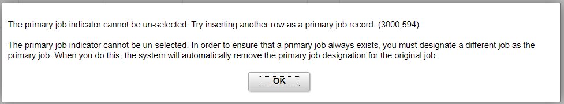

1. Add a new row by clicking on the Insert New Effdt (this is an old screen )

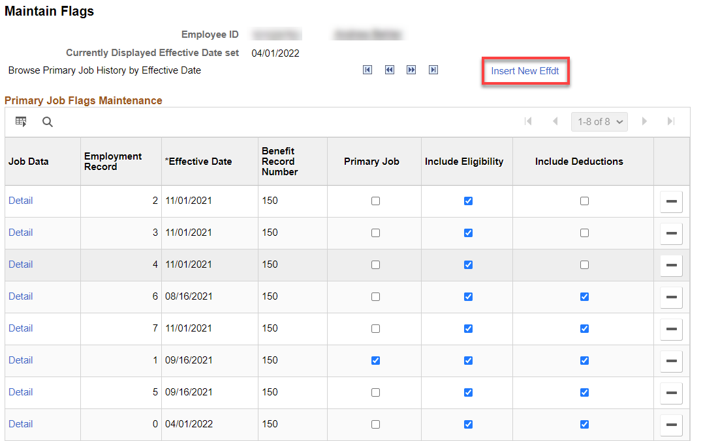
Before

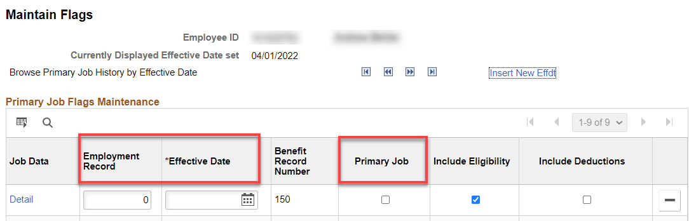

2. Add the Employment Record you want to change the Primary Flag to, Effective Date, check Primary Job, Save (the changes will take effect upon the Save).

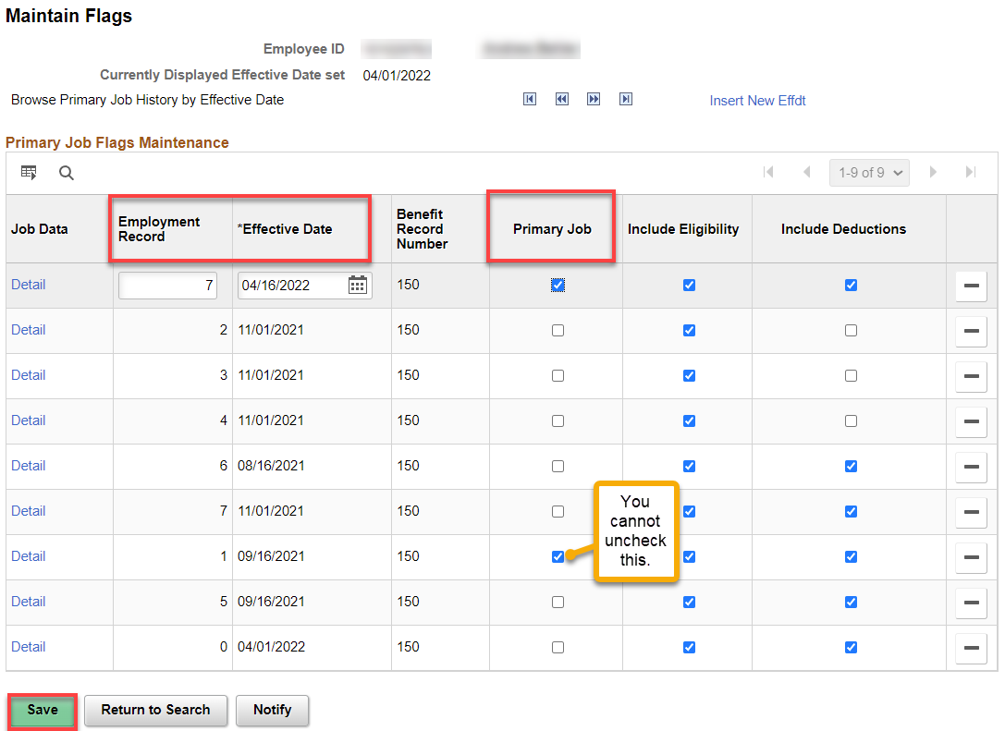

After

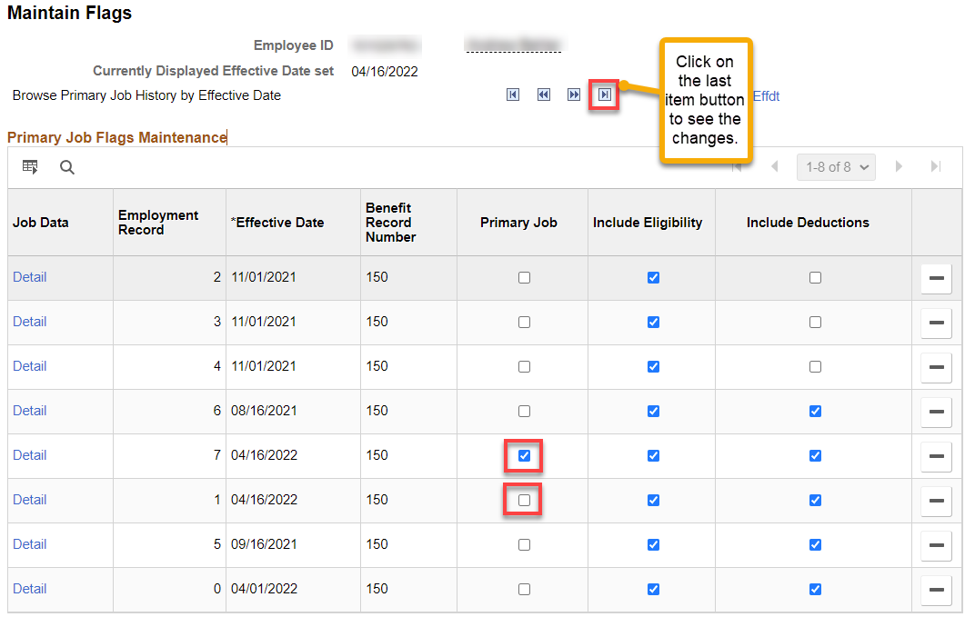

That’s it!

