Adding Benefits

BE SURE to let payroll know about benefits so they can make sure the deductions are taken out correctly. Also, be sure to tell payroll about those going on TIAA so they can take out the proper fees.

Medical and Dental are put in PAY1 and the information is automatically entered into ctcLink overnight. The information CAN be put in manually but anything different than what is in PAY1 will be overwritten in ctcLink (BE SURE TO DBL CHECK IF THE INFO CAME OVER FROM PAY1 – sometimes it doesn’t and you need to go back into PAY1, make a change, save, then change it back, save, and check ctcLink the next day to see if it came over. The example below shows what it looks like for a coverage begin date of 3/1/21 (wasn’t entered into PAY1 until 3/10/22). Choose View All to see both medical and dental on one page.

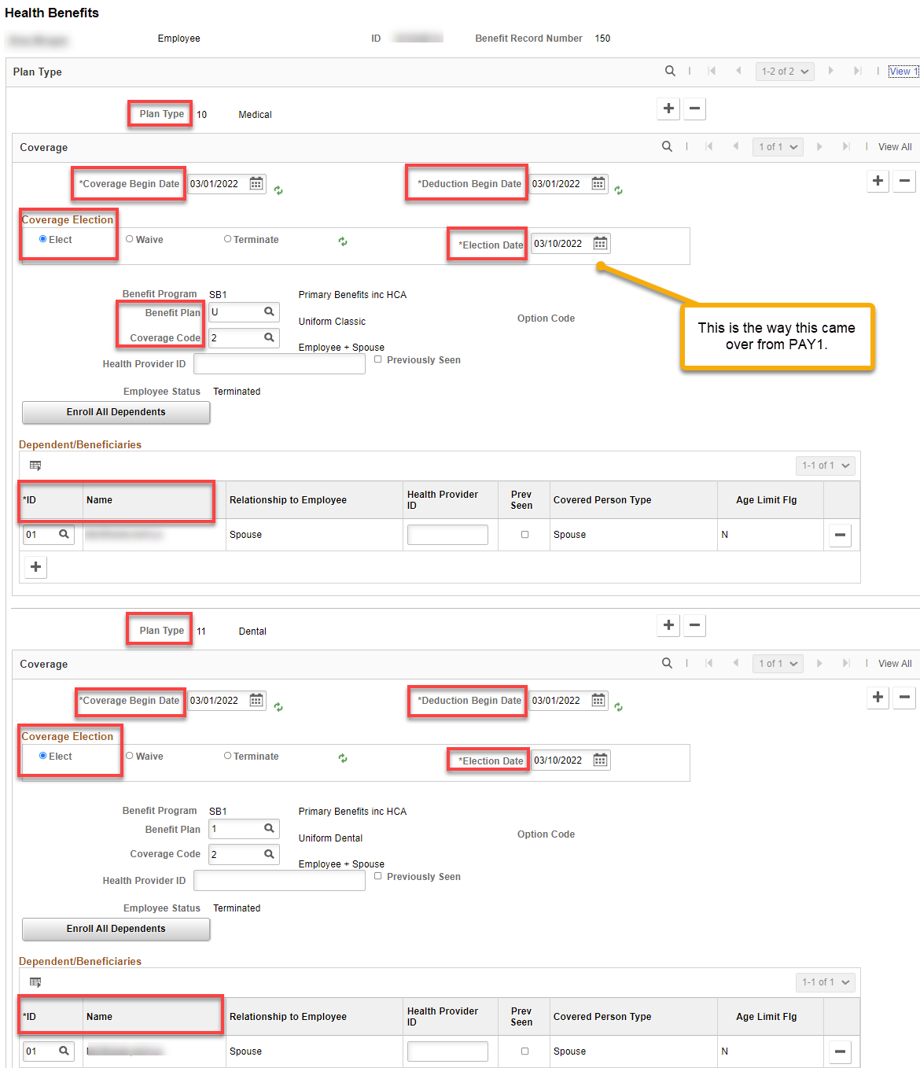

Simple Benefits such as Spousal Medical Surcharge and Tobacco User Surcharge, if any are also populated through PAY1.

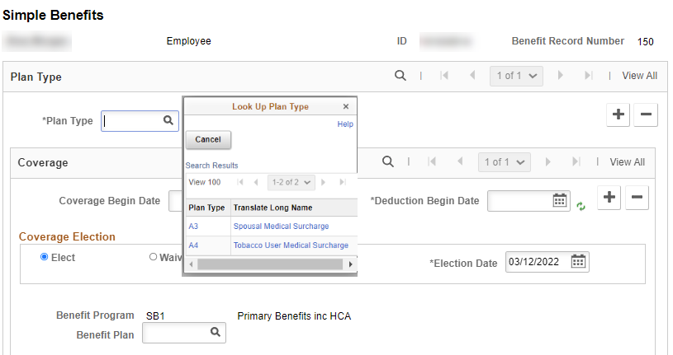

Life Insurance is through MetLife and therefore we do not need to do anything in ctcLink

Disability Benefits must be entered in ctcLink

Nav>Benefits>Enroll in Benefits>Disability Benefits

E-188 (SBCTC auto process) will continue to default employees who are without any OLTD plan selected into the 60% plans provided there is a retirement plan available for the process to logically select the correct OLTD Plan. College Admins must continue to manually key in:
- Employees who opt out of OLTD
- Employees who opt for 50% plan
- Any retirees who are not eligible for retirement plan and anyone else who has benefits and not retirement

There is NO AUTO-UPDATE from PEBB/PAY1 into ctcLink for LTD (as of 2/22).

If the employee-paid enrollment was automatically added and the effective dates are the same, you can use Correct History to decline or change to 50%.

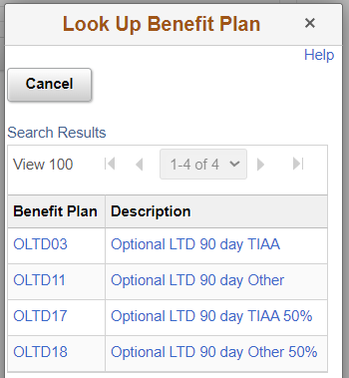
If you are enrolling or changing employee-paid LTD, you need to know what type of retirement they have (TIAA or Other), then click on the Benefit Plan Search Tool to find the coverage needed.

If you are changing coverage, the Benefit Plan will already tell you if the retirement plan is TIAA or Other.

Non-retirement-eligible employees will be “Other.”

SEE documentation: Benefits-LTD-Adding ABBRs for PT Faculty

If enrolling for the first time, add + a row in Plan Type, choose plan, add + a row in Coverage, enter Coverage, Deduction and Effective dates (use the same date for all), choose Benefit Plan and Save.

Note: you can effective date in the future, i.e., put in 3/1 even if it is currently 2/9 (according to the experts ).

Basic – add Plan Type, Coverage and Deduction Begin dates (both the same) and Election Date (Election Date can be different), add Benefit Plan, Save.

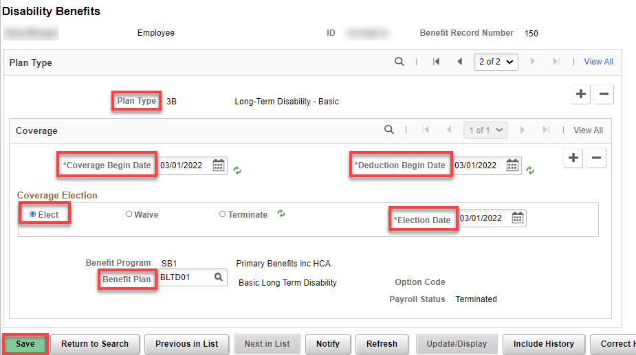

Employee Paid - Add a row (+), choose Plan Type (Optional), add Coverage and Deduction Dates (both the same-1st of the month after signature) and Election Begin Date (Election Date can be different), add Benefit Plan, if applicable, Save.

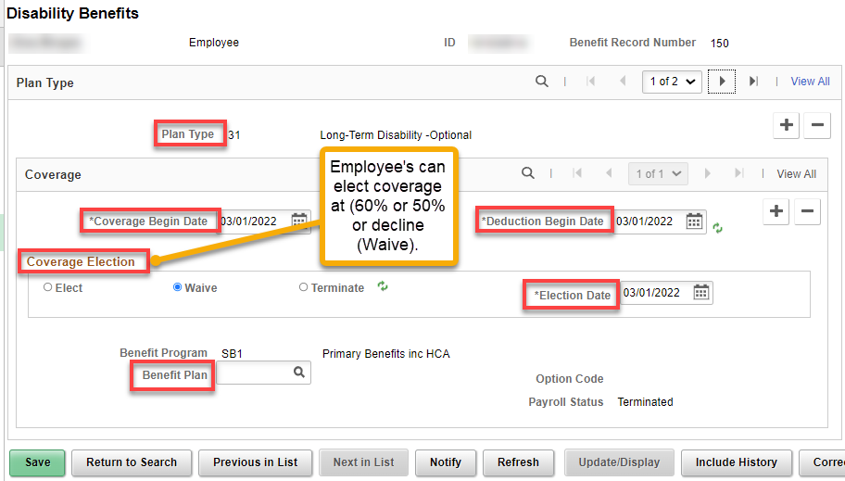

Savings Plans SBVIP or DRS Deferred Comp – Can be done any time. Deferred Comp is done through DRS and they will send a form. Add Plan Type, Coverage Begin Date, Deduction Begin Date, Coverage Election, Election Date Benefit Plan, Investment amount or percentage in Before and/or After-Tax Investment amount(s), Save. Election Date can be the actual date it was added.

If Changing amount(s) or adding a Savings Plan, add + a row and follow the directions above.

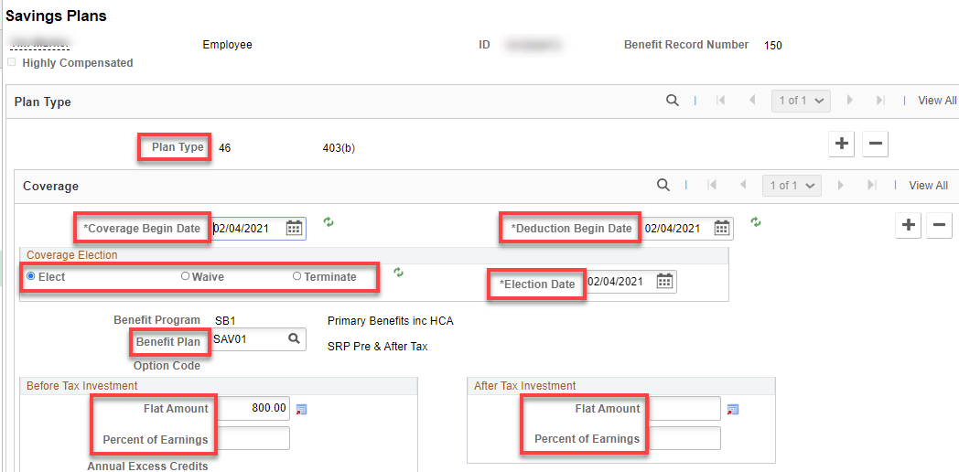

9.2 Enrolling an Employee in Spending Accounts

Nav>Benefits>Enroll in Benefits>Spending Accounts

FOR FACULTY THAT WORK IN THE SUMMER (PT or other), the deduction/reduction WILL be taken out. FOR THOSE THAT DO NOT WORK DURING THE SUMMER, have payroll NOT TAKE RETRO DEDUCTIONS/REDUCTION.

Enrolling in HSA, FSA or DCAP:
For new enrollment for full time employee (24 payments (20 for FT faculty – 19 for PT faculty?)-Jan 10 through Dec 25 – Coverage Begin Date and Deduction Begin Date after 12/16), you don’t have to figure Flat Deduction Amount, however, I recommend it in case there is a change in a person’s contract, the deduction will continue to be taken.

For those with less than 24 payments, take the Annual Pledge/number of payments and put in the amount in Flat Deduction Amount Override – Optional.

Choose Plan Type (HSA, FSA [FSA, specify regular or limited purpose (limited purpose is only for those with the CDHP medical plan] or DCAP), fill out Coverage, Save.

Health Savings Account

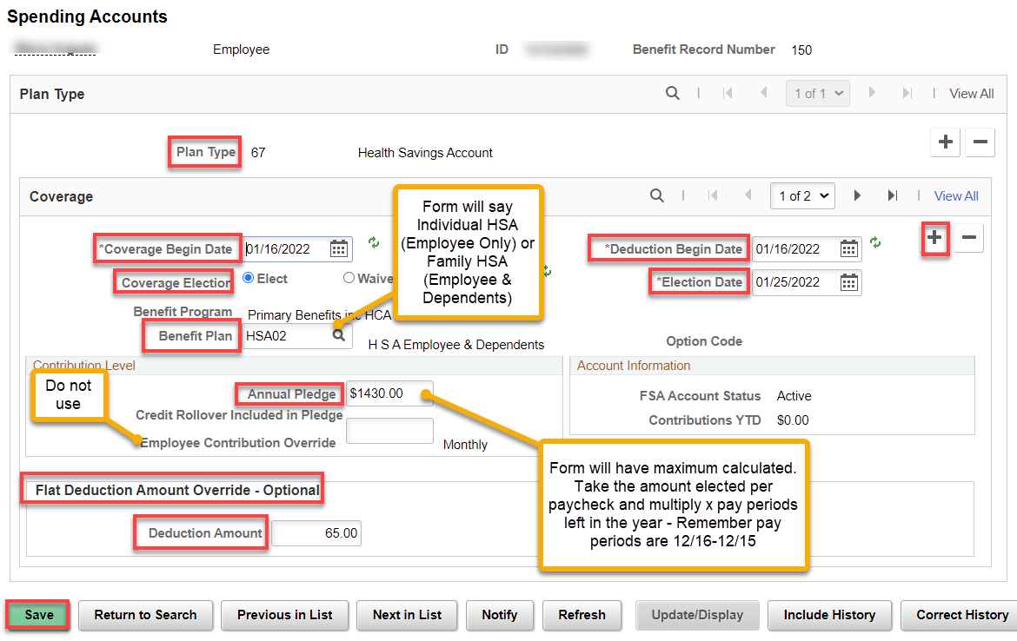

The following Warning will happen. Click OK. Save.

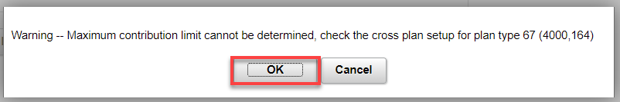

Flexible Spending Accounts

For Benefit Plan, use FSA01 with the regular FSA and FSA02 for the Limited Purpose FSA.

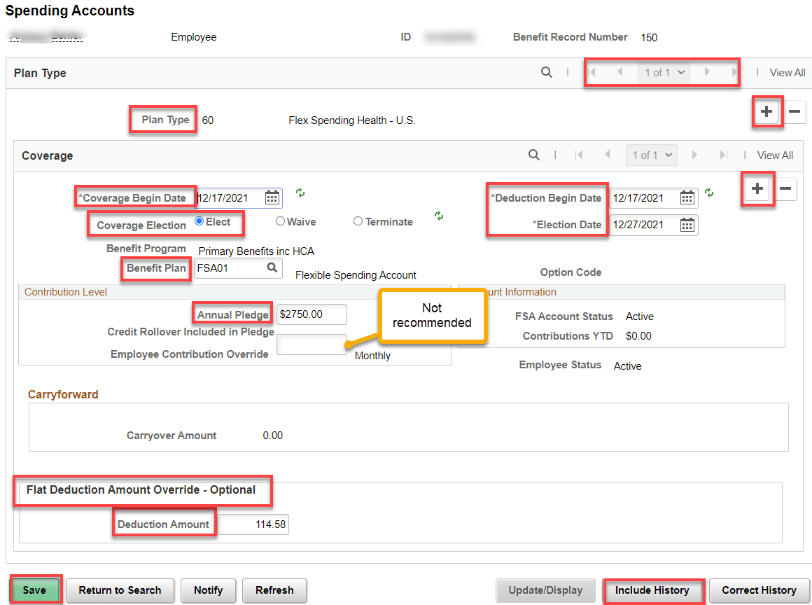

Dependent Care Assistance Program (DCAP)

If adding FSA and DCAP, Include History and Add + or arrow over to the Plan Type, add + a row for coverage and fill out Coverage, Save. Election Date can be the actual date put in.

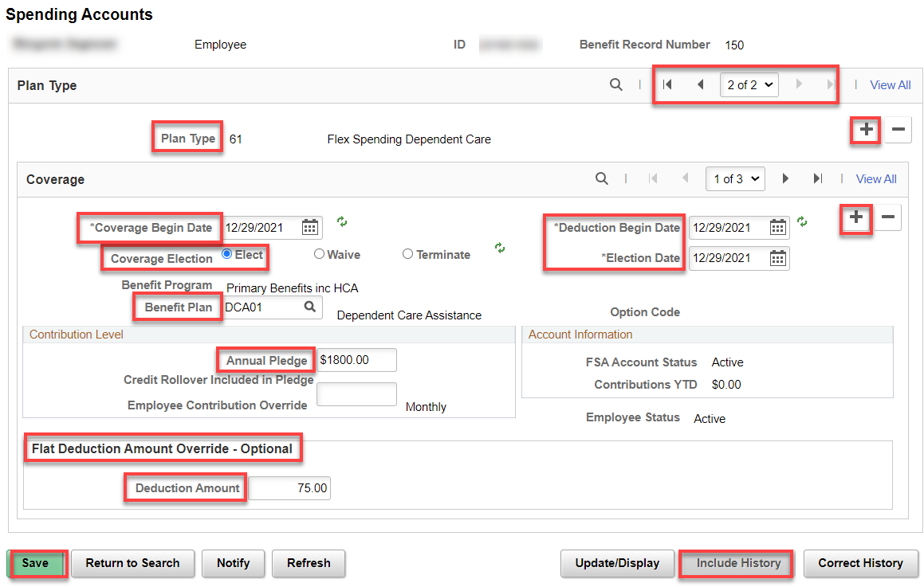

Retirement Plan:

Note: for the SBRP, you will need to know the employees age.

Dates are very important and must be the same on both the Retirement Plan and Retirement Fields pages. See QRG Dates on Retirement Plan Pages.

Add Plan Type, Deduction Begin Date, Election Date (DATES MUST BE THE SAME-NEVER CHANGE THE ELECTION DATE IF THERE IS A PRIOR DATE…DRS wants only one Election Date) and Benefit Plan, Save.

If the Payroll Status is “Terminated,” you must go to Benefits>Maintain Primary Jobs>Maintain Flags and change the Primary Job Flag to the correct Empl Record. See Benefits-Maintain Primary Flags documentation.

Retirement Plan

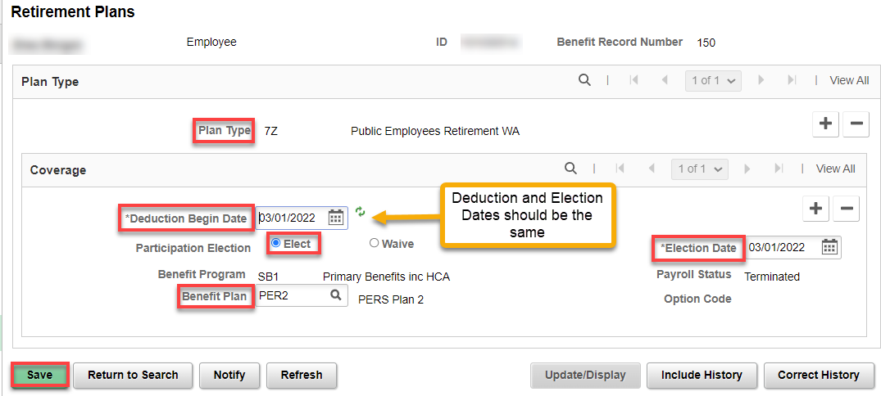

Enter Retirement Fields
Nav>Benefits/CTC Custom/Retirement Fields

If this is the first time on retirement, add a New Value AND choose the correct Empl ID. Add the Effective Date, DRS Option, DRS Option Date, and Retirement Plan Effective Date, Save.

THIS IS FOR DRS PLANS ONLY (nothing needed for TIAA)

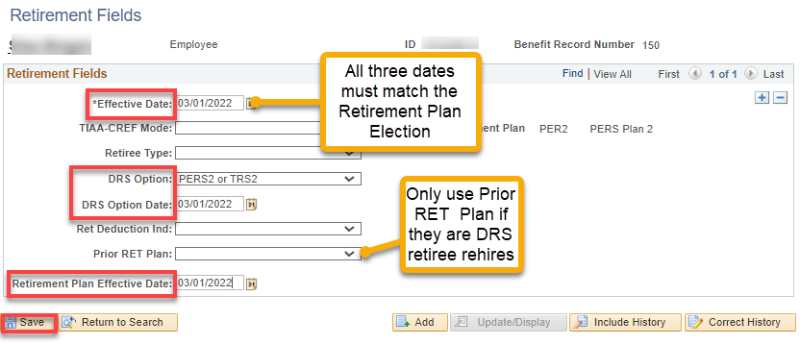

DRS Transaction
Nav>Benefits>CTC Custom>DRS Transaction

Payroll takes care of this page…thank goodness.

How do the retirement plans get updated for the different ages? It’s an automatic process, E-188, that is run by Central Payroll each pay cycle.

BE SURE to let payroll know about benefits if the deductions are late or are changed so they can make sure the deductions are taken out correctly. Payroll needs to know what retirement plan people are on.

That’s it!

