Changing settings so PDF’s open in Adobe Acrobat instead of a web browser

In order to change W-2 withholding, you must have Adobe PDF’s open with Adobe Acrobat instead of a web browser, follow these steps.

On Chrome, click on settings, then click on Security and Privacy

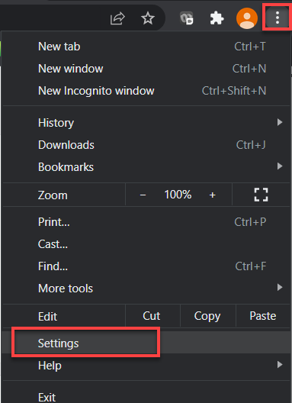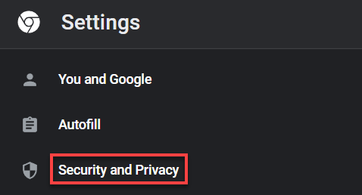

Click on Site Settings

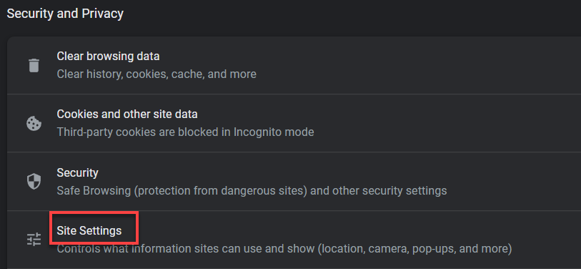

Under content, click additional content settings, then click PDF documents.

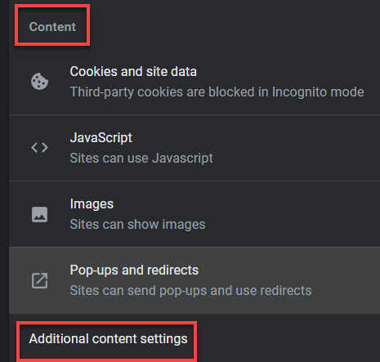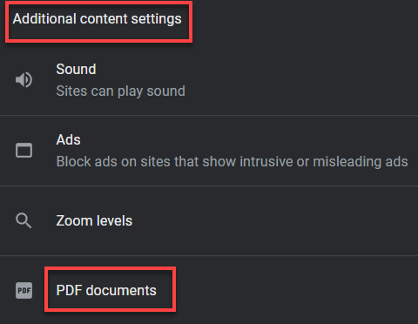

Select Download PDFs and close the tab.

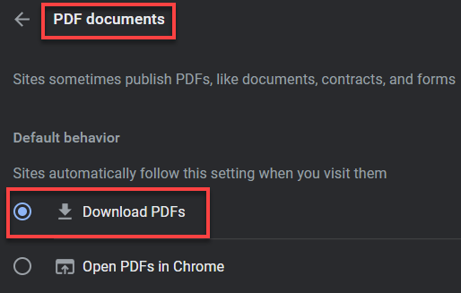

That’s it!

Site to download Adobe reader for free:

https://acrobat.adobe.com/us/en/acrobat/pdf-reader.html

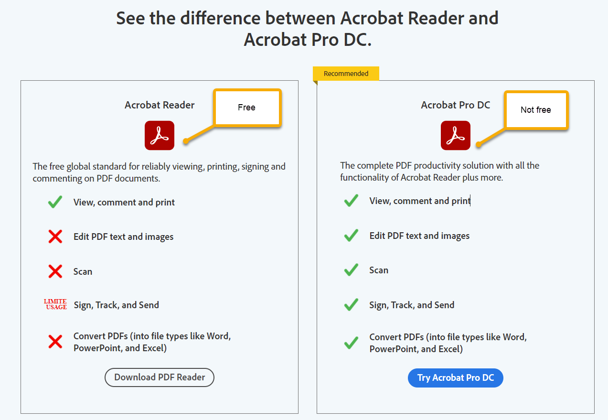

Employees that have questions or want more information about Acrobat Pro DC should call the Helpdesk.

