Add A New Employee Instance

Nav>Workforce Administration>Job Information>Add Employment Instance

PT Hourly

Work Location tab: Put start date as effective date. Add Company and Department and hit tab and the rest will autofill. If the Last Start Date has a different date, it will update after you refresh or hit OK at the end of the process.

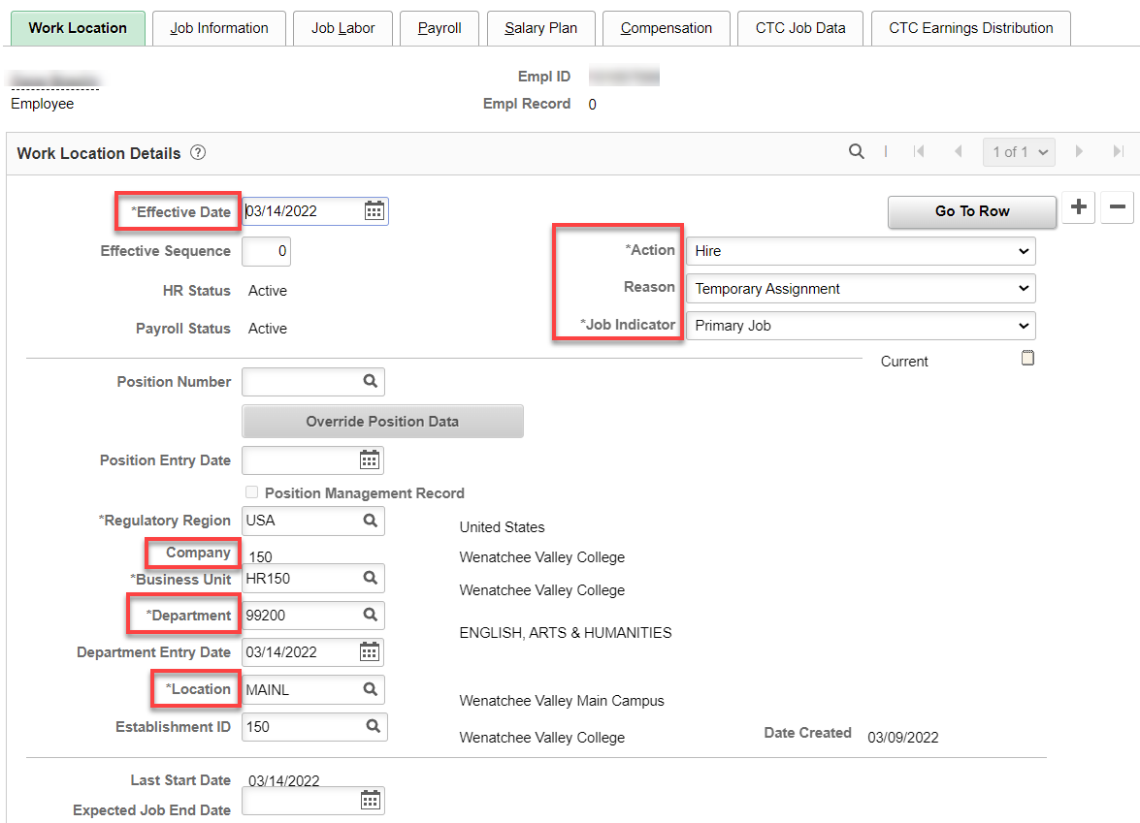

Job Information tab: Add Job Code, Supervisor ID, Temporary, Part-Time, Hourly and the rest is auto-filled. Work Period is W.

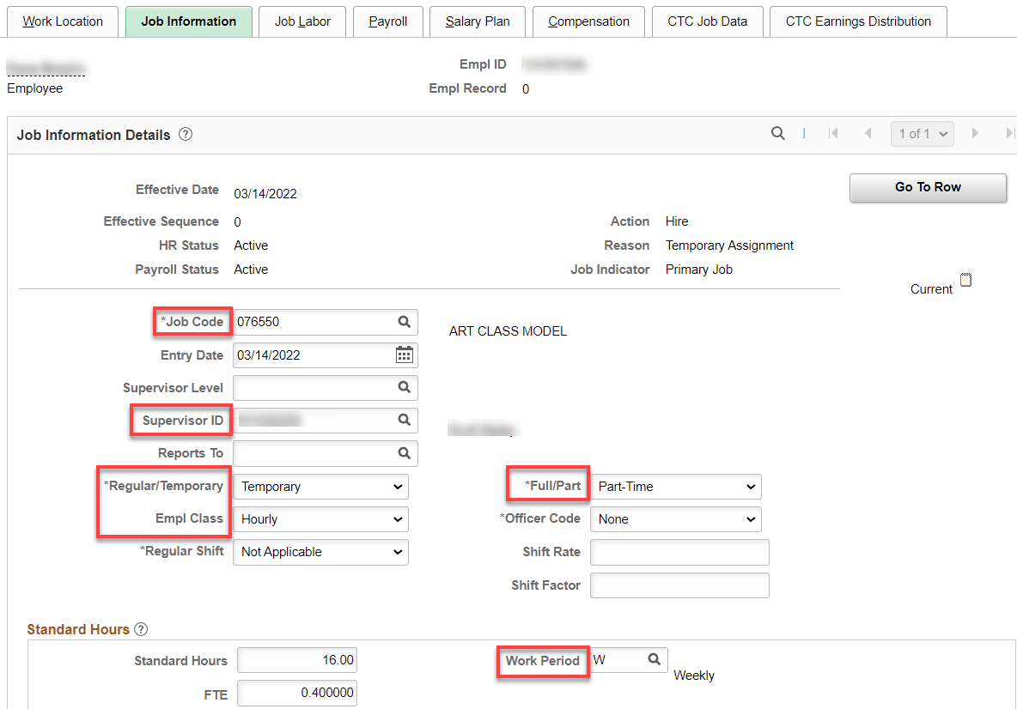

Nothing for Job Labor

Payroll tab: Add Absence System (Absence Management) and Pay Group, the rest will autofill. IF ALREADY IN ABSENCE MANAGEMENT FOR A DIFFERENT HOURLY POSITION, Keep “Other” IN ABSENCE SYSTEM.

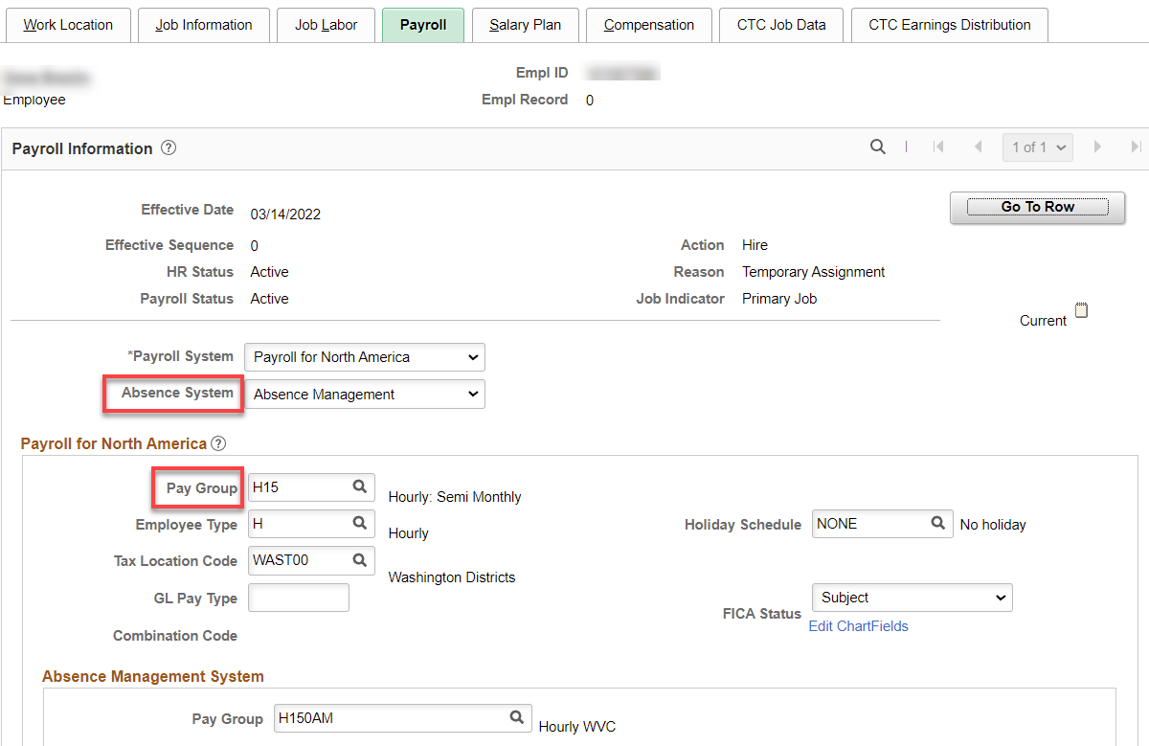

Nothing for Salary Plan

Compensation tab: Enter Rate Code, Comp Rate, change Frequency to H and hit Calculate Compensation.

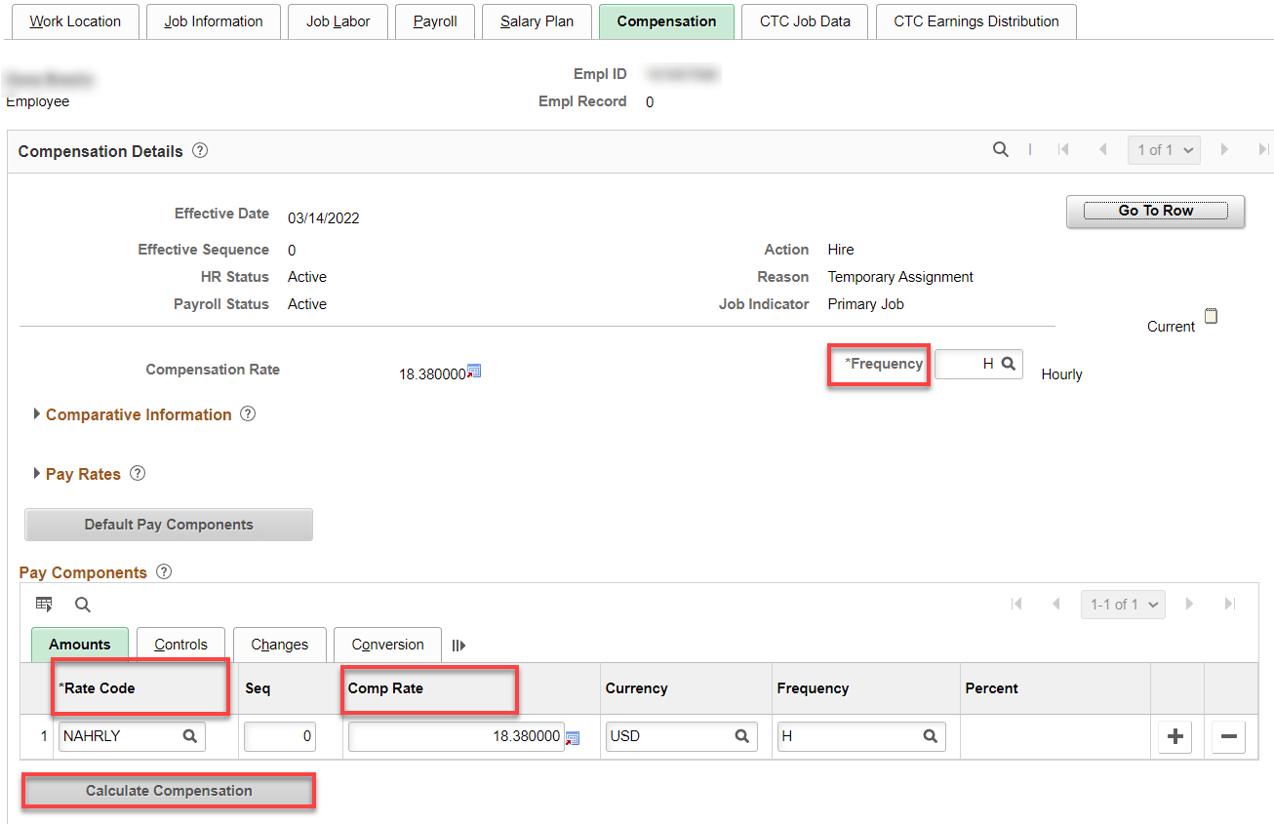

CTC Job Data tab: Leave accrual date is the first of the month of the start date. Put in Job Emp Type. You can put in start and end date (they are not necessary) but I like them.

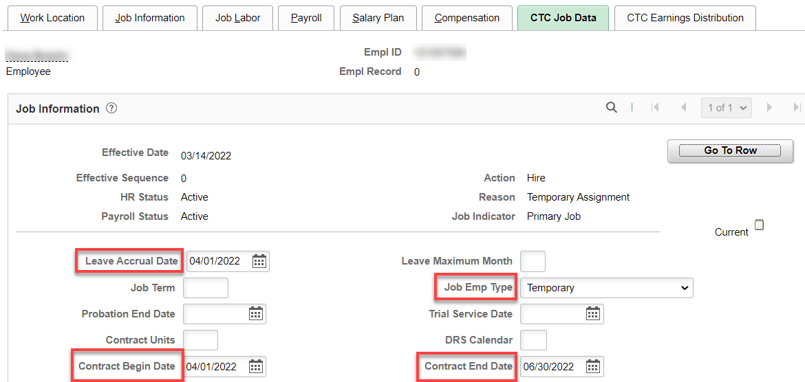

CTC Earnings Distribution tab: Enter the Earnings Code, Percent of Distribution, check Primary on all codes (if more than one); click on Edit Chart Field hyperlink.

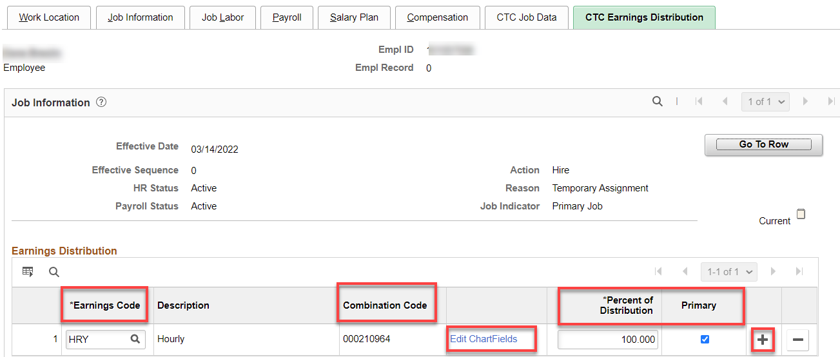

Enter the combo code (hit enter for the chart field to complete). Check the chart field (budget lines) to make sure it matches the PT hourly agreement.

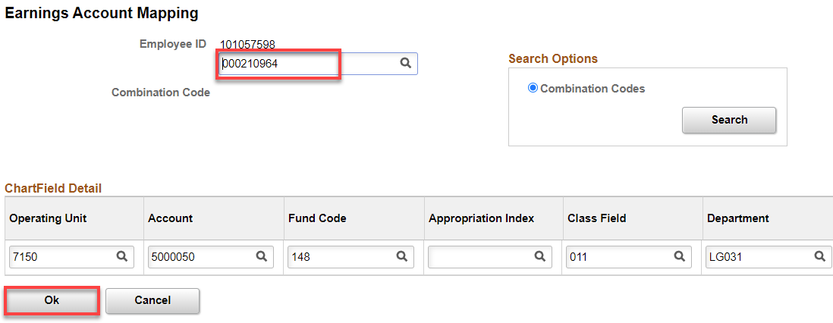

Click on Employment Data hyperlink
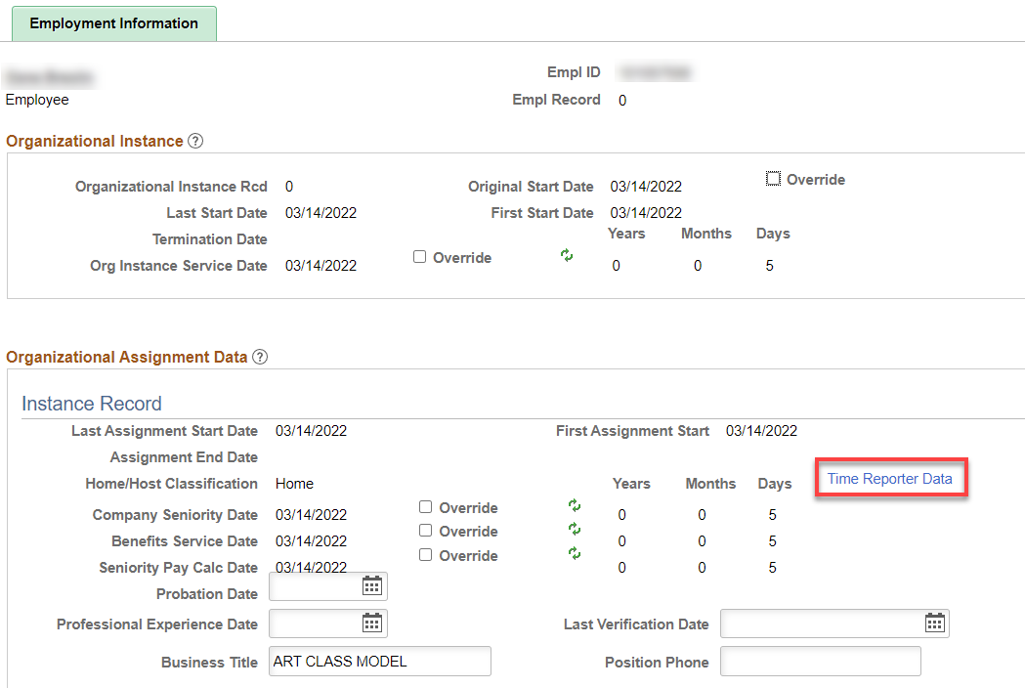

Click on Time Reporter Data hyperlink.

Change the effective date to the hire date, if needed, put in the Time Reporter Type, Punch Time Template, Work Group, Task Group and hit refresh. That will update the Employment Information screen (above).

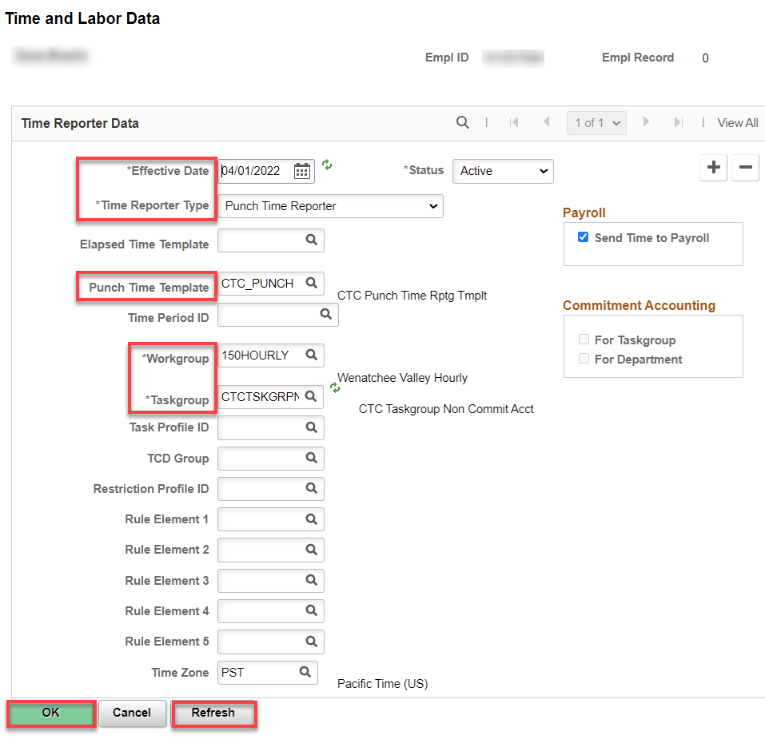

Click on Benefit Program Participation hyperlink. Add Benefit Record Number, Save.

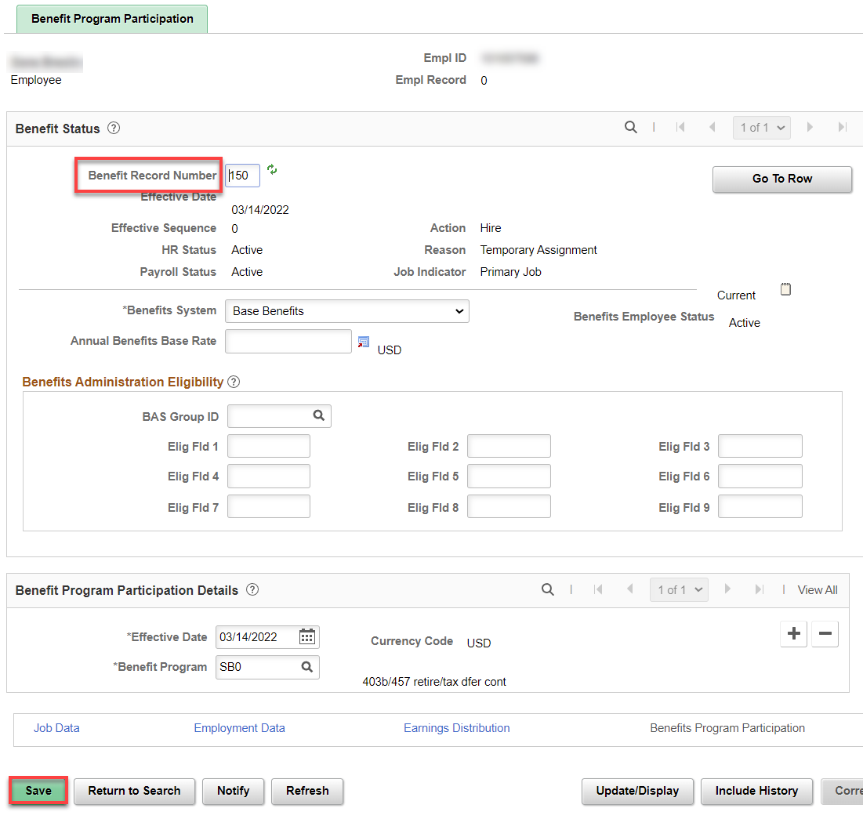

Two Warning windows will pop up, hit OK.

Assign ACA Status – Nav>Benefits>CTC Custom>Assign ACA Status

Add Effective Date (hire date), choose appropriate ACA Employment Status (all PT hourly are Less than 130 avg hrs/mth), Save.

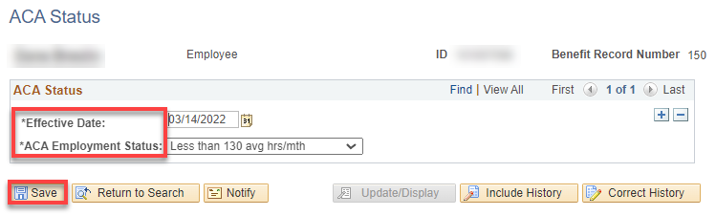

That’s it!

