Add A New Employee Instance

Nav>Workforce Administration>Job Information>Add Employment Instance

FT Faculty – Extended Days

Work Location tab: Add effective Date (if even pay periods, put the beginning of the pay period), Reason, Company, Department, Department Entry Date (first day of the quarter).

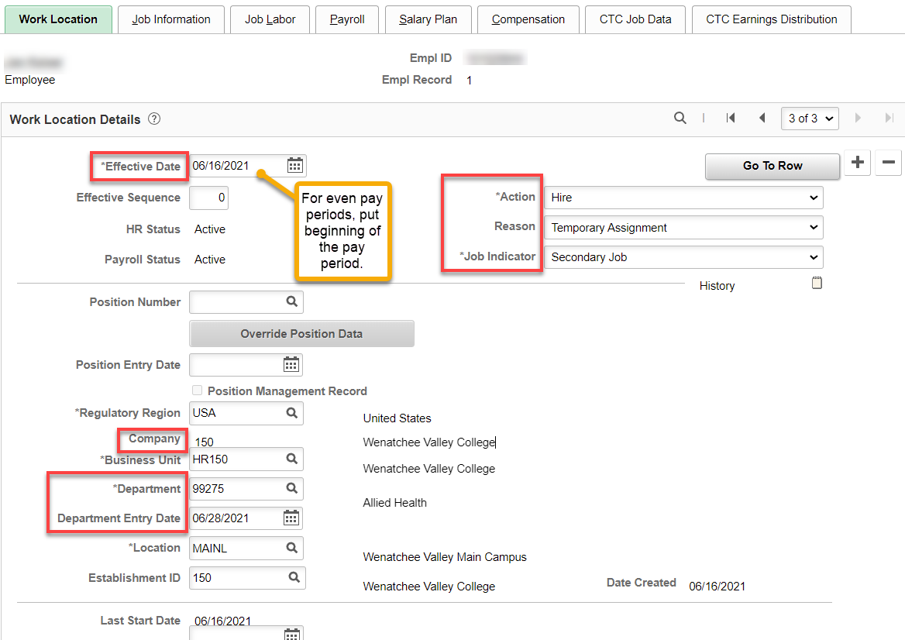

Job Information tab: Add Job Code, Supervisor ID, Temporary, Full-Time, Empl Class (Faculty), Work Period (D39 for all extended days-has to do with hourly rate), correct FTE back to 1.00.

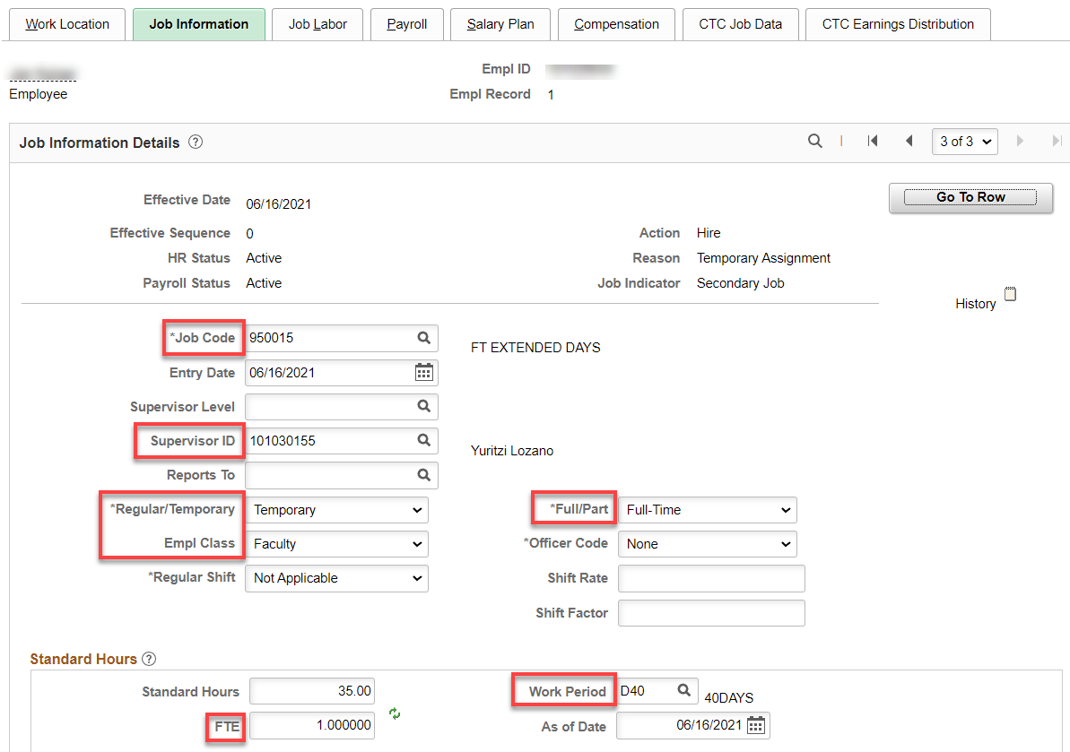

Job Labor tab: Union code auto fills

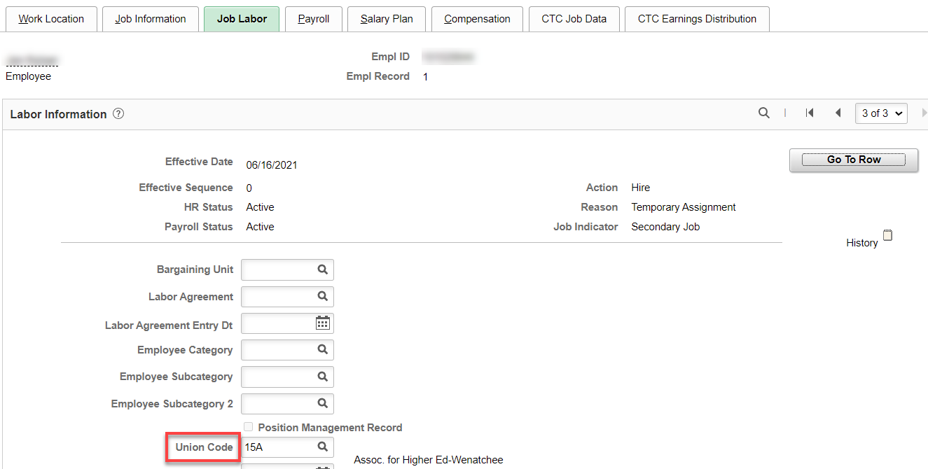

Payroll tab: Set Absence System to “Other” if they already have an Absence System, add Pay Group (F15)

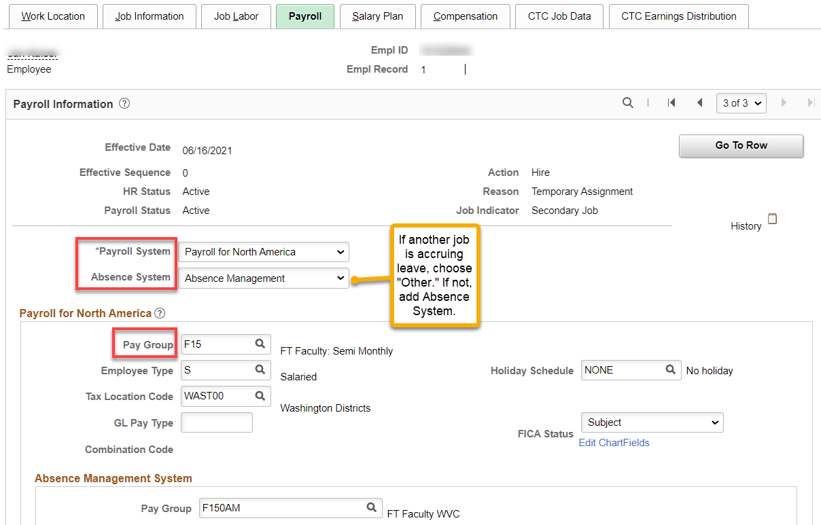

Salary Plan tab: Nothing to fill in

Compensation tab: Add Rate Code, Comp Rate and Frequency (number of pay periods); hit Calculate Compensation.

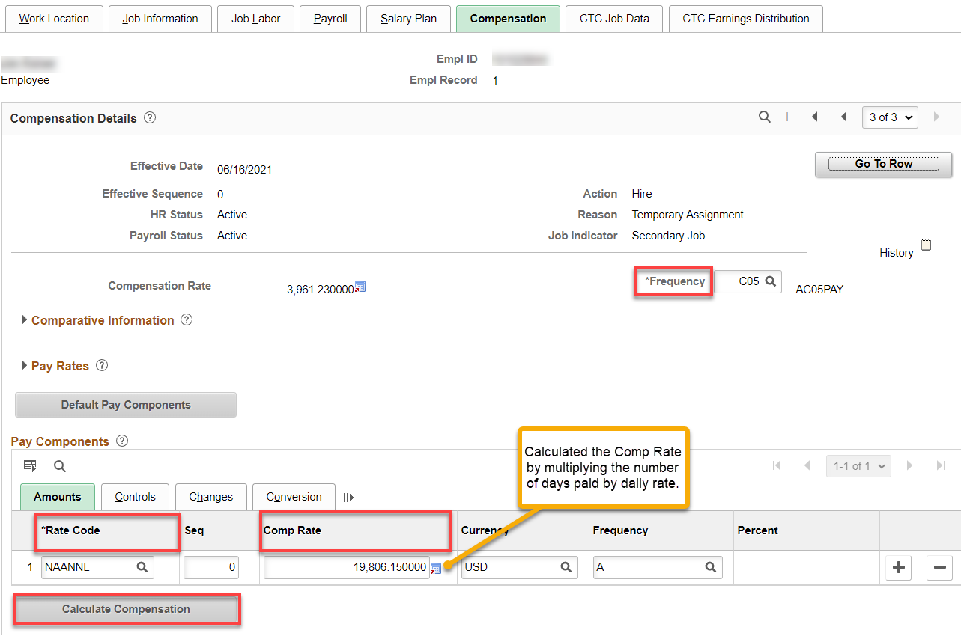

CTC Job Data tab: Add Leave Accrual Date, Job Employment Type, Contract Units, DRS Calendar, Contract Begin and End Dates.

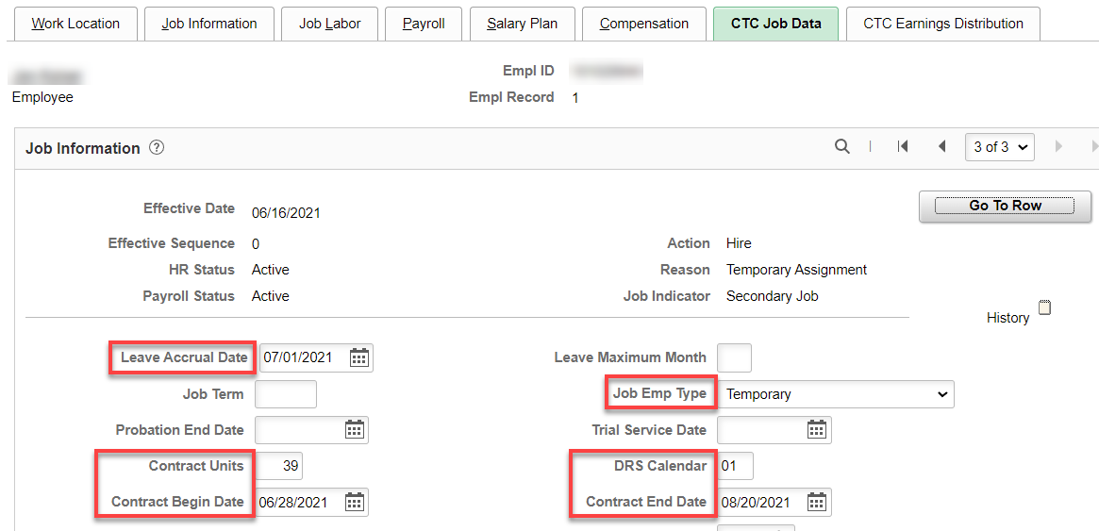

CTC Earnings Distribution tab: Add Earnings Code (FTF), Percent(s) of Distribution, set all to Primary, click on Edit Chart Fields and enter Combo Code(s).

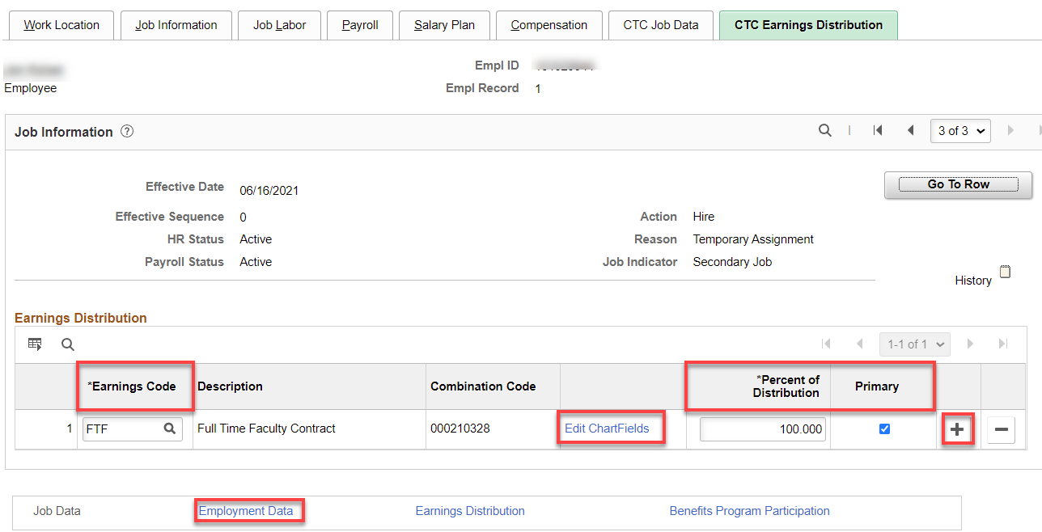

Click on Employment Data link and then Time reporter Data

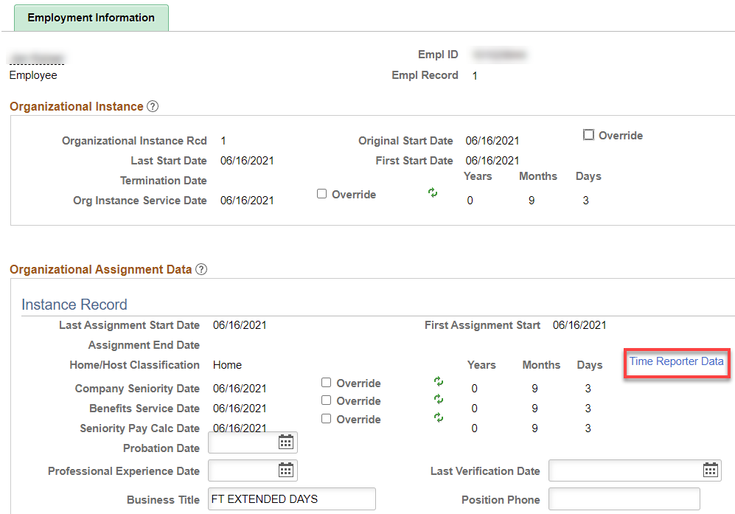

Click on Time Reporter Data, Effective Date should already be the beginning of the pay period, Time Reporter Type should already be Elapsed Time Reporter, add Elapsed Time Template. Workgroup & Taskgroup, click OK.

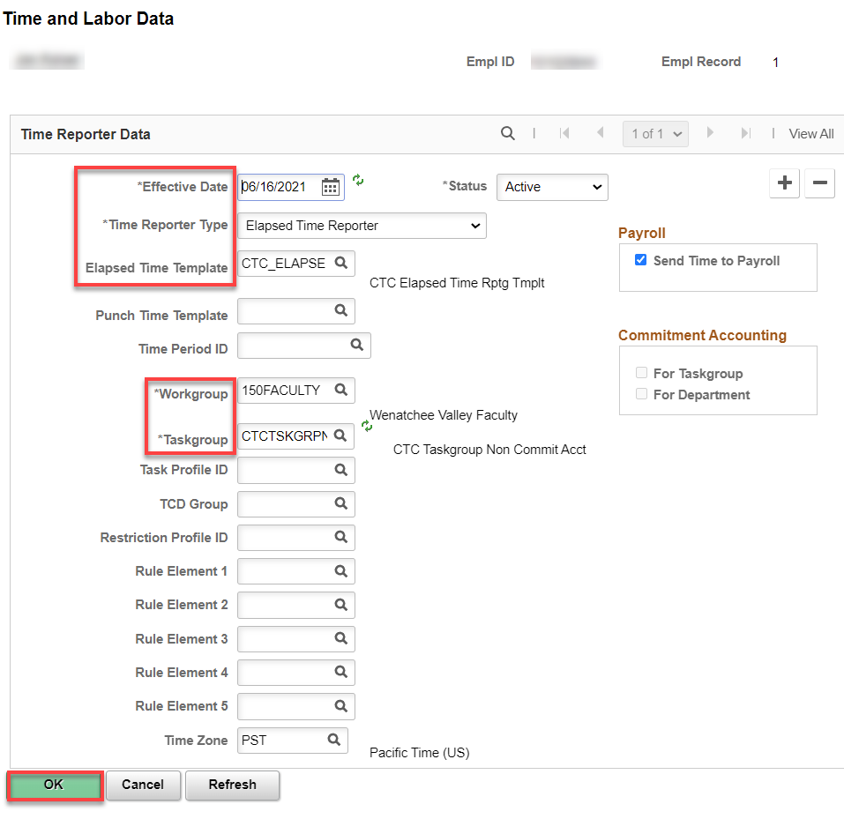

Benefit Program Participation link - Since this is a secondary job, there should be nothing to do on this screen.

That’s it!

