Add A New Employee Instance

Navigation: NavBar > Navigator > Workforce Administration > Job Information > Add Employment Instance

Classified staff also Teaching PT Faculty
The effective date is the current date or a date before the quarter starts (very important to do this so FWL runs properly)

Work Location tab: Add Effective Date (must be prior to the quarter start date), Reason, Company, Department, Department Entry Date (start of quarter)The Department Entry Date (first day of the quarter).

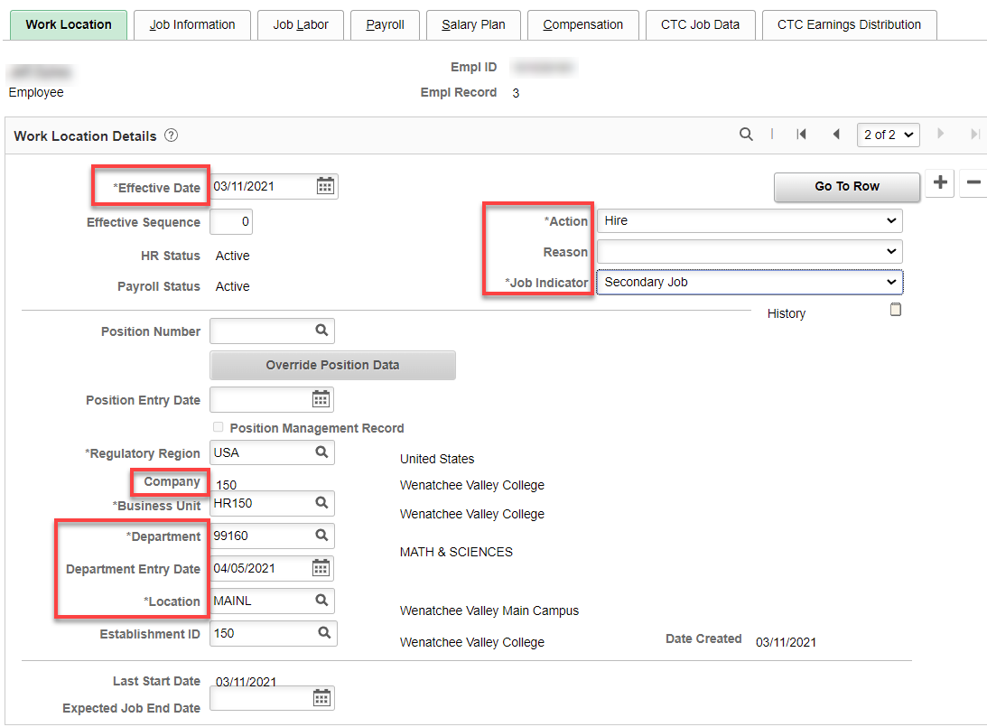

Job Information tab: Add Job Code, Supervisor ID, Regular/Temporary (Temporary), Full/Part (Part-Time), Empl Class (PT Faculty).

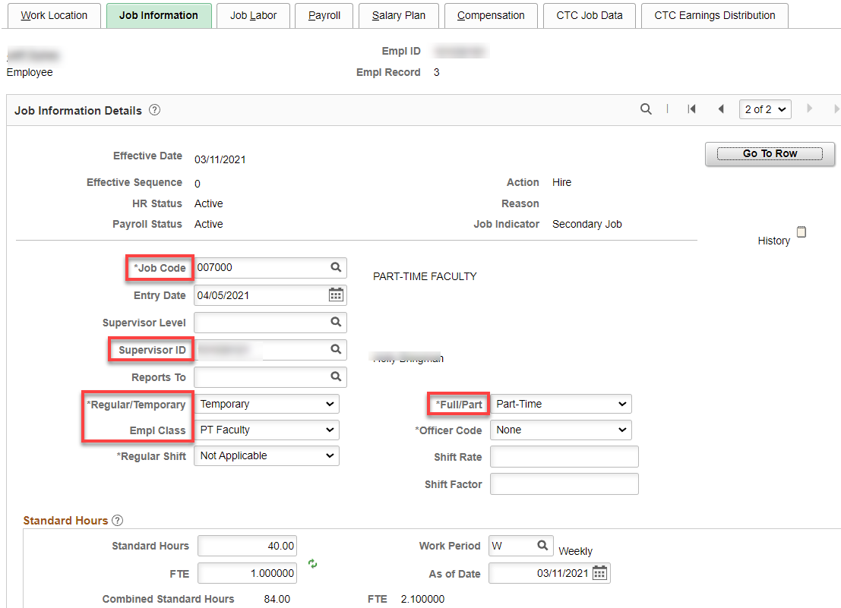

Job Labor tab: Union code auto fills

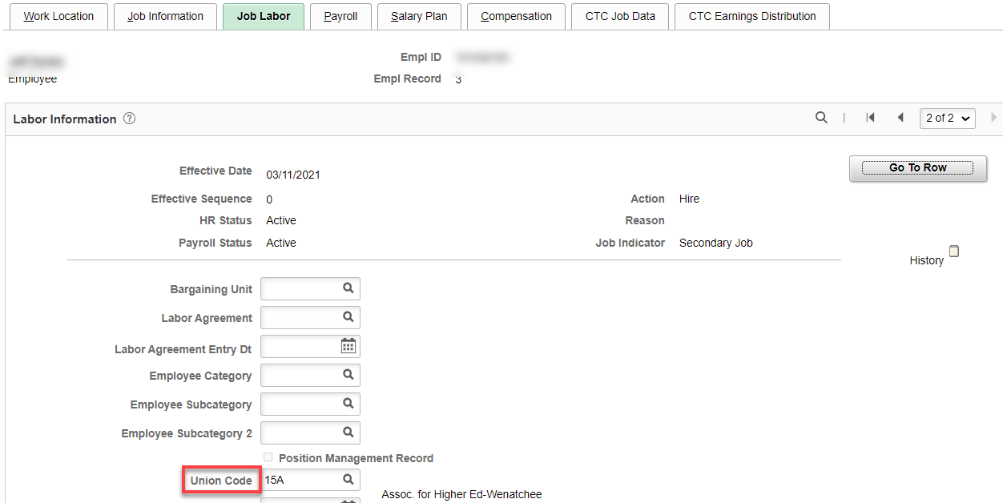
Payroll tab: may be Other or Absence Management—we don’t let classified teach unless they are ½ time so they can have another Absence System for their PT faculty job) – Add Pay Group (P15).

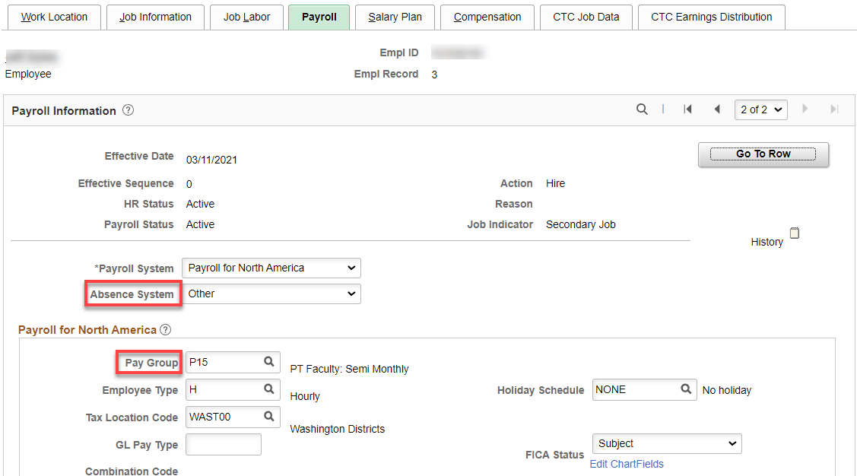

Salary Plan tab: Leave blank.
Compensation tab:- Leave blank (FWL will populate).

CTC Job Data tab: - Just fill in Leave Accrual Date if they have a second Absence System (beginning of the hire date month) , Job Employment Type (Temporary) and DRS Calendar. I like to add the contract begin and end dates but not necessary.

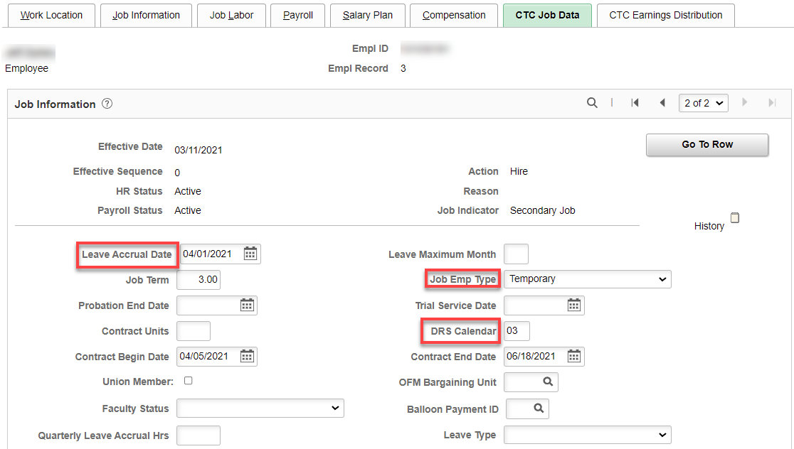

CTC Earnings Distribution tab: Add Earnings Code (PTC), Percent(s) of Distribution and set all to Primary. Click on Edit ChartFields to enter Combo Code(s).

Using PTC prevents union dues from being collected on the PT faculty job.

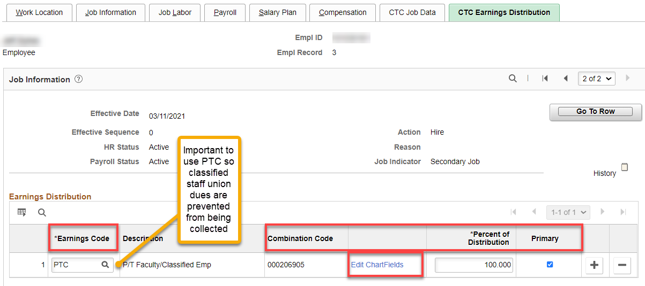

After entering the Combo Code, hit enter and the ChartField Detail will populate; check budget to see if it matches what you need, click OK.

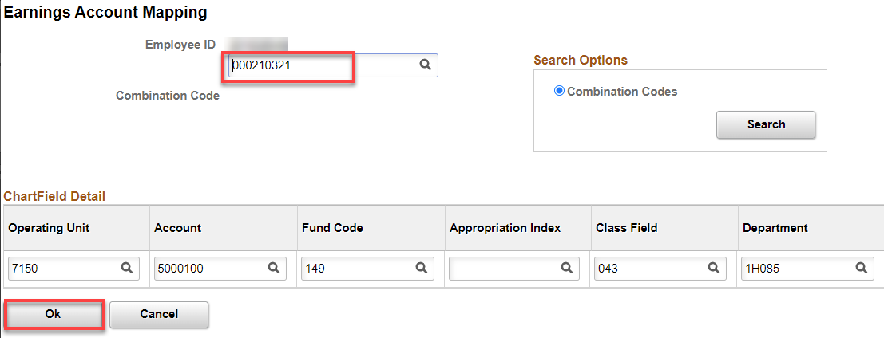

Click on Employment Data link and then Time reporter Data

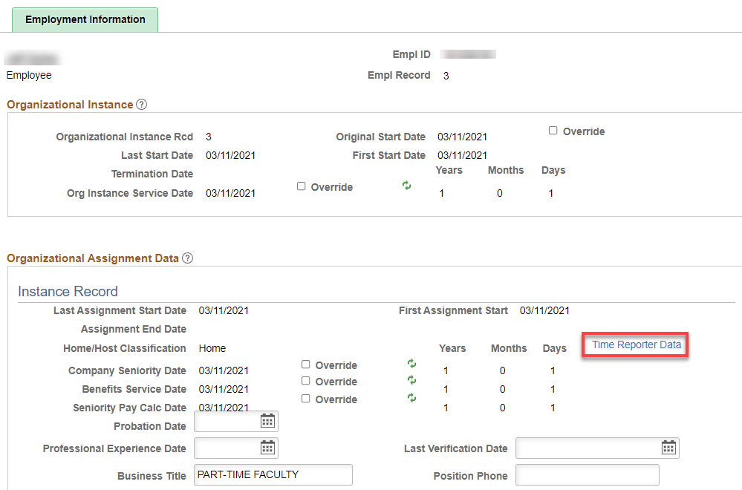

Click on Time Reporter Data first, change the effective date to the quarter start date, add Elapsed Time Template. Workgroup, Taskgroup, click OK. Employment Information should have filled in like above. Yes, the dates are not the actual start dates and you can override them if you choose.

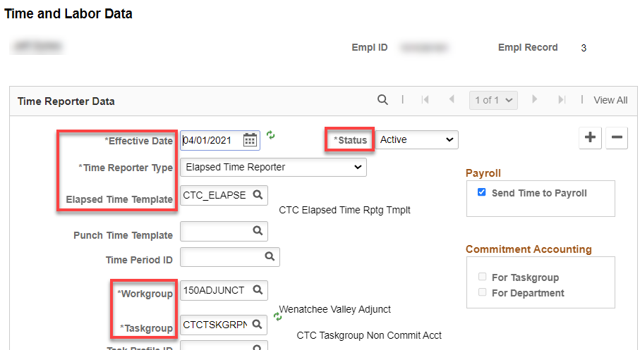

Benefit Program Participation - Since this is a secondary job for a classified, there should be nothing to do on this screen. Save.

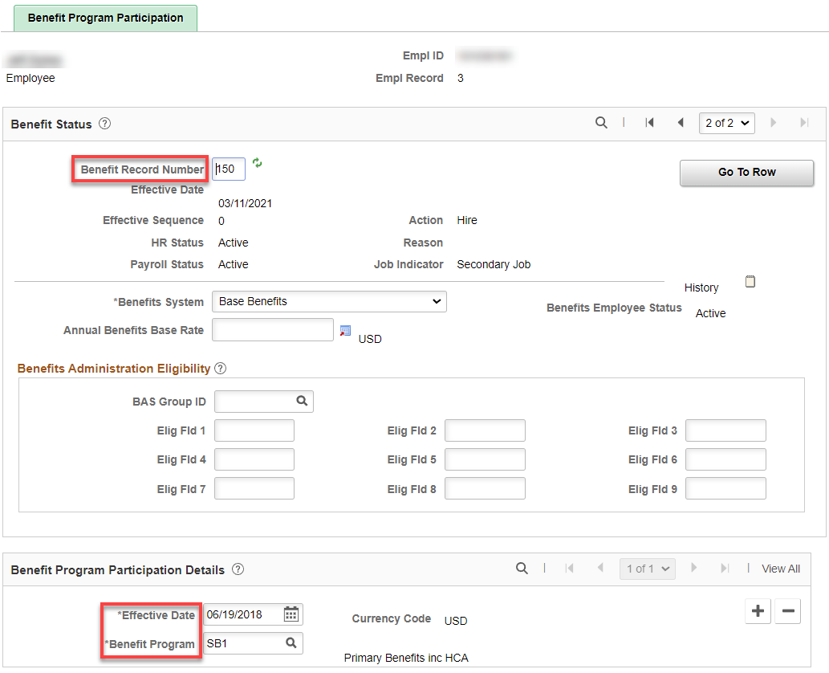

That’s it!

