Transferring Student, Hourly Sick Leave from one Empl Record to Another

First, if there is a pay group change in the same Job record - No need to transfer the balance. Sick leave accrual (SHL E 150) is same for both hourly and student employees.

If a different Empl Record was created for a student or hourly, and the EE wants the noncompensable sick leave hours transferred so they can use them, It really easy…really .

This can be done from student or hourly to NSL if the person is hired as a classified employee (or exempt for that matter) as long as you have NSL added as a leave type to classified and exempt.

First, check the leave events and leave balances (subtract any that haven’t been finalized).

Balances

Nav>Workforce Administrator>Absence Administration Tile>Review Absence Events and then Absence

Then adjust the balances.

Nav>Global Payroll & Absence Mgmt>Payee Data>Adjust Balances>Absences

Search for the employee.

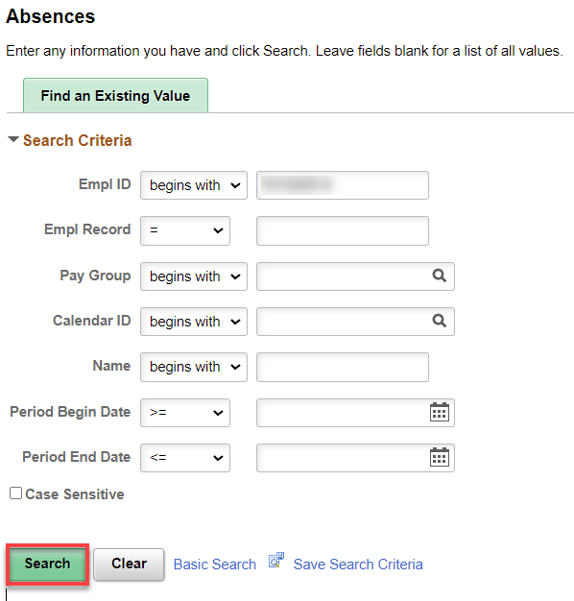

In this example, I’m moving SHL from Empl Record 0 to NSL Empl Record 2.

First, reduce the balance from Empl Record 0 and add the balance in Empl Record 2. Use the ENT Calendar that will run next.

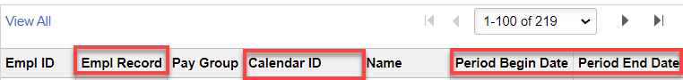
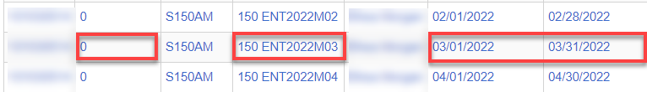

Enter in the adjustment from Empl Record 0 (Element Name, Amount (-), Begin and End Dates, Comment if you choose, Save.

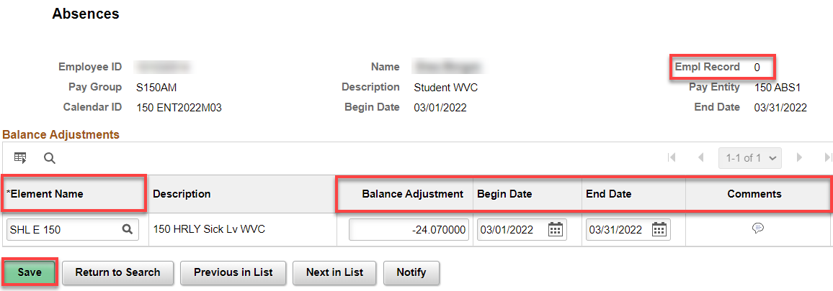

Return to Search and choose the same month ENT Calendar for Empl Record 2.

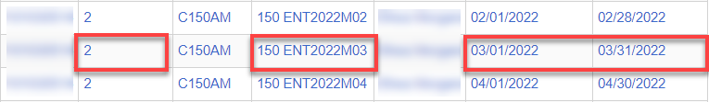

Enter in the adjustment from Empl Record 1 (Element Name, Amount (+), Begin and End Dates, Comment if you choose, Save.

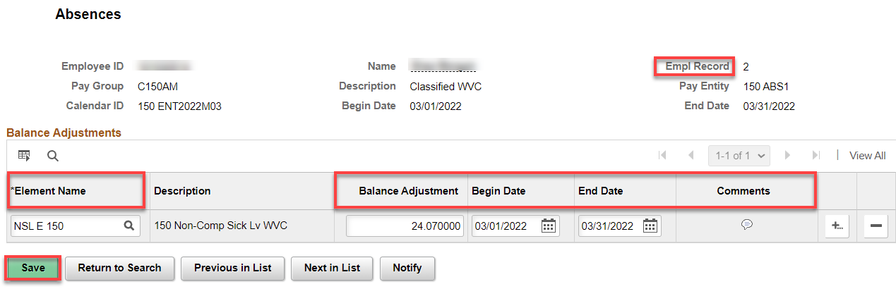

During the absence recalculation process, the system will reduce the balance in Empl Record 0 and add the balance to Empl Record 2.

That’s it!

