Absence Management - Checking Leave Takes or Accruals
Workforce Administrator>Absence Administration tile
OR
Nav>Global Payroll & Absence MGMT>Absence & Payroll Processing>Review Absence/Payroll Info>Results by Calendar Group

You can also run an Absence Balance Report for individuals or all by all leave types that shows beginning balances, leave takes, entitlements, adjustments and ending balances (see Absence Balance Report documentation).

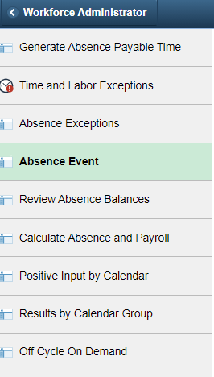

This gives you a quick look at absence events. This “screen” also allows HR staff to change, delete all kinds of things from changing the Absence Take from CSL to VAC or P/H to PRL, etc., delete a row and reenter the time or allow the employee to reenter time (ctcLink doesn’t allow two transaction to happen the same day so if someone puts in 4 hours of leave and then wants to change it, HR has to delete the row (which is best so the supervisor can approve it). HR staff can make the change and it automatically approves – very cool.

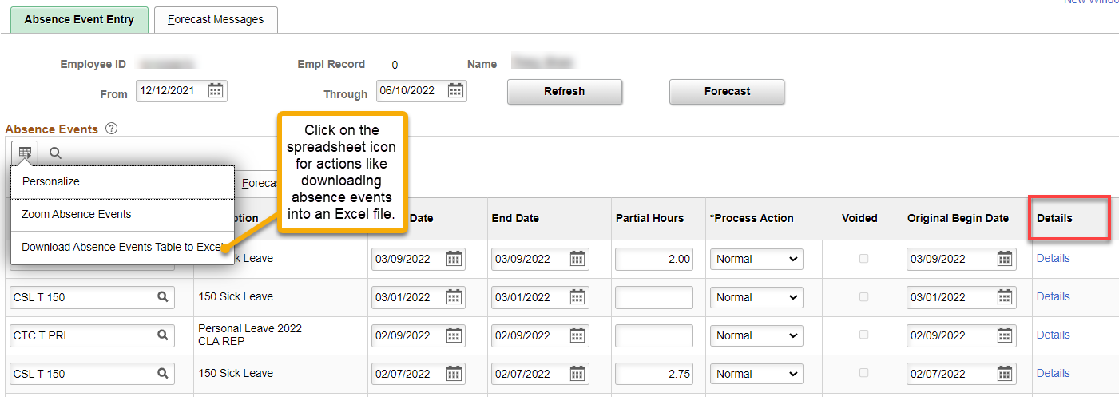

The Details link shows the Process Status to see if the leave has been submitted, processed
and finalized. Only HR can see this.

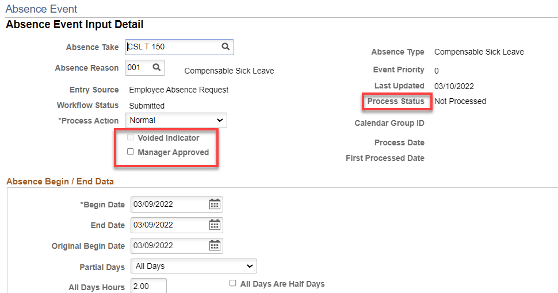

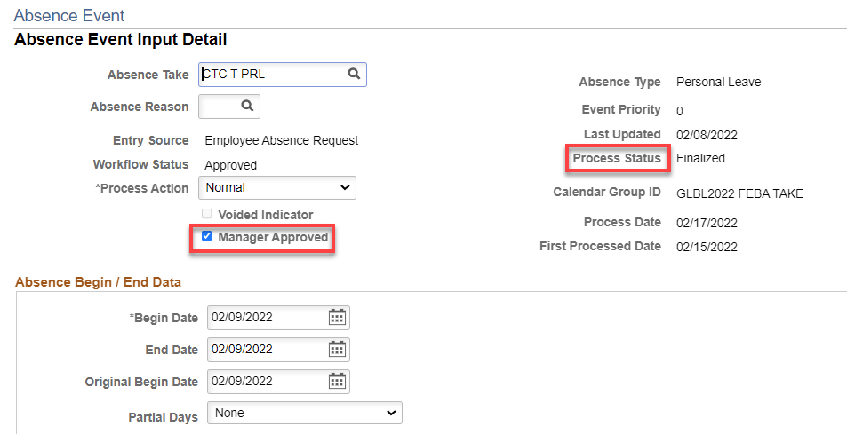

To see leave takes by pay period, go to Results by Calendar Group.

Enter the Empl ID or Name (first name then last name [no space])

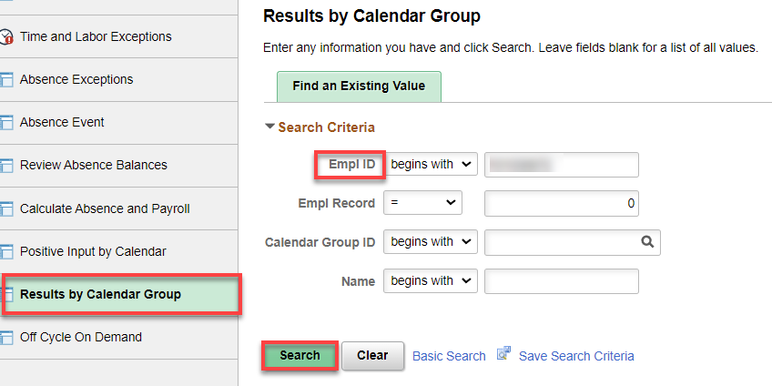

Click on the correct month of either Take or Ent (entitlement [accrual])

Absence Take (A or B payroll) then Absence Data tab brings up the Absence Takes for that pay period.

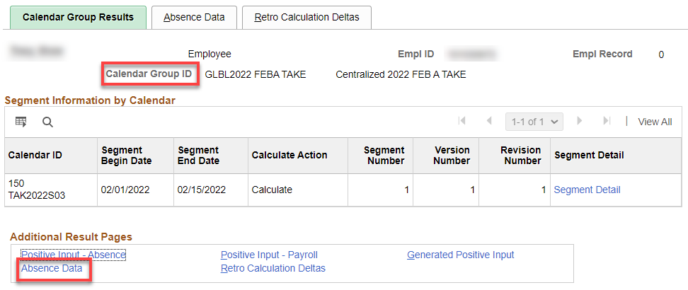

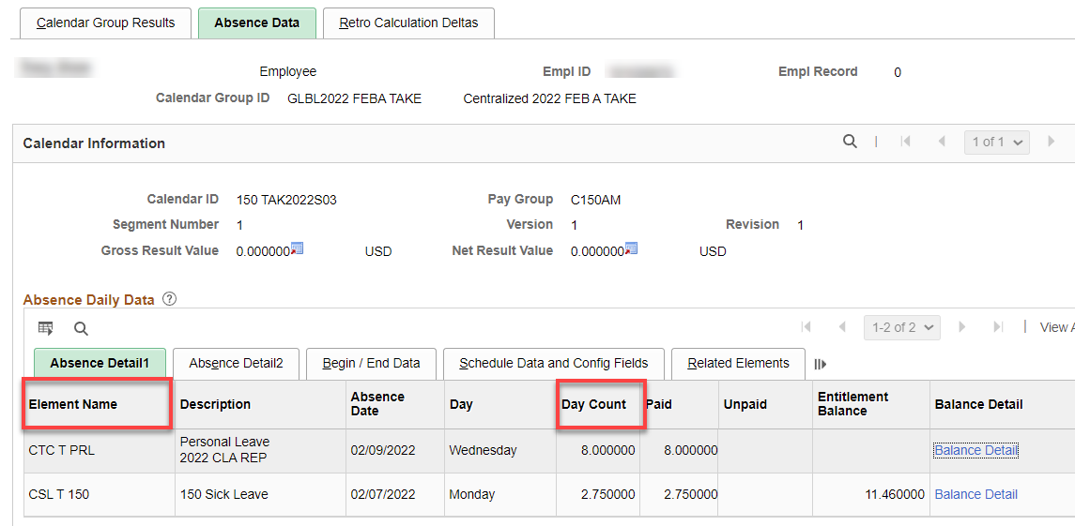

Entitlements can give you accruals by clicking on Accumulators tab

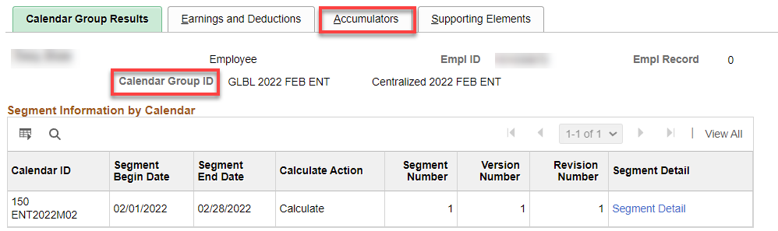

Accumulators Tab gives you Year to Date info (notice that there are 14 items)

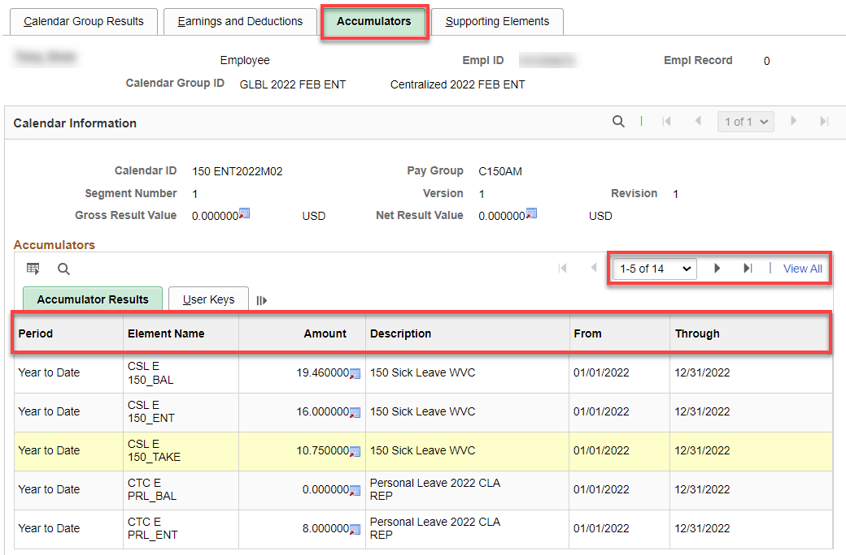

Supporting Elements gives you accruals (entitlements). This is a classified EE that accrues 12 hours of vacation per month. Very useful if an employee leaves and you want to pay out the vacation before it accrues, you can check to see the amount and then add the amount to the current balance.

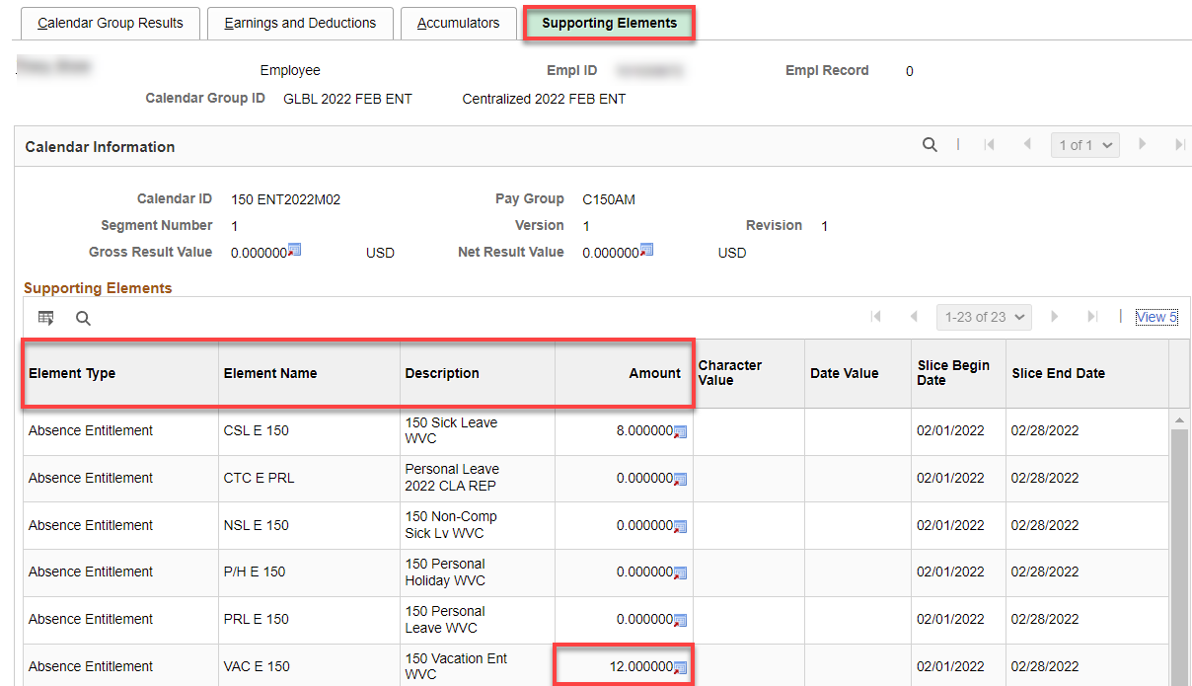

Click on View All and it gives you all kinds of info

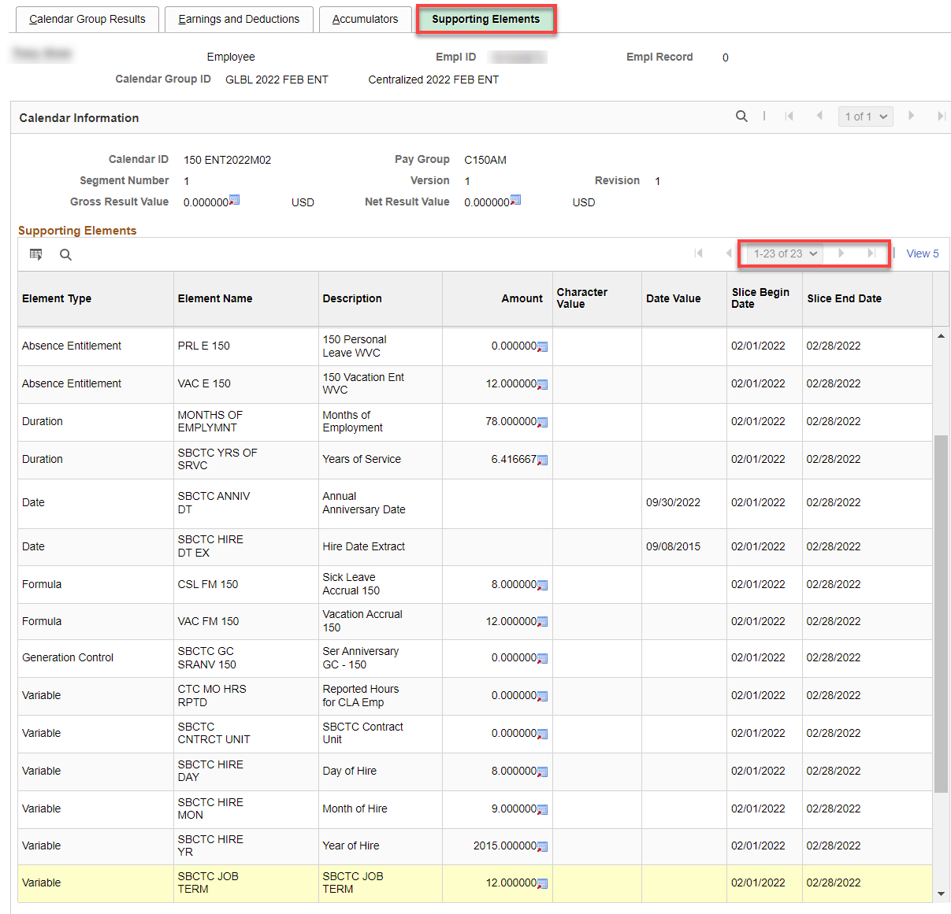

That’s a lot! Good luck

