Leave Balances, Accrual, Takes and Adjustments (skip to the last page for an adjustment only)
Workforce Administrator>Absence Administration Tile

Note: there is a 90-day maximum retroactive processing period.

This documentation is for looking up and adjusting balances for a termed employee.

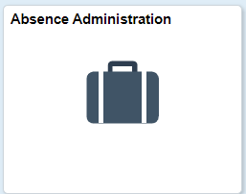

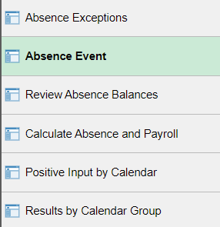

Check Absence Events DELETE ANY FUTURE ABSENCE EVENTS (make sure all absence events are all in – email person or wait until absence management takes are done for the month). I like to do it this way.

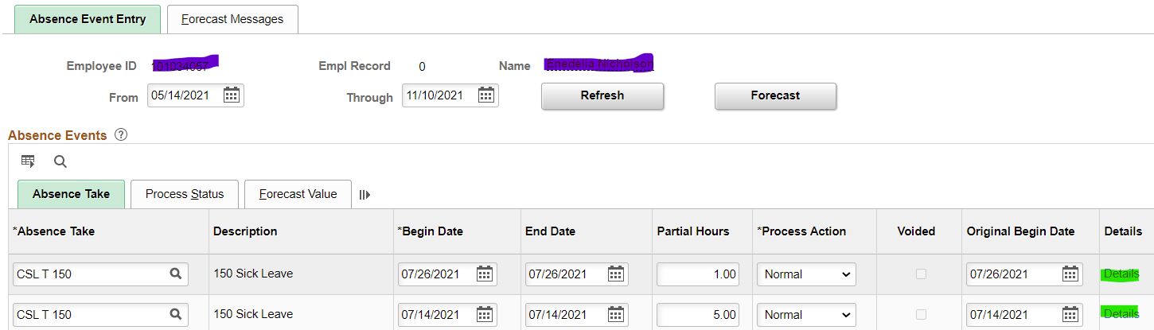

This shows that 4 hours of vacation leave has been taken (click on Details” to see if it has been approved and finalized or not). If the absence has not been finalized, it is not subtracted from the balances.

Check to see if it has been subtracted from the leave balance:

WARNING: The following is the encyclopedia Britannica version of Absence Administration. You will learn shortcuts but at least many of the steps you could take are explained.

Go to Results by Calendar Group, click on the take month (in this case it’s JunA Take)

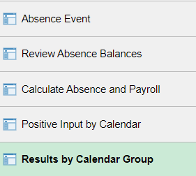

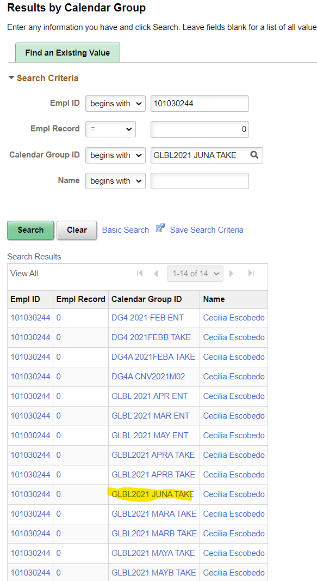

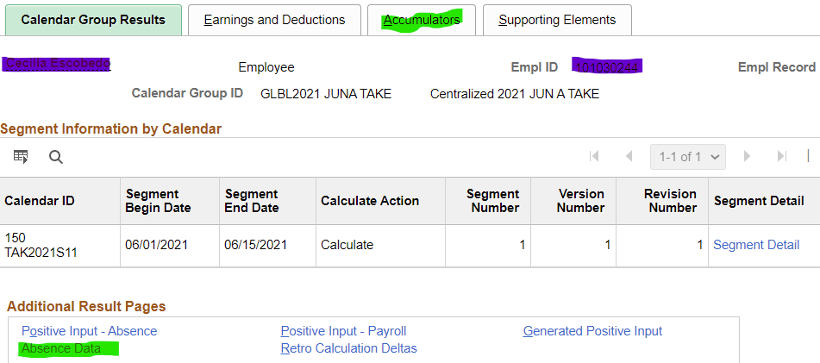

Check out the Accumulators tab and see the balances as well as other information

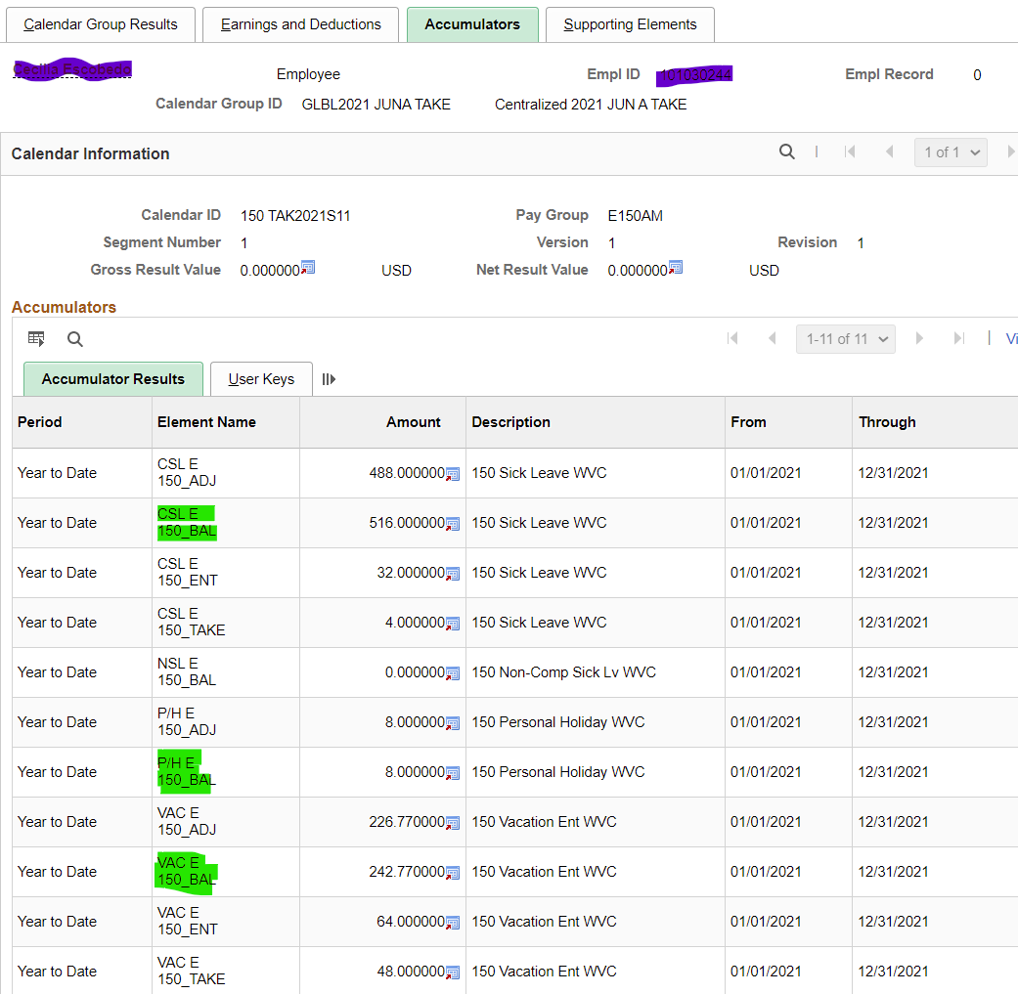

Click on Absence Data hyperlink

Absence Data (to go back to the main page that has the Accumulators tab, click on Return to Main Results Pages hyperlink at the bottom left.

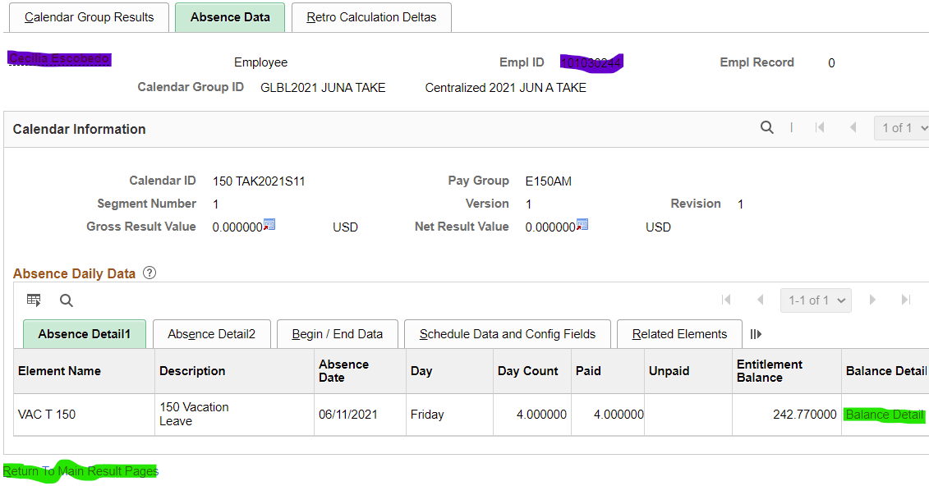

It shows that 4 hours were taken. Click on Balance Detail to see the before and after balances.

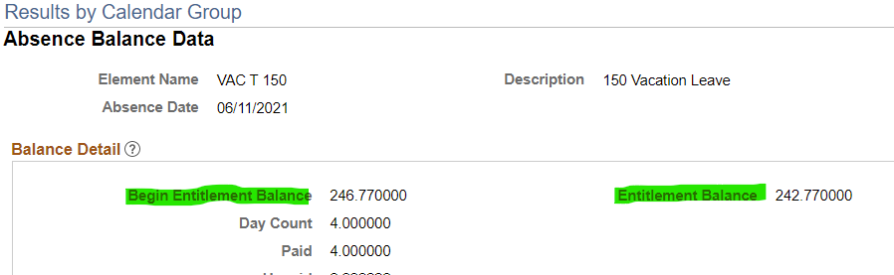

Now check on the amount accrued each month by going back to Results by Calendar Group and clicking on the previous month’s entitlement (in this case May ENT) OR click the Previous in List until you get to where you need to go.

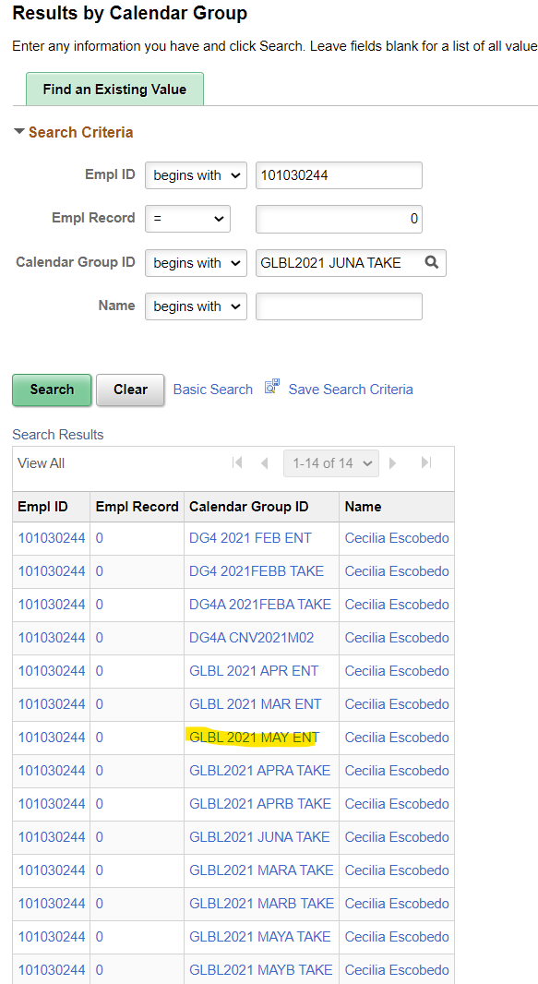

Click on the Supporting Elements Tab to see accruals. Keep in mind that if it is a month that personal holiday or personal leave hours accrue, or in the case of classified staff, leave accrual goes up because of length of service, you may have to account for those extra hours when adjusting leave. This person accrues 8 hours of CSL and 16 hours of VAC.

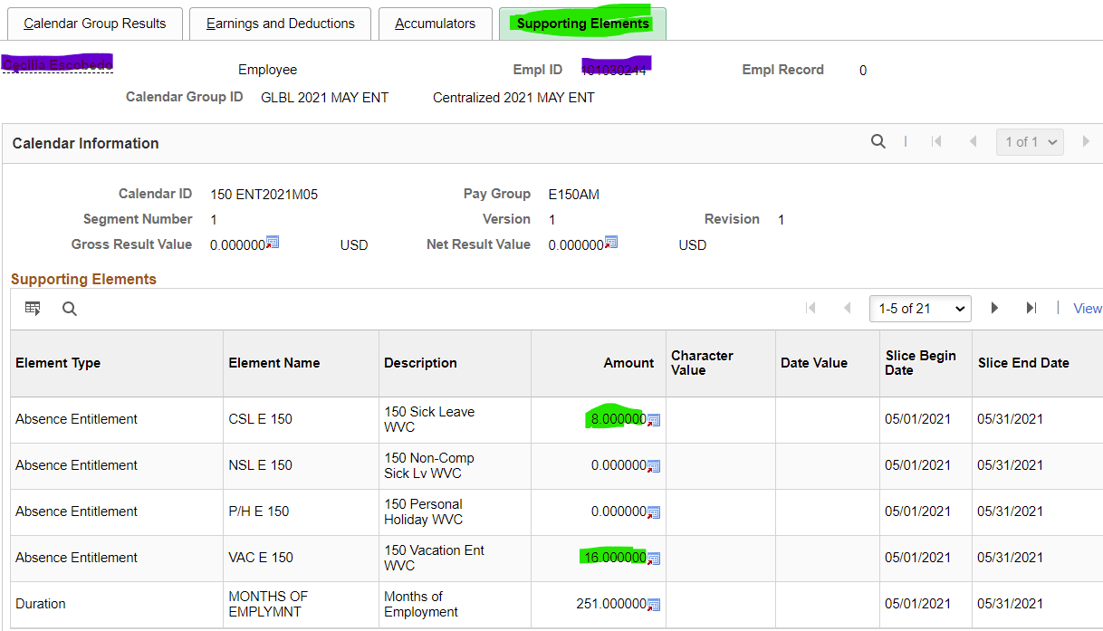

Review Absence Balances (sometimes the leave takes are not reflected in the balances – that’s why it is so important to either wait for the leave take process to run or look at the ending balances under balance detail)

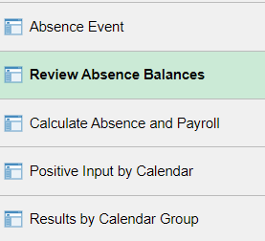

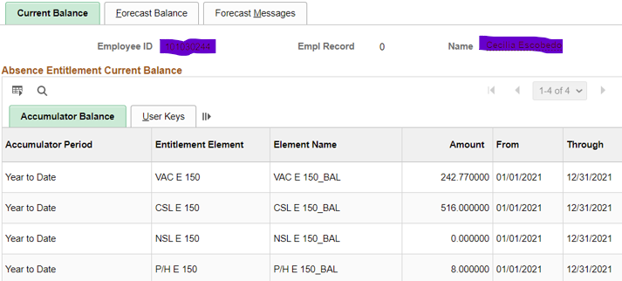

Adjusting Leave Balances (after checking leave taken and email person to make sure all leave is in and following the steps above).

Nav>Global Payroll & Absence Management>Payee Data>Adjust Balances>Absences

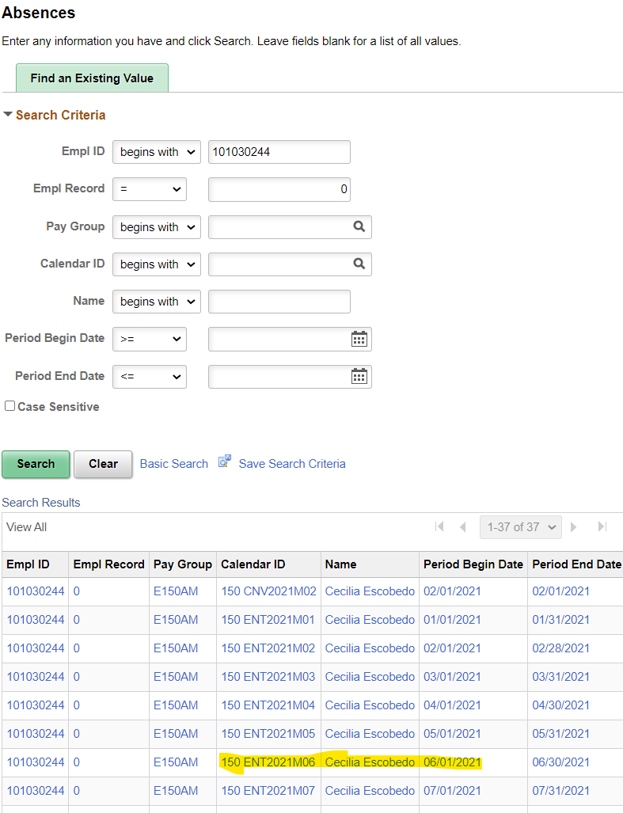

If termed on the current month, you can do the adjustment through On cycle process - Adjustment needs to be entered in the system before the current month accrual run.

If employee is termed/retired in previous month - run the off cycle process to adjust the balance.

Choose the current month to subtract the hours (if not waiting until the leave take for the month, make sure to leave enough hours for any leave taken but not approved or adjusted from the balances).

In the example above, 4 hours of vacation were taken BUT they were approved and subtracted from the leave balance already.

Do you remember the balances? I suggest printing them out, adding, subtracting, whatever so this next step is correct. Oh look, I put the leave balances in again

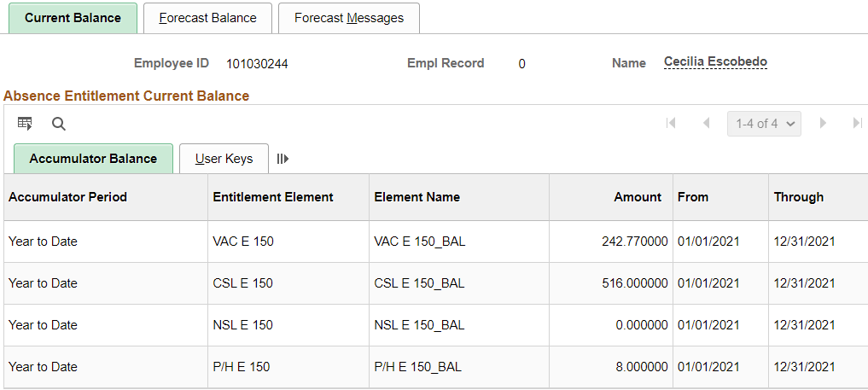
We know that this person accrues 8 hours of sick leave and 16 hours of vacation leave.
For this person all we need to do is subtract the balances plus accruals.

Add Adjustment Leave Code(s), as many rows as necessary, enter minus “-“ hours for subtracting hours and Begin and end Date (put in comments if you want). Save.

FOR TERMINATED EMPLOYES, THE END DATE HAS TO BE THE LAST WORKING DAY, NOT THE END OF THE MONTH (unless that is the last day worked) or the adjustment will not be made.

We still use the Entitlement Calendars*. Use the green highlighted codes for balance adjustments (transfer in/out, term, moving from one record to another, etc., orange for accrual adjustments (adding/subtracting P/H, PRL, vac, etc.), blue for adjustments to takes for Absence Balance Report, sick leave balances for sick leave buyout, etc.

*The January Entitlement Calendar cannot be used for P/H (Use 01A Take); the June Entitlement Calendar cannot be used for PRL (use July 01A Take).
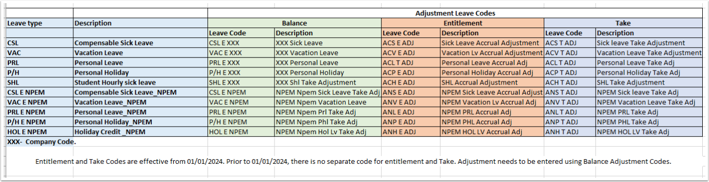
The following refers to the Absence Administration tile>Results by Calendar Group>Accumulator tab>Accumulator Results.

Using CSL, VAC, etc., will add the adjustment to the year to date Balance Accumulator but will not add/subtract the adjustment to the year to date Entitlement Accumulator nor will it adjust in the Review Absence Balance page (for administrators).

Using ACS, ACV, etc., will add the adjustment to the year to date Balance Accumulator and the Entitlement Accumulator Results and it will adjust the Review Absence Balance page (for administrators).

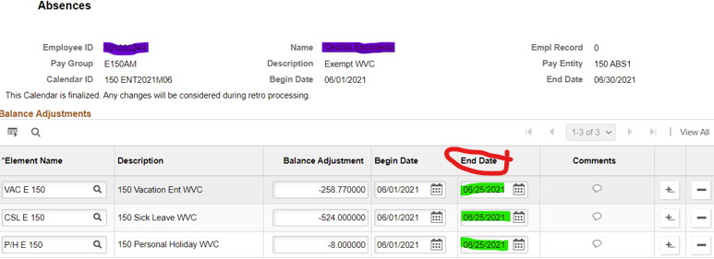

MAKE SURE ALL THIS INFO IS ON THE PAF SO PAYROLL CAN PAY OUT VACATION & SICK LEAVE, if applicable.

If termed on the current month, you can do the adjustment through On cycle process - Adjustment needs to be entered in the system before the current month accrual run.

If employee is termed/retired in previous month - run the off-cycle process to adjust the balance.

Choose the current month to subtract the hours (if not waiting until the leave take for the month, make sure to leave enough hours for any leave taken but not approved or adjusted from the balances).

After accruals and takes are done, all balances should be zero. I’ll check back to see…

If an Off-Cycle Absence Process needs to be ran, see Absence – Run Off-Cycle Absence Process documentation.

That’s it!

