District No. 15
Wenatchee, Washington

WENATCHEE VALLEY COLLEGE BOARD OF TRUSTEES
Board Meeting
January 19, 2025
Wenatchee Campus - Zoom

MINUTES

ATTENDANCE
Trustees Present:
Paula Arno Martinez, Chair
Steve Zimmerman, Vice Chair
Wilma Cartagena
Phylicia Hancock Lewis (virtually)

Absent
Tamra Jackson

Also Present:
Cabinet Members
Faculty and Staff

BOARD WORK SESSION – 10:00 am

COMMUNICATION
Trustee Paula Arno Martinez would like to nominate the Wenatchee Foundation for the ACCT Partner of the Year Award, she would also like to have Dr. Treat make a recommendation for the Faculty Member of the Year Award.

REPORT FROM TRUSTEES
During the visit to the ACCT Legislative Congress in Washington, DC Trustee Hancock Lewis spoke about the workforce program with Representative Schrier's office. She shared student success stories and the need for Pell grants as they are instrumental in students making a difference, particularly in the agriculture industry.

Trustee Arno Martinez shared that this year’s National Legislative Summit was one of the best ones. It reassured that Washington State representatives are in support of higher education. .

FINANCIAL REPORT
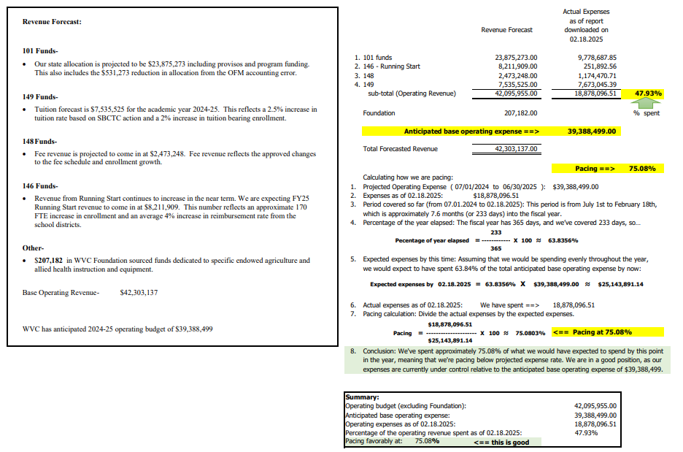

LEADERSHIP REPORTS
Full leadership reports can be found in the board packet for February 19, 2025.

Instruction, Dr. Tod Treat: Dean’s Day focused on: pathways minded advising its impact, accessible IT requirements, gateway courses and ways to bridge the gap, Title IX training for faculty and the annual schedule coordination for

Student Affairs, Dr. Diana Garza: Student Affairs continues to review the best practices to ensure student success. Process and improvement review was created around graduation and program completion.

Administrative Services, Brett Riley: BAC was held at Pierce College. Continued discussion around centralized accounting services. The 2025-2027 biennial budget is starting to come into focus and getting better clarity regarding the impact of the overallocation. Staff are working with CLA and Davis Farr to complete the 2021 audit and the 2022 financial audit.

Human Resources, Lisa Turner: Continued work with staff and supervisor training. Completed the DEIB and Title IX trainings, out of 474 staff 271 attended one of the eight sessions. Based on a survey there was high satisfaction for the Title IX training.

ASPIRE, Dr. Robin Angotti: Continuous work on building a data culture. Created the Data Detective newsletter to engage staff in the culture. Trustees enjoyed reading the newsletter.

Omak Campus, Cal Goolsby: FTE and headcounts continue to grow. Also seeing an increase in student success rates: 88% including Running Start for those under 24 years old and 93% for those over 24 years old.

Strategic Enrollment & Student Success, Ellia Sablan-Zebedy: Spring advising for Running Start students has begun. 71 students in Omak have completed advising and 275 students in Wenatchee. Application counts for the spring quarter are up when compared to spring 2024 (16% increase).

Public Information, Marcine Miller: Focus has been on developing proactive communications with faculty, staff, and students. Working on improving community relations, creating a more welcoming environment and, showcasing the great work that WVC is doing. A major project for the PIO office has been the development of the final strategic plan report, next step is for external communication.

Grant Development, Jessica Perez Bravo: Working on an NSF grant for Scholarships in STEM (S-STEM). The duet date is March 4, 2025, and the max funding is 2 million dollars over six years. Would like to audit the grants program and take a deeper look.
Title V & HSI Initiatives, Vanessa Saldivar: The program is very unstable, continued work on specific grant deliverables. Other HSI initiatives include the Dreamers Task to support students and respond when in need.

President’s Office, Dr. Faimous Harrison: Attending meetings with the state board to learn more about the financial impact on higher education due to the state-wide shortfall. Will be having an all-district meeting on February 21, 2025, where the budget impacts will be shared. Enrollment decline and economic impacts, the 40% reserve recommendation by NACUBO, and the financial reduction impact. WVC payback or budget reduction range will be from $540 - $1.6 million.

LEADERSHIP DEVELOPMENT
Jason Hetterle, Director of Technology provided the trustees with the GLBA – Cyber Security Report and Training. Training is a yearly requirement.

MISSION FULFILMENT & SCORECARD
Dr. Robin Angotti presented WVC mission fulfillment for the 2024-2025 academic year. She also presented the dashboard the ASPIRE team has built. The board approved the mission fulfillment and scorecards.

ACTION
Brett Riley presented changes to the following policies: 700.100, 700.210, 710.000, 710.210, 710.250.

REGULAR BOARD MEETING

CALL TO ORDER: 3:00 P.M.

LAND ACKNOWLEDGMENT

APPROVAL OF MINUTES

January 15, 2025, Regular Board Meeting, January 21, 2025, & January 31 2025, Special Meeting Minutes

Trustee Zimmerman moved that the minutes of January 15, 2025, Regular Board Meeting, January 21, 2025 Special Meeting and January 31, 2025 Special Meeting be approved. The motion was seconded by Trustee Hancock Lewis and carried unanimously.

MOTION NO. 2386

CELEBRATING SUCCESS

Conconully Outhouse Races
The Omak student club Community Engaged Knights (CEK) showcased extraordinary dedication and creativity at the Conconully Outhouse Races on January 18. Jose Cabello-Preciado, Gabe Cabello-Preciado, Max Gadeberg, Greg Johnson, Angel Rendon-Garcia, and Fabian Campos designed and built a castle-themed outhouse, racing it down the frozen streets of Conconully to win first place! This victory highlights the club's commitment to engaging with the community as representatives of Wenatchee Valley College Omak.
Students invested time, energy, and enthusiasm in planning, building, and participating in this long-standing community event. WVCO is so proud of this first-year club and their engagement activities this year including a local Zombie Fun Run and a Trunk or Treat event which saw 2000 kids come through the line and lots of superheroes and princesses “jousting” with our mascot knight. These achievements are not theirs alone—the outhouse race was made possible through the support of faculty and staff who generously contributed their time, skills, and resources.

Sustainability and Love the Planet Partnership
WVC Sustainability Committee hosted Love the Planet with Chelan Douglas Land Trust in the Maguire Center. Students, Faculty, and community members were invited to learn about recycling, composting and trail etiquette, and make sustainable Valentine's Day cards out of recycled material.
Community partners Winton MFG Compost Works, Sustainable NCW, and CDLT Joined WVC to provide free, fun and interactive educational experiences.
Dr. Joan Quazi, WVC’s Sustainability coordinator and Geography faculty member, continues to build partnerships across our community through her work with the Sustainability Committee. Student representatives were actively involved in the planning and helped community members learn about recycling on campus with displays and prizes.
This event was a great example of the work taking place across the college to make our campuses in Omak and Wenatchee an anchor in our communities.

ASWVC Formal
The Wenatchee Student Government hosted a formal event on January 24th at the Student Recreation Center from 4:00 PM to 7:00 PM. This event was student-driven, with a survey sent out beforehand to gather student preferences on activities and music selection.

Throughout the week leading up to the event, the ASWVC Student Senate transported decorations and supplies to the Student Recreation Center. On the day of the formal, setup began around 1:00 PM, with the ASWVC Student Senate decorating the space and coordinating final preparations. Food for the event was ordered through the campus food service, featuring a menu of salad, chicken alfredo, pasta, lemonade, water, and cake.

The event featured several interactive elements for students to enjoy. A snow globe-making station was set up in the yoga room, allowing students to create their own winter-themed keepsakes. A photo booth was placed at the main entrance, where students could take and keep their pictures. Round tables on the south court provided seating for students to enjoy their meal, while the north court featured a projector playing music for dancing.

Approximately 70 students attended the formal, dressed in professional and elegant attire. The event was well-received, offering students an opportunity to connect, celebrate, and enjoy a memorable evening.

INTRODUCTION OF NEW EMPLOYEES

The following new employee was introduced: Gladis Garibay, Program Assistant for Educational Planning.

SPECIAL REPORTS

Amber Watson, ASWVCO President
Amber Watson – Had a good turnout for the Valentine's Day Scavenger hunt. Prizes included gift cards for those who found the stuffed animals. The next event will be a clothing swap.

Dania Cuevas, ASWVC President
Dania Cuevas not present.

Sharon Wiest, AHE President
Sharon Wiest was not present.

Wendy Glenn, Chief Steward WPEA
Returned to bargaining on Jan. 12, there has been no movement from the state. Will meet again on Feb. 26, 2025. Went to Olympia to advocate for education. Met with Representative Burnett and spoke about the AI bill.

STAFF REPORTS

Brett Riley, Vice President of Administrative Services
Brett Riley did not ass to his written report shared during the work session.

Dr. Tod Treat, Vice President of Instruction
Dr. Treat did not add to his written report shared during the work session.

Dr. Diana Garza, Vice President of Student Affairs
Dr. Garza did not add to her written report shared during the work session.

Lisa Turner, Interim Executive Director of Human Resources
Lisa Turner did not add to her written report shared during the work session.

Dr. Faimous Harrison, President
President Harrison did not add to his report.

PUBLIC COMMENTS
No comments

ACTION

Rescind policies: 700.100 Electronic Information Resources, 700.210 World Wide Web Privary, 710.000 Administrative Technology, 710.210 Written Agreement to Comply, 710.250 World Wide Web

Trustee Zimmerman moved to rescind policies 700.100, 700.210, 710.000, 710.210, 710.250. The motion was seconded by Trustee Hancock Lewis and carried unanimously.

MOTION NO. 2387

EXECUTIVE SESSION: The Board entered an Executive Session to discuss issues related to personnel. The Executive Session lasted 60 minutes and ended at 4:45 pm.

ADJOURNMENT – 4:46 P.M.

_______________________________________ _________________________________________
Secretary Date Chair Date

